**E-Barangay Information Management System for Barangay 599**

**A Software Proposal**

Presented to the

Faculty of the College of Computer Studies and Systems

University of the East, Manila

In Partial Fulfillment

Of the Requirements for the Degree in

**Bachelor of Science in Information Technology**

By

**Dela Cruz, Kim Renzo C.**

**Ledesma, Francine Voltaire**

**Morales, Nathaniel Ervin**

**Sallan, Arnold D.**

**Viray, Vergel C.**

**May 4, 2021**

**TABLE OF CONTENTS**

**TITLE PAGE**

Title Page 1

Table of Contents 2

List of Tables 3

List of Figures 3

**Chapter**

1. **PROJECT OVERVIEW**

Project Background 6

Objectives of the Project 8

Statement of Work 10

* Scope of the Project 10
* List of Deliverables 15

1. **ANALYSIS OF EXISTING AND RELATED SYSTEMS**

Review of Existing Systems 18

Review of Related Literature 24

Review of Related Systems 28

Operational Definition of Terms 41

1. **SOFTWARE DEVELOPMENT METHODOLOGY**

Software Design and Development Approach 46

* Software Process Model 46
* System Framework 51
* Process Flow (DFD) 53
* E-R Diagram and Table Normalization 61

Constraints and Assumptions 64

Project Schedule 67

Testing and Evaluation Procedure 73

Bibliography 75

Appendices

* Appendix A (Sample Pictures from the Barangay Hall) 79
* Appendix B (Sample Forms from the Barangay) 84
* Appendix C (Transcripts of Interviews) 94
* Appendix D (Revision list of Panelists) 129
* Appendix E (Turnitin Similarity Index Result) 131
* Appendix F (System Prototypes).......................................................137

List of Tables

Table 3.1: CARM Board 62

Table 3.2: Color coded legend for Gantt Chart 66

Table 3.3: Testing and Evaluation Survey Questionnaire 73

List of Figures

Figure 2.1: Data Flow Diagram of the Existing system (Level 0) 18

Figure 2.2: Data Flow Diagram of the Existing system (Level 1) 21

Figure 2.3: Hybrain Landing Page 28

Figure 2.4: Dashboard for HyBrain 29

Figure 2.5: Resident Information Management (Hybrain) 30

Figure 2.6: Add New Resident Feature (Hybrain) 31

Figure 2.7: Resident Profile View (Hybrain) 31

Figure 2.8: Blotter Record Management (Hybrain) 32

Figure 2.9: View Blotter Information (Hybrain) 32

Figure 2.10: File New Blotter (Hybrain) 33

Figure 2.11: Settlements and Reports (Hybrain) 34

Figure 2.12: Crystal Report Generation – Clearance (Hybrain) 34

Figure 2.13: Crystal Report Generation – Certificate (Hybrain) 35

Figure 2.14: Project paradigm framework for BMIS 36

Figure 2.15: Main Menu (BOMS) 37

Figure 2.16: Treasurer Menu (BOMS) 37

Figure 2.17: Secretary Menu (BOMS) 37

Figure 2.18: Process framework for the Development of Computerized Information System of Barangay Poblacion, Danao City, Cebu 39

Figure 2.19: Architectural Design of the e-Barangay System (Conceptual Framework) 40

Figure 3.0: AGILE Model 46

Figure 3.1: System Framework of the Proposed System 51

Figure 3.2: DFD of the Proposed System (Level 0) 53

Figure 3.3: DFD of the Proposed System (Level 1) 55

Figure 3.4 DFD of the Proposed System (Child Diagram for Accessing the system) 57

Figure 3.5 Data Flow Diagram of the Proposed System (Child Diagram for Update Web Content) 58

Figure 3.6: Data Flow Diagram of the Proposed System (Child Diagram for the Supply Service Requirements Process) 59

Figure 3.7: Data Flow Diagram of the Proposed System (Child Diagram Payment) 60

Figure 3.8: ER Diagram and Table Normalization 61

Figure 3.9: Gantt Chart for CAPS A 67

Figure 3.10: Gantt Chart for CAPS B 68

Figure 3.11: PERT for CAPS A 69

Figure 3.12: PERT for CAPS B 70



UNIVERSITY OF THE EAST

Manila

College of Computer Studies and Systems

**May 4, 2021**

This is to certify that the manuscript entitled **E-Barangay Information Management System for Barangay 599**, by the following students:

**DELA CRUZ, KIM RENZO**

**LEDESMA, FRANCINE VOLTAIRE**

**MORALES, NATHANIEL ERVIN**

**SALLAN, ARNOLD**

**VIRAY, VERGEL**

in compliance for the thesis defense is found to be complete and checked by the undersigned.



**PROF. ARNE R. BANA**

**Adviser**

**CHAPTER 1**

**PROJECT OVERVIEW**

**PROJECT BACKGROUND**

Integration is crucial, the needs and desires of people tend to require faster and more accurate results and with the uncertainties happening in the surroundings it is evident how significant it is. E-governance or Electronic Governance/Government is one of those innovations and by far is one of the more productive forms of it. E-governance was established in the late 1990’s with the sole purpose of extending the contributions of the field of information systems towards the society – involving the integrations of processes in the fields such health care, security, construction, welfare etc. (Horan,2005). It applies to almost all forms of governance.

In the Philippine setting, the lowest unit of governance is the barangay. However, despite its lower scaling a barangay still covers a wide scope of population and jurisdiction meaning the governing body of the barangay is still responsible for its inhabitants and the activities inside that area. The barangay hall is where the official of the barangay is based; this is where residents of the barangay settle their queries, requests, transactions, certifications etc. This array of processes involves a lot of tedious processing which makes it more fitting for what an e-governance system can bring to the table and in the case of the project’s subject which is Barangay 599 in Sta. Mesa Manila Philippines the adaption of the

concept of e-governance could yield them an e-barangay system: a system in which is centric towards the processes that circulates in the barangay.

Barangay 599 has been one of the forerunning barangays along the streets of “Victorino Mapa” and as stated by a corresponding local of the barangay it has been established way before she was born which was during the early 1970’s and since then, not many integrations were made nor committed by the municipality. According to the barangay’s secretary, there are about 5,600 registered citizens. Barangay 599’s roster of officials is composed of the Barangay Chairman (Jose Milo L. Lacatan), Barangay Secretary (Maria Cecilia C. Dela Cruz), SK Chairman and Kagawads (Erwin L. Sampaga, Florante V. Bonagua, Crisantro G. Lorica, Alexander S. Ceño, Nelson L. Labrador, Marivic Villareal). Supporting these leaders are the 20 barangay enforcers, 20 “lupontagapamayapa’s”, 3 advisers and being composed of 10 puroks, 10 purok leaders. However, mostly the secretary’s team and the chairman handle the processes, queries, and requests of their residents.

The introduction of an e-Barangay System to Barangay 599 will greatly improve their processes. It will bring utmost convenience to both residence and governance. The barangay currently has a manual system which caters to thousands of both registered and unregistered citizens. This is tedious and the e-barangay system can solve it. Remember good governance is done by catering the needs and ensuring the safety of the people and never by fear.

**OBJECTIVES OF THE PROJECT**

**GENERAL OBJECTIVE**

The general objective of the e-Barangay Information Management System is to provide an easier option for the Barangay and the Barangay officials to keep track and edit records and other transactions done within the Barangay and to lessen all physical contact especially during the pandemic. The system aims to replace their manual processes and offer them a more comprehensible and effortless procedures of handling transactions in the barangay.

**SPECIFIC OBJECTIVES**

The specific objectives of the project are the following:

* To provide faster, easier, and more comfortable way in the Barangay especially in the process of payment/transactions etc.
* To use SMS for disseminating of announcements/events in the barangay.
* Use of web hosted e-Barangay Information Management System.
* To develop a visual and working prototype of the system that displays the list of residents and necessary information.
* To develop an information management system that is capable of: displaying, updating, filtering, and handling data of the residents of the barangay.
* To develop an information management system that offers the capability of the generation/issuance of the residents’ barangay clearance, certificate of residency, and other necessary certificates.
* To develop an information management system that offers the capability to create and handle forms of barangay summons/blotter.
* To create a prototype that will monitor the transaction logs of the barangay with easier access and data handling.
* To develop a module that can keep track of the schedules of the barangay officials.
* To develop a module that can: create, update, delete and keep track of schedules for the settlements, and businesses of the barangay.
* Rental of equipment of the barangay (tables, chairs, library, darts etc.)
* Rental of infrastructures of the barangay (basketball/volleyball court, parking, day care etc.)
* Barangay summons.
* To develop a module that will allow the residents of the barangay to fill up an online survey form for them to be recognized as an official member of the barangay.
* To develop a module for keeping track of the active COVID cases of the barangay.
* Location of purok with active COVID-19 cases with geographical map.
* List of residents who are considered as PUI (Patient(s) Under Investigation) or PUM (Person(s) Under Monitoring).
* To use GCash application and its proof of payment as an online payment/transaction in the barangay.

**STATEMENT OF WORK**

*Scope of the Project*

The proposed e-Barangay Information System will replace the manual process of the barangay which is the use of logbooks that hold the records of their residents’ Information and financial transactions. The proposed information system will provide a database for all the residents of the barangay and all the transactions in the barangay will all be recorded. This will ease the barangay officials and the residents of the barangay. This is also to lessen all physical contact within the barangay due to COVID-19 virus.

The proposed e-Barangay System for Barangay 599, Sta. Mesa in Manila will cover the following:

* Update/display list of necessary information Module
* This module will update/display the information of residents within the barangay.
  + Display Resident Records (Certificate Issuance History)
* Search/Display resident by information (Name, Age, Records, etc.)
* Search/Display Blotter Records
* Search/Add/Edit/Delete information of the residents (Name, Age, Records, etc.)
* Dashboard Module
* This module will display some information to the user.
  + Visual details of the Barangay (Name, Resident Count, Logo, Background)
  + List of active officials on a specific date

Display demographics of the Barangay (Number of residents, Age Range, Number of Voters etc.)

* SMS Announcement Module
  + This module will allow the barangay officials to send their announcements in the system as an SMS to the residents of the barangay.
    - Can search/add/edit/display, the previous announcements and give the barangay officials the option to send the announcement as an SMS to the residents of the barangay.
* Generation/Issuance of the Resident Module
* This module generates and issues the certificates available/requested by the constituents.
  + Can search/add/edit/display, the requested and received certificates for the current year to prevent multiple issuances of certificates.
* The following certificates are:
  + Forms without Fees
    - Barangay Clearance
    - Certificate of Residency
    - Proof of Residency
    - Certificate of Indigency
    - Certificate of Good Moral
    - Burial Assistance
    - Clearance for Lipat-Bahay
    - Barangay Resolution Form
    - Summon Letter
    - Blotter Form
    - Barangay Acceptance Form
  + Forms with Fee
    - Business Permit
      * Business Capital is Below PHP 10,000 - The constituent must pay PHP 300.
      * Business Capital is within the range of PHP 10,000 – PHP 50,000 - The constituent must pay PHP 500.
      * Business Capital is above PHP 50,000 – The constituent must pay PHP 1,000.
    - Certificate for Local Employment
      * The constituent must pay PHP 20.
    - Certificate for Loan
      * The constituent must pay PHP 50.
* Rental Request Module
  + This module will allow residents to send a request to rent properties of the barangay
  + The following properties are:
    - Properties with fees:
      * Library
      * Basketball/Volleyball Court
      * Parking
      * Daycare
      * Barangay Halls
    - Properties without fees:
      * Tables and Chairs
* Transaction Log module
* This module will show the transactions that the user has made along with the date and time.
  + Display the previous transactions of the constituent (Request of Certificates, past paid transactions etc.)
* Login Audits Module
  + This module will show the timestamps whenever a barangay official logs in and logs out of their account in the barangay system.
* Payment Module
  + This module will allow the users to send a proof of payment to the barangay system for their requests that need payment to be accepted/verified
* Online Survey Form Module
* This module will allow the residents of the Barangay to fill up an Online Survey Form to certify that they are residents of that area.
* Summon/Blotter module
* This module will allow the user to make summons/blotters when requested by residents.
  + Create Summon/Blotter Form
  + Visual display of the List of Summon/Blotter Records
  + Search query of Summon/Blotter Records of a certain resident.
  + Search query of Summon/Blotter Records of the entirety of the Barangay.
  + Display Summon/Blotter details
  + Generate printable narrative reports.
  + Search/filter list of Persons Involved in other Summon/Blotter Records.
  + Display status of said Summon/Blotter if it has been resolved or not.

**LIST OF DELIVERABLES**

* Conduct User Acceptance Testing (UAT)
* This is when actual users test the software to see if it can carry out the required tasks it was designed to address in real-world situations. This is to know what the required improvements for the system find any bugs and make sure the system can maintain properly and can last longer. This step will be conducted approximately in late June (June 22-24, 2021) until early July (July 6-8, 2021)
* Online Tutorials/Training Program
* The online tutorials on how to manage/operate the system will be conducted with the barangay officials. The proponents will guide the barangay officials step by step to ensure that the system will be used efficiently and accurately. There are 2 parts in the tutorial course. The first part conducted in approximately the middle of July. The approximate date will be July 10 – 11, 2021. This date is chosen specifically at the weekend to ensure that the barangay officials will have time to attend the training course. The second part will be conducted a week later, the approximate date will be July 17-19, 2021 chosen specifically to accommodate the barangay officials as the dates fall in the weekend.
* Interview
* The proponents set interviews towards the certain personnel of the barangay in which served as the means of gathering crucial information regarding the barangay and their specific requests. The meeting of the barangay officials will be held in approximately early to middle of June, the proponents approximate the date to be June 18-19, 2021.
* User Manual
* This will serve as a guidebook that will explain what every item does in the online system and shows the instructions to navigate certain modules and explains the purpose and design of each module. The distribution of the User Manual for the barangay officials will be after the online training courses are done. The proponents approximate the date to be at July 19-20, 2021.
* Maintenance Plan
* An Information Management System will be provided that can allow the administrators to edit/add content, provide maintenance and integrate updates to the system.

**CHAPTER 2**

**ANALYSIS OF EXISTING AND RELATED SYSTEMS**

The following chapter will be tackling the dissection of the currently implemented system which the proposed system will be adapting. A data flow diagram is constructed for the analysis of the said existing system. Along with these are the gathered resources related and would be influencing the proposed system’s development.

Resources such as related scholarly documents and related developed systems. All of the following information’s authors are given citation. This is to ensure the avoidance from any form of copyright issues.

**REVIEW OF EXISTING SYSTEM**

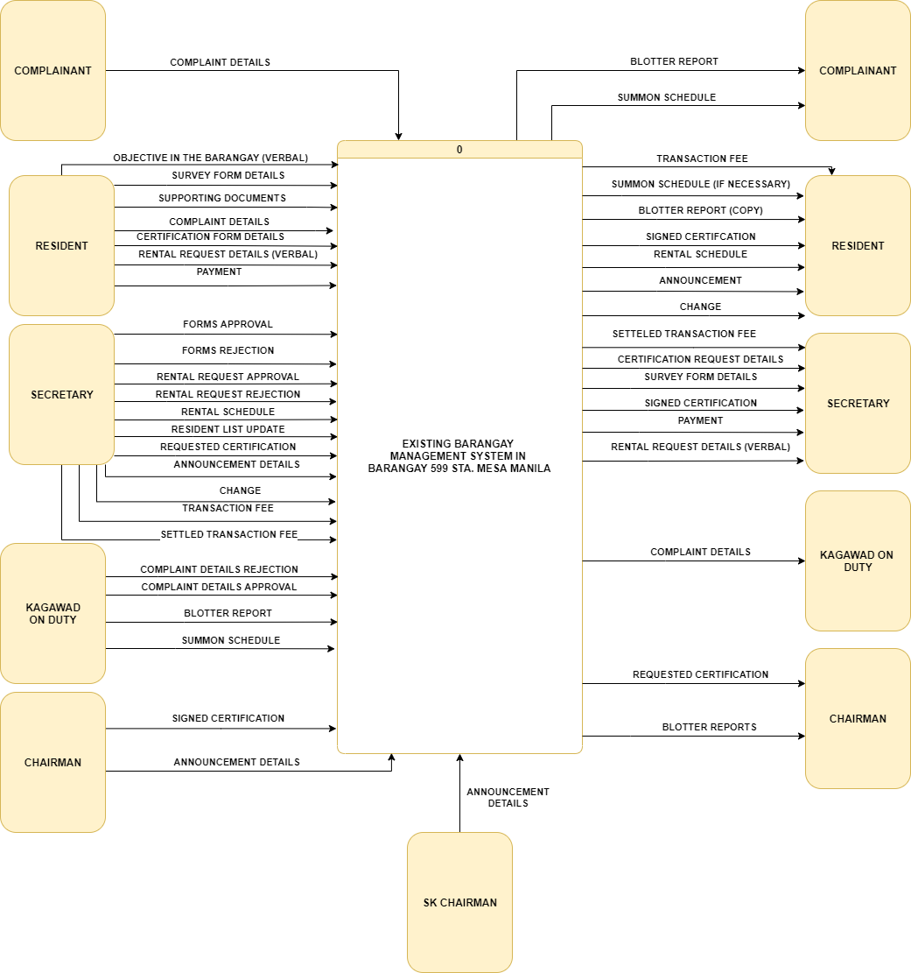

**Figure 2.1: Data Flow Diagram of the Existing System (level 0)**

The following diagram presented is the context level data flow diagram of the currently implemented system in the barangay. Synthesized from the data gathering sessions held are the inputs and outputs presented in this diagram. In this diagram, the exchange of data between among the stakeholders is presented. As seen here the resident can send details in which will correspond to their requests or queries in the barangay. A resident as stated by the diagram sends the following: their objective in the barangay, the complaint details, survey form details, rental request details, payment and of course the details of their certification forms. The stakeholders coming from the barangay’s management also have their set of inputs and outputs. As the secretary has the following inputs: verifications in the rental, certification form and survey form details, after said verifications the secretary is then the one to perform the creation or documentation of their respective requests (e.g. resident record update, requested certificate etc.), if the verification process of the request finds the person non legible for the request then she can reject the request, the secretary has the responsibility of addressing the public with an announcement that could either come from a notice from a higher governing body or the chairman of the barangay (e.g. lockdown updates, amelioration program announcements, water interruptions etc.), she also is the one to verbally tell the requestee the fee they have to settle for the service they availed and lastly she is to provide change for the fee paid by the requestee. The secretary can receive the matters related to the following: rental, certification, survey form, payment and of course the signed certificate that will come from the chairman. The “Kagawad on duty” is expected to handle blotter related matters therefore receiving the complaint details and creating a blotter report regarding it accompanied by the summon schedule. The chairman is the highest governing personnel in the barangay; however, it is stated that he’s duties goes beyond the services the barangay offers; he’s only called upon to contribute in these services, when necessary, that’s why he is still given access to the blotter report, he also receives the unsigned certificate created which will correspond to the input he provides which is the signed certificate. The chairman also does the announcement himself sometimes. The “SK chairman” is said to announce youth related programs reason why he also has an input for announcements in the barangay.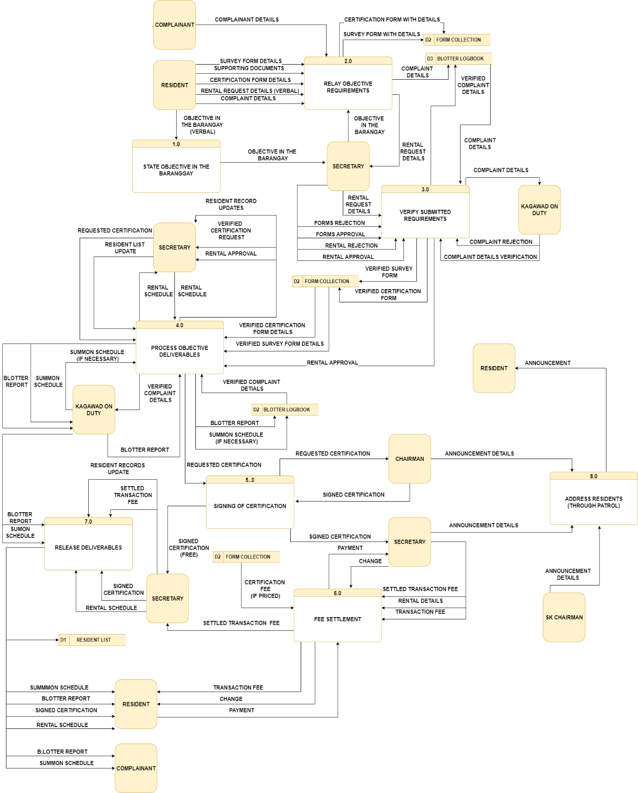

**Figure 2.2: Data Flow Diagram for the Existing System (Level 1)**

The visual presented above is the level 1 diagram of the existing system. This diagram is derived from its context level diagram. In this diagram is where the inputs of the entities are applied in its appropriate processes. Each input has its ending destination or ending form. If an input undergoes a process it is expected to undergo movement or transformation. Processes are necessarily in sequence as it is important to show the correlations of each other.

The diagram expresses the processes that happen within the office of the barangay; note that these services are done using the manual system they are currently implementing and is all through walk in process. The processes or the data flow in the barangay starts by having a resident of the barangay arriving in the barangay’s premise in which he/she states their objective. With those objective personnel in the barangay are to attend to them and redirect them to the respective personnel dedicated for that service’s objective. Regardless of who attends to them whether it will be the “Kagawad on duty” or the secretary the official shall ask the person to relay the parameters of their requested service. This is where they will be supplying the details that the service calls for. The blotter being one of those services is to receive the details of the complaint which will be recorded in a logbook which will have the details handwritten even so after the verification coming from the “Kagawad on duty” and transforms into a report it will remain as a record in that logbook. For request involving a form such as the acquiring of residence which involves the survey form and as well as the certification request form. The resident will have to supply the contents for both being the personal details accompanied by the supporting documents it calls for and the certification form details which will undergo verification coming from the secretary which will determine whether supplied details is sufficient and valid otherwise if it isn’t then it is to be rejected. Upon verification for the residency information update (survey form) and its accompanying documents it is to be supplied in the resident records of the barangay. As for the certification it will undergo identification whether it requires fee or not; if found free then the release of the requested document is swift and as for the one’s requiring fees requestee must pay up before the release of the request happens. This payment and release procedure also applies for a verbal transaction such as the rental; the barangay states that there are no actual records that keep track of their properties’ rentals therefore request details are only verbally given. No record is left for the barangay in terms of these service. The SK chairman can create announcements as well as the chairman and secretary, the following are given the privilege to address the public as they have the responsibilities; the SK chairman being the youth’s representative, secretary being the one of the chairman’s personnel and of course the chairman being the superior governing person in the barangay.

It is also evident here that there are several times wherein the passing of the details or data returns to an entity such as the secretary. This is due to the lack of an actual processing system that handles this, leaving the stakeholder stuck with the gravity of the numerous workloads. For an instance, the secretary handles both receiving, verification, creation as well as the release of the certification request, she is also the person to ask the chairman for the form’s signature.

**REVIEW OF RELATED LITERATURE**

The following citations of literature are materials retrieved from other developers’, researchers’, or any legitimate source of information such as governmental, scholarly and any other academics’ works. All of which are given proper citations to avoid copyright issues.

The growth of automation is at every corner of the country and in the field of governance is one of its major patrons. It is mentioned by certain study that municipalities increasingly rely on computer-based systems and data management. The information which was usually and or traditionally exchanged through human communications is now possible through electronic or say automated means. ***(Zeb et al., 2012)***.

As defined by an article, e-governance and/or e-government refers to the delivery of national or local government information and services via the Internet or other digital means to citizens or businesses or other governmental bodies ***(Palvia and Sharma, 2019)****.* In the setting of the Philippines, barangay system is the conventional term for smaller scale governance. As defined a barangay is known as *balangai* during the precolonial period, is currently the lowest political administrative unit of the Philippine government ***(Porio and Sarmiento 2019)*.** An e-barangay system is most appropriate form of e-governance in the topic. Having studied and analyzed the current state of barangay 599 it seems it is in dire need of such solutions or integration.

Integration is likely, as mentioned in a study that the automations of today or a computer-based system is much efficient and accurate. Computer-based information retrieval operates using software that can offer information services for an institution. Information technology is a significant in process of upgrading leadership through services that every Barangay are work with and in their case, which is in Barangay Cuatro where it is the place where public market of Indang is located. The term management information system was originally used to distinguish a computer application from the traditional accounting jobs ***(Justo and Morales, 2017).***

The developers of UE-CCSS proposed an e-Barangay system for Barangay 599 in Sta. Mesa Manila. It is to use PHP to create a web-based system to monitor the population of the barangay. Recommended by a proposed study where they used PHP as well wherein, they performed a study in exactly thirty (30) barangays in Malita Davao Occidental. Wherein they had conducted a survey as their medium for data gathering in all the thirty barangays. Their project was dedicated in the automation of the management of barangay’s households, commodities, and population. Which serves as a form of monitoring of the increase and decrease of the following information which are crucial for the barangay. They made use of “geotagging” in handling the households and commodities for the barangays. The project was made possible by the creation of a web-based system that utilizes Google Map Application Programming Interface (API) in locating the commodities from barangays. Their system is also equipped with a module that will store and populate barangay household, population and geotagged commodities was provided. Language used in the study was PHP through sublime text editor accompanied with a WAMP local server. Through these means they were able to create a functioning system which had satisfied their objectives ***(Aparci and Ruelan, 2018)***.

Aside from monitoring of residents the system must be capable of being able to cater the transactions necessary in the setting of the barangay. One of which is a blotter system. The barangay is responsible for the peace and welfare of its constituents therefore it has a sole responsibility of settling and handling such scenarios. Given that it is established that minor disputes and criminal offenses be “amicably settled” by the barangay leader, or captain, without the presence of lawyers all of which in the setting of a barangay ***(Shoemaker, 2010)***. A process in which can be modified through the help of automation.

According to a certain study, a secure and harmless environment is a very much important aspect in promoting investment and economic growth. Along with that is their proposal of a system of such that is capable of monitoring crime to modify and enhance the barangay justice system existing. A Web-based Crime Monitoring Module capable of record keeping, and management of offenses in the community. The system provides a more effective way of monitoring offenses and blotter cases in the selected barangays that leads to better administration of peace-and-order (Antonio, 2020). Like what the system will be presenting as one of its modules.

Unlikely events tend to happen yearly, may it be calamities, accidents and even pandemics. The year 2020 had given the Philippines tons of these. However, along with that it had also made the people realize the importance of automation and during the pandemic it has been established that physical contact must be lessened as advised by WHO and the CDC one must maintain distance in contact with certain individual; stating that to conduct social distancing 6 feet shall be maintained between you and the other person to avoid possible transmission ***(CDC, 2019)***. These certain constraints that COVID brought the people to rely on cashless payments, flexible learning systems and of course distanced transactions. Due to the pandemic, strict caution is executed with interactions in the barangay. Manila being second in the ranking of most amount of tallied COVID cases with manila honing 22,683 as of October 30, 2020 ***(DOH, 2020)***.

**REVIEW OF RELATED SYSTEMS**

The following are related works, projects, designs, or diagrams to the proposed system. The following shall be references that will manifest its influences to-wards the project’s conclusion. These will also serve as proof of the system’s significance.

**HYBRAIN (Jayme, 2020)**

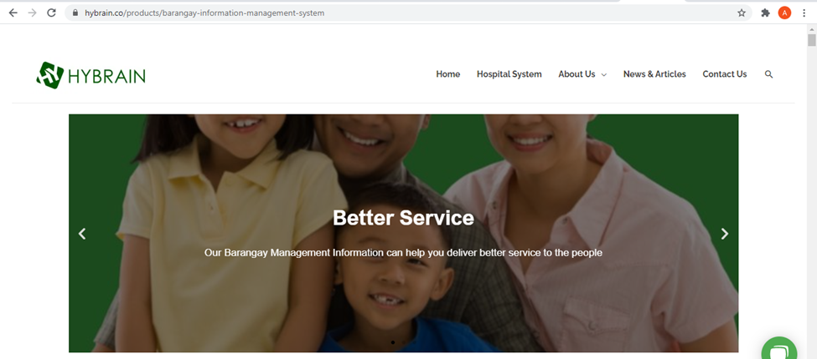

**Figure 2.3: Hybrain Landing Page**

“Hybrain” is a website that offers several products which are automations of different systems. In this presentation is Hybrain’s version of a generic Barangay system. As a generic type of web application, it is expected to contain the generic modules that a typical e-barangay system is expected to have.

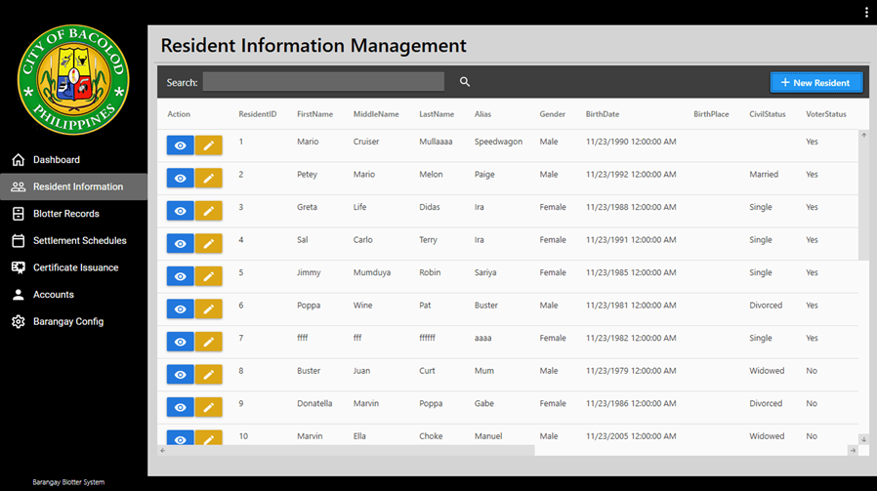

**Figure 2.4: Dashboard for HyBrain Generic Barangay System (Barangay Montevista, BACOLOD)**

The following representation showcases what a typical e-barangay system should be composed of. In this figure is the number of registered residents in the barangay, the segregation of genders in said population, the number of registered voters, purok/areas present, a list view of the officials of the barangay in the system along with their details such as their position and assignment, and lastly is a navigation on the left side for easier navigation between modules.

These features are a must on the e-barangay system of 599 as the tallying of officially registered individuals of the barangay is one of their demands as it is crucial and currently problematic. Same as for the navigations, the developers would want to ensure that the stakeholders will not have any trouble regarding the configuration of the system in the span of training them during system implementation process.

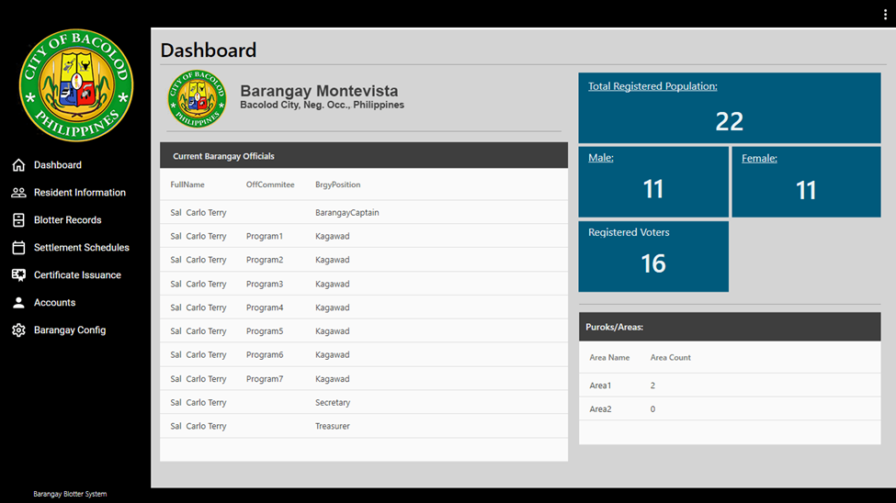

**Figure 2.5: Resident Information Management**

The figure above is the system’s resident information management feature. This feature is made for the tabulation of the registered residents and along with their names are their resident ID, full name, and other vital details that every resident has in the printed version of their forms such as the marital status, gender, date of birth, voter status etc.

The functionality “add new resident” will be adapted as it will be compliant towards the demands of the clients as they are in need for a less problematic yet faster and more accurate way of adding new residents in the barangay. There are also other functionalities present which are the view profile and edit as well.

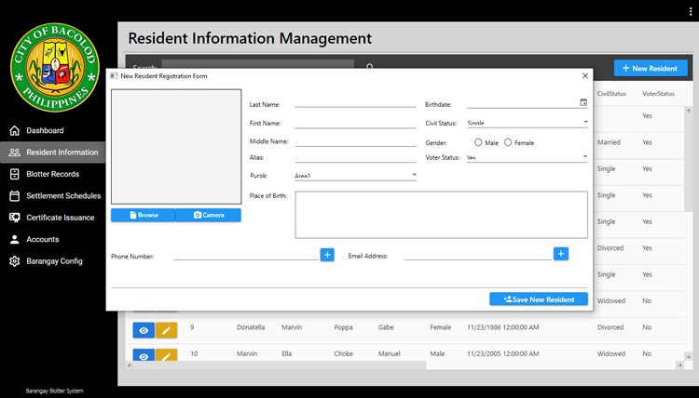

**Figure 2.6: Add New Resident**

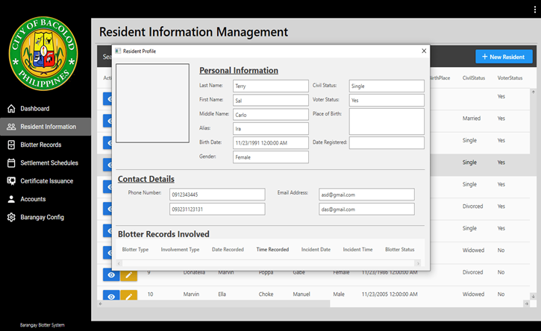

**Figure 2.7: Resident Profiling (can also be edit view)**

**Figures 2.6 and 2.7** presents the functionalities present in the module. First is the “add new resident” (Figure 2.6) which prompts a modal that asks of vital inputs for the persons identification as new resident. Next function is the “edit or view pro-file” (Figure 2.7) which can present the resident’s profile and can transition in an edit view for the modification in their data in case there will be sudden need for alterations regarding resident’s data.

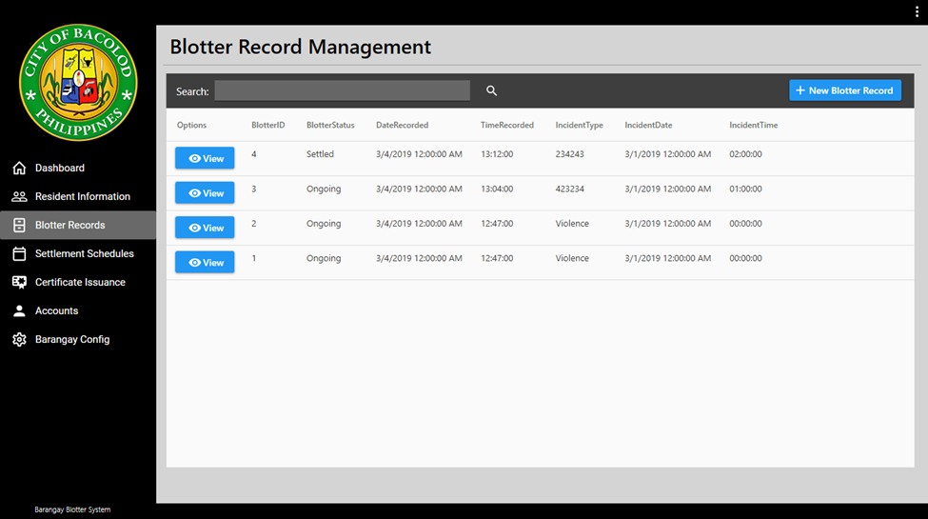**Figure 2.8: Blotter Record Management**

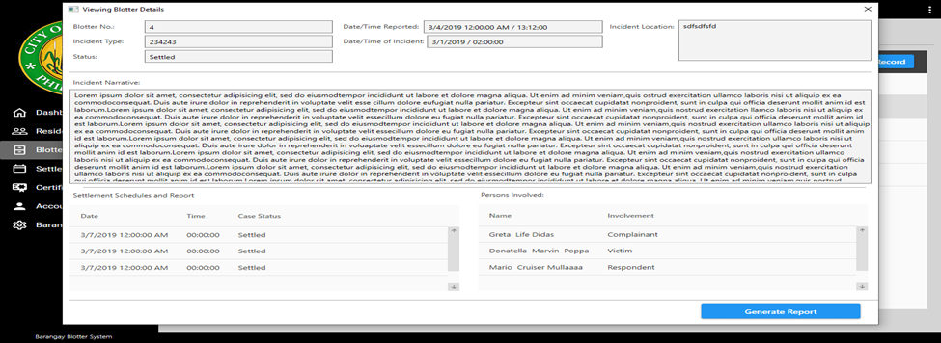

**Figure 2.9: View Blotter Details**

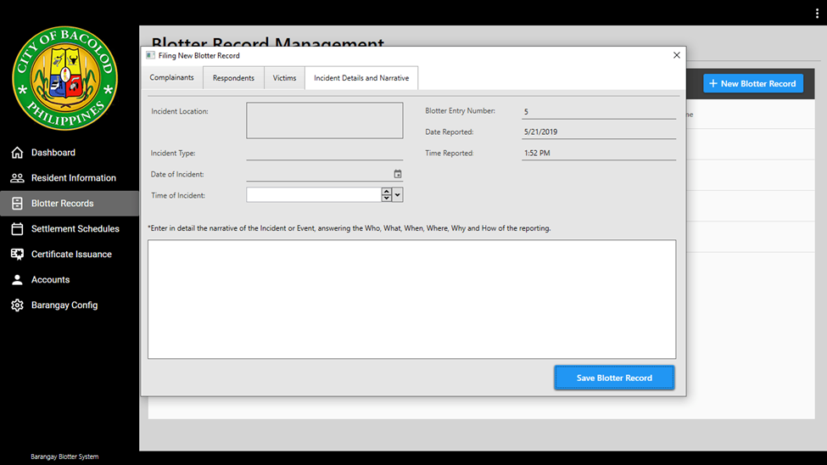

**Figure 2.10: File New Blotter**

**Figures 2.8 to 2.10** are features of the blotter module of the system. The logs of blotters reported (Figure 2.8) in the barangay is present and along with the view summary (Figure 2.10) which will prompt the user a window containing the summary of the blotter; will contain specific details and testimonies that are crucial for the report. The filing of new blotter is also present (Figure 2.10) for new blotter transactions performed.

These features are to be adapted as it will be compliant towards the client demands as it is a usual feature for an e-barangay system.

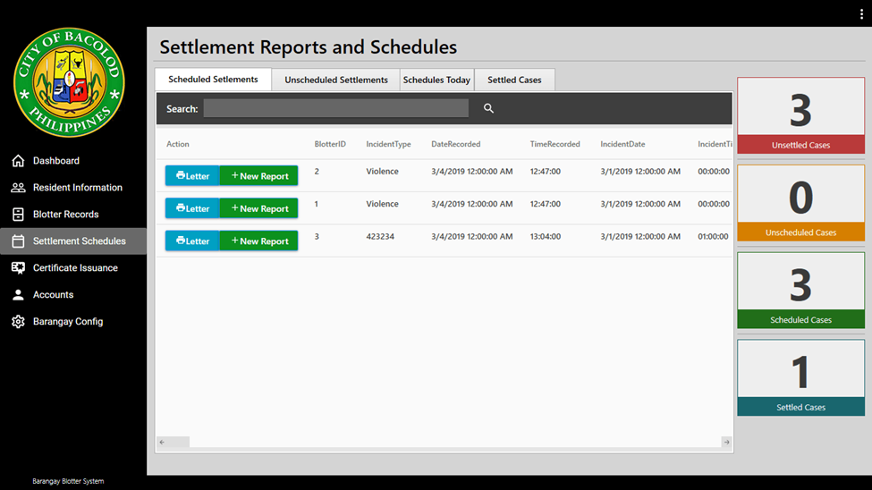

**Figure 2.11: Settlements and Reports**

The figure above presents the current active and scheduled cases of the blotters that happened. It shows a reminder onto the number of settled, scheduled, or unsettled cases.

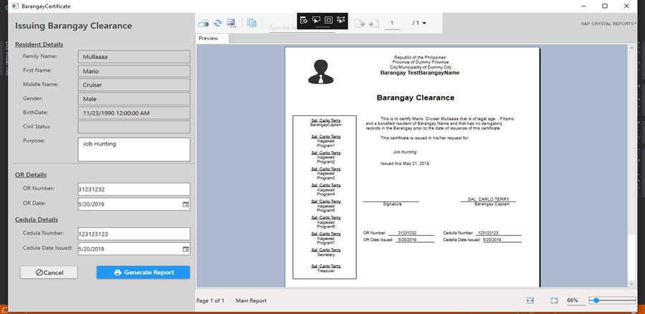

**Figure 2.12: Crystal Report Generation (Barangay Clearance)**

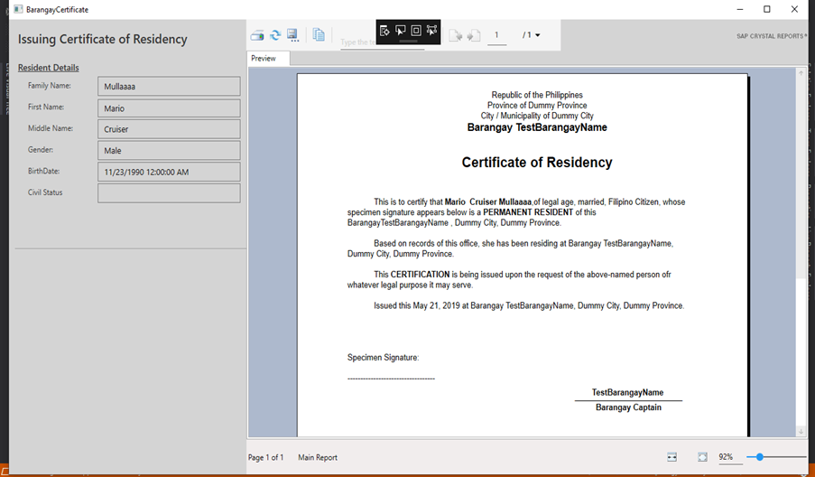

**Figure 2.13 Crystal Report Generation (Certificate of Residency)**

**Figures 2.12 and 2.13** respectively showcases the generation of important certificates. One is the issuance of a barangay clearance and the next is the issuance of an official residency of the individual in the barangay.

The system will be adapting this as the client asks for the following features for their clearances and certificates distribution.

**BARANGAY MANAGEMENT INFORMATION SYSTEM (BMIS) FOR CITIES AND MUNICIPALITIES IN THE PHILIPPINES**

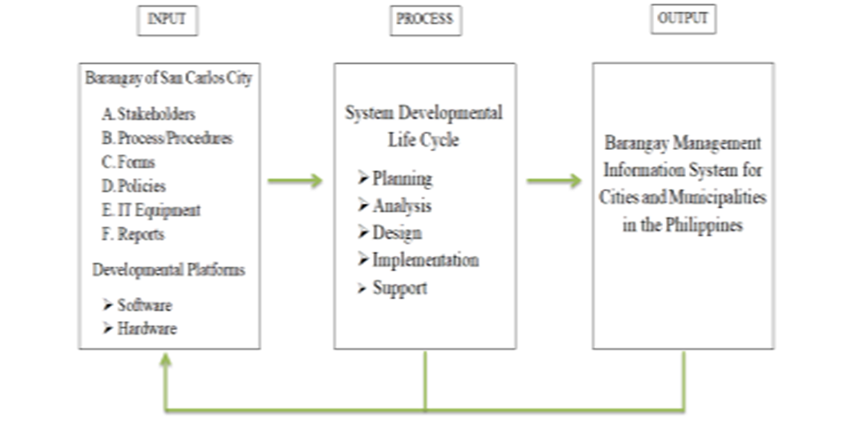

**Figure 2.14: Project paradigm framework for BMIS**

As stated by (Imus et.al 2018), an Information System is an organized combination of people, hardware, software, resources, and communication networks. Information system is also a scientific study that covers strategic, managerial, and operational activities. These three activities basically deal with the following operations. Gathering of Information, processing of information and storage of information. The framework serves as the basis of the proponents in conducting the study. This included inputs, process and output of the study as shown in Figure 2.14.

According to him this is the framework that was used in the process of the projects creation as it specifies the necessary inputs, processes, and expected output for the project’s creation.

**BARANGAY OFFICE MANAGEMENT SYSTEM**

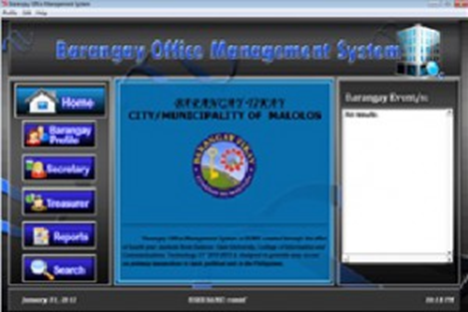

**Figure 2.15: Main Menu**

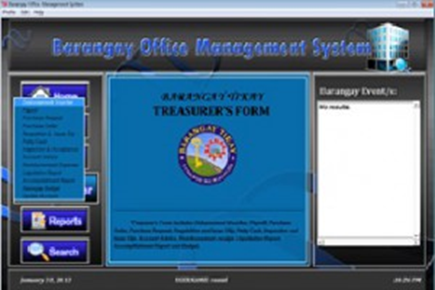

**Figure 2.16: Treasurer Menu**

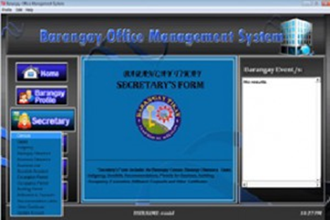

**Figure 2.17: Secretary Menu**

As stated by the proponents the study is focused on creating a Barangay Office Management System facilitated by the Barangay Secretary, Barangay Treasurer, Barangay Record Keeper, and Barangay Clerk depending upon the transaction they are involved. Barangay Census is the procedure of systematically acquiring and recording information about the members of a given population. The secretary is the administrator who can manage all the records while the Barangay Clerk and Barangay Record Keeper can only view the stored information. The receipt serves as a financial and clearances. Barangay Clearance is a certification from a Barangay Captain stating that person is a verified resident of the said barangay while Business Clearance is a legal document that offers proof of compliance with a definite city or state laws regulating structural appearance and safety as well as the sale of products. Another is Indigence Certification which is an official document declaring that the requesting person belongs to underprivileged families in the barangay. The Secretary, Barangay Record Keeper, and Clerk can perform command such as add, edit, and save information. It should have control number in every form. Barangay Case Records is a written account of those people who have violated the barangay laws. The Secretary can access all the transaction while Barangay Record Keeper and Barangay Clerk can only view and search the details. (Polumbarit and Suarez, 2017)

The proponents also state that the project has the following views varied depending on who is accessing the system. The figures above show the following views the main menu (Figure 2.15) for general viewing, the treasurer view (Figure 2.16) for the barangay treasurer and the last secretary view (figure 2.17) for the secretary of the barangay.

The view variation could be considered given the number of trustees in the chosen barangay of the study conducted.

**COMPUTERIZED INFORMATION SYSTEM IN BARANGAY POBLACION, DANAO CICITY, CEBU**

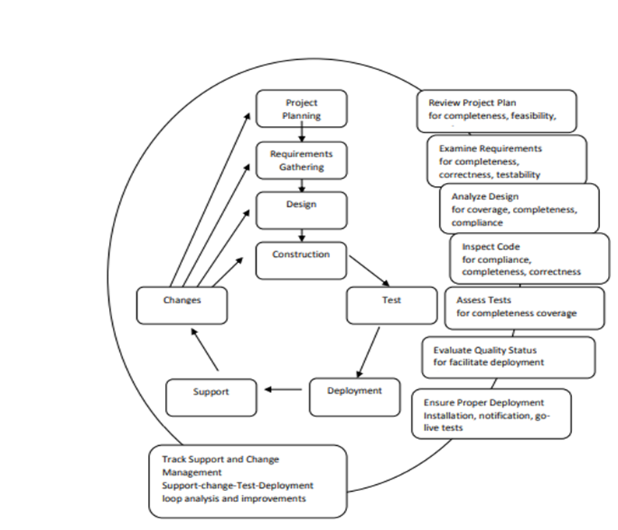

**Figure 2.18: Process framework for the Development of Computerized Information System of Barangay Poblacion, Danao City, Cebu**

This served as the software life cycle of the implemented system entitled:

Computerized Information System in Barangay Poblacion, Danao City, Cebu. (Lado et. al, 2017)

The following framework shall be influencing the output of the e-barangay system that will be made by the developers. It will serve as reference for the development of the systems architecture in further stages of the study.

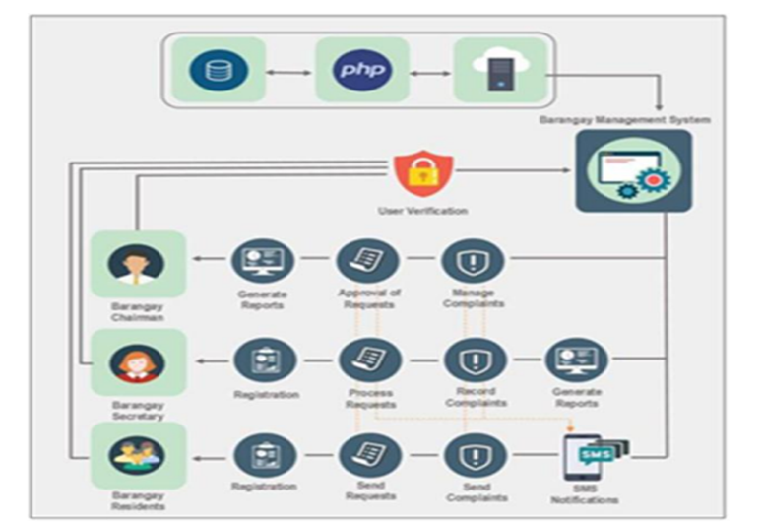

**Figure 2.19: Architectural Design of the e-Barangay System (Conceptual Framework)**

The proponents have adapted the Prototyping Methodology as guide in the development of the Barangay Management System (e-barangay). A version of the system is developed in system prototyping to quickly check the customer’s requirements and the feasibility of some design decisions. This type of methodology supports change avoidance as it allows users to experiment with the system before delivery and so refine their requirements. (Carpio, 2020)

**OPERATIONAL DEFINITION OF TERMS**

* **Barangay** 
  + It is a small administrative division of the Philippines is a native Filipino term for a village or district. The barangay is subdivided to purok or zone, it manages by the barangay captain and his fellow councilors and secretary and treasurer.
* **Barangay Captain**
  + A Barangay captain, also known as a barangay chairman, is the highest elected official in a barangay, the smallest level of administrative divisions of the Philippines.
* **Barangay Reports** 
  + A report is a document that presents information in an organized format for a specific audience and purpose.
* **Barangay Secretary** 
  + The barangay secretary mostly does the office work in the barangay hall. He/she keeps and maintains all records and documents of the barangay.
* **Barangay Summons** 
  + The offended party files his complaint orally or in written form to the Lupon chairman.
* **Barangay Treasurer** 
  + The Barangay Treasurer has the responsibility of collecting and issuing official receipts for taxes or payments accruing to the barangay treasury, disbursing of funds.
* **Computer** 
  + A computer is a machine that can be programmed to carry out sequences of arithmetic or logical operations automatically.
* **Database** 
  + A database is an organized collection of data, generally stored and accessed electronically from a computer system.
* **GCash Application** 
  + GCash is a digital wallet that holds your money, plain and simple. Each amount in the wallet has an equivalent amount of peso in real life.
* **Household** 
  + Individuals who comprise a family unit and whose live together under the same roof; individuals who dwell in the same place and comprise a family, sometimes encompassing domestic help; all those who are under the control of one domestic head.
* **Information System** 
  + Itis any organized system for the collection, organization, storage, and communication of information. More specifically it is the study of complementary networks that people, and organizations use to collect, filter, process, create and distribute data.
* **Kagawad** 
  + A barangay councilor and in Filipino as a konsehal ng barangay, is an elected government official who is a member of the Sangguniang Barangay.
* **Module** 
  + A module can be defined as a unit, chapter, topic, or segment of instruction.
* **Online** 
  + Controlled by or connected to another computer or to a network.
* **Prototype** 
  + A prototype is an early sample, model, or release of a product built to test a concept or process.
* **SK Chairman** 
  + SK Chairman represents the barangay in the municipal or city association.
* **Survey** 
  + A survey is a research method used for collecting data from a predefined group of respondents to gain information and insights into various topics of interest.
* **Technology** 
  + Machinery and equipment developed from the application of scientific knowledge.
* **Text Messages/SMS** 
  + Text messaging service component of most telephone, Internet, and mobile device systems. It uses standardized communication protocols that let mobile devices exchange short text messages.
* **Transaction** 
  + A financial transaction is an agreement, or communication, carried out between a buyer and a seller to exchange an asset for payment.
* **Web Host** 
  + A web hosting service is a type of Internet hosting service that allows individuals and organizations to make their website accessible via the World Wide Web.
* **Website** 
  + A website is a collection of web pages and related content that is identified by a common domain name and published on at least one web server.

**CHAPTER 3**

**SOFTWARE DEVELOPMENT METHODOLOGY**

This chapter is intended to tackle the methodologies the proponents will use to ensure the materialization of the proposed system. The concept or approach that the proponents in their Software development process is in this chapter as the proponents will be developing a software. Specific diagrams are constructed and will be seen here as well as it is part of those methods the proponents will apply to the system’s development; diagrams such as frameworks, DFD *(Data Flow Diagram)* levels, scheduling charts such as Gantt charts and PERT CPM diagrams as these are important guides for developing systems. Database schema or the ERD *(Entity Relationship Diagram)* along with its normalization will also be crucial in this chapter as it presents the relationships of entities that the system development will be following.

**Software Design and Development Approach**

This chapter contains the Software Process Model, System Framework, Data flow Diagrams, E-R Diagram and Table Normalization.



**Figure 3.0: AGILE Model**

The Agile Development Methodology (SDLC) is the chosen software process model by the proponents. The Agile Methodology is an iterative development and prototyping methodology and is used in various projects, may it be an industry, scholar, and other types of projects. It is a method known for its lightweight development method that can deliver when it comes to changes of requirements (Kumar, 2012). The SDLC model has 6 phases such as: Requirement Gathering, Analysis and Design, Implementation or Coding, Testing, Evaluation, and Maintenance. These phases are essential to the system as we are going for the incremental approach. Having an incremental approach quickly adapts to changes, issues and other unfortunate events minimizing great risks in creating the system. Being a company-based system, the proponents’ top priority is their request and changes to the system, the agile methodology enables the proponents to adjust flexibly to the said requests. This also puts a solid center in collaboration, which gives the team with more openings to work with the client and to get their vision or their request. It can also provide rapid feedback to the client and will open more for suggestions. Taking the client’s needs/request for the system into account is vital. It leads to improve the quality of the system. This can also help the team to be more organized and efficient in prioritizing different processes and features of the system.

**REQUIREMENT GATHERING**

During this phase, the proponents gather all information needed to build a backbone/idea of the system that is being requested. In a series of interviews, the proponents get all the information they need to have an idea about the possible problems and solutions of the Barangay. After gathering information, the scope and limitations of the system/project is built and worked around on. The planning stage is also included in this phase. This involves formulating possible solutions to replace some of the manual system procedures and its problems in the Barangay. The proponents are always open for suggestions in the system while we are still working on it. The proponents have researched about other e-Barangay information systems to have more ideas about the system. This is to ensure that the minimum required modules of the system will be included. During the interviews, the proponents have also asked about the manual processes in the barangay. Some manual processes are on how they record the payments and transactions of the residents of the barangay to their deliverables, such as: certificates, rentals, sponsorships and so on. The proponents started gathering said information approximately at the start of September 2020, when the proponents had interviews with the secretary of the barangay. The proponents requested the forms to have an idea on what to include in the create form module in their system. From time to time, the proponents reach out to the secretary of the barangay for examples of the forms.

**ANALYSIS AND DESIGN**

In this phase, the requirements and scope and limitations needed for the system are specified. The creation of the entirety of the system should be in line with the requirements given. The scope plays a big role in the system as it specified the different modules that is present in the system and defined the required materials mainly hardware (Available PCs) and software (Domains and Databases) requirements. Inputs, Processes and Outputs are also defined and identified in this phase along with the deliverables presented by the proponents to the users. The proponents have worked the system to be a user-friendly system, that is to be able to learn and understand more about the system, like the system’s navigations and its proper process on how to use it smoothly and properly. This is also to avoid complications in learning the system, because not all of us are tech savvy that can learn quickly and memorize how to use the system or in other technologies. The proponents ensure that the design of the system will satisfy the barangay, that is to use proper combinations of colors, shapes, icons etc. The proponents conducted an interview to know if the barangay had the necessary hardware and software requirements to accommodate the system at approximately September 2020.

**IMPLEMENTATION AND CODING**

This is the phase where the creation of the proposed system is executed. The information gathered from the interviews from the company is vital, as it defines what will be the guidelines of the system. After analyzing the data gathered, the creation phase will be started. This phase consists of creating/designing/polishing the user interface and making sure that there are no risks when it comes to security. Being an e-Barangay system, the security of the information in the system is top priority. Maintaining the database is crucial for an e-Barangay information system because it is the one that storing all records in the barangay like the population of the barangay, individual information in the barangay, different transactions in the barangay etc. This is the reason why the proponents always ensures that the coding for the database is correct and precise, not just only in database, we also ensure that our codes in the system are functioning/executing properly specially when it comes to different navigations of the system. The proponents started working on the prototype at approximately February 4, 2021.

**TESTING**

As the name suggests, this phase evaluates whether the created system runs efficiently/smoothly. First, the proponents will create or add a testing resident then fill up the required fields for the adding of new resident, like names, address, contact number etc. After correctly filling up the required fields, we will check in our database if that testing resident is existing in our database, if not, of course we will check thoroughly our system, especially in the coding parts. If the testing resident exist in our database, we will try to create a blotter form and to schedule or to rent a basketball court. After all processes and transactions are all done, the said testing resident will be deleted from the database. The proponents aim to test the system at approximately late April.

**EVALUATION AND MAINTENANCE**

The proponents determine the performance of the system and its functions whether it was reliable or not. If the proponents notice something off with the system, a quick fix/maintenance is required. The proponents will teach the barangay officials how to use/navigate our system. It is stated in the deliverables that an online training course will be held for the barangay officials that will use the system. One of the proponents has direct contact with one of the barangay officials. If the proponents encounter a special scenario, the proponents can easily contact the said barangay official to resolve the issue immediately. An evaluation form is made by the proponents to gather responses from the barangay officials to know if the system is efficient and if the barangay officials are satisfied with the system. The proponents aim to execute this phase at approximately early June 2021.

**SYSTEM FRAMEWORK**

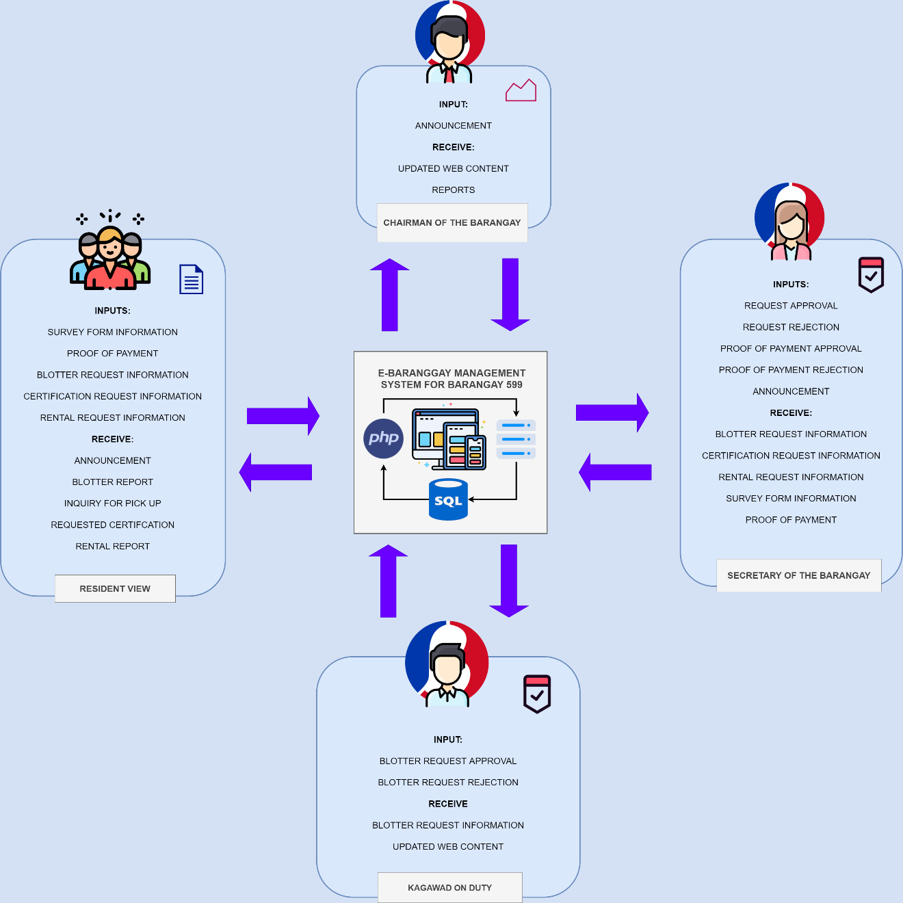

**Figure 3.1: System Framework of the Proposed System**

The presented figure above is the proposed system’s framework. This diagram exhibits the most probable stakeholders of the system. It will show the exchange of data among the stakeholders using the system. In the proposed system the team of developers aim to lessen the amount of work the stakeholders has to exert. With the presented framework it is evident how that will be possible. As stated in the figure there is no inputs for the stakeholders of the barangay management where it is an actual receivable. This is due to the presence of the proposed system; the system will take off the generating and adjusting same also as for the monitoring hassles. It will be the one to create reports and documents or certifications for the stakeholders. The residents will also be given an option to conduct their queries online and not through walk in which could be handy in times like the online blotter request possibility. As seen int the figure the jobs of the stakeholders such as the “Kagawad on duty” and the secretary is to verify only while the chairman’s job of monitoring these transactions as the barangay’s superior is much easier also with the automatic updates the system provides. Automatic updates in a sense wherein when a stake holder applies change to a certain module or feature it would automatically reflect onto the point of view of the other authorized views. The team also aim to make the system as responsive as possible to cater to a wider scope of devices (e.g. smartphones, tablets, computer etc.). Notice also that the framework’s figure allotted for the visual of the proposed system presents the composition of the system. The system shall be implementing PHP in the system and MySql as its primary database handling, all of these to be hosted by a premium web hosting server.

**PROCESS FLOW (DFD)**

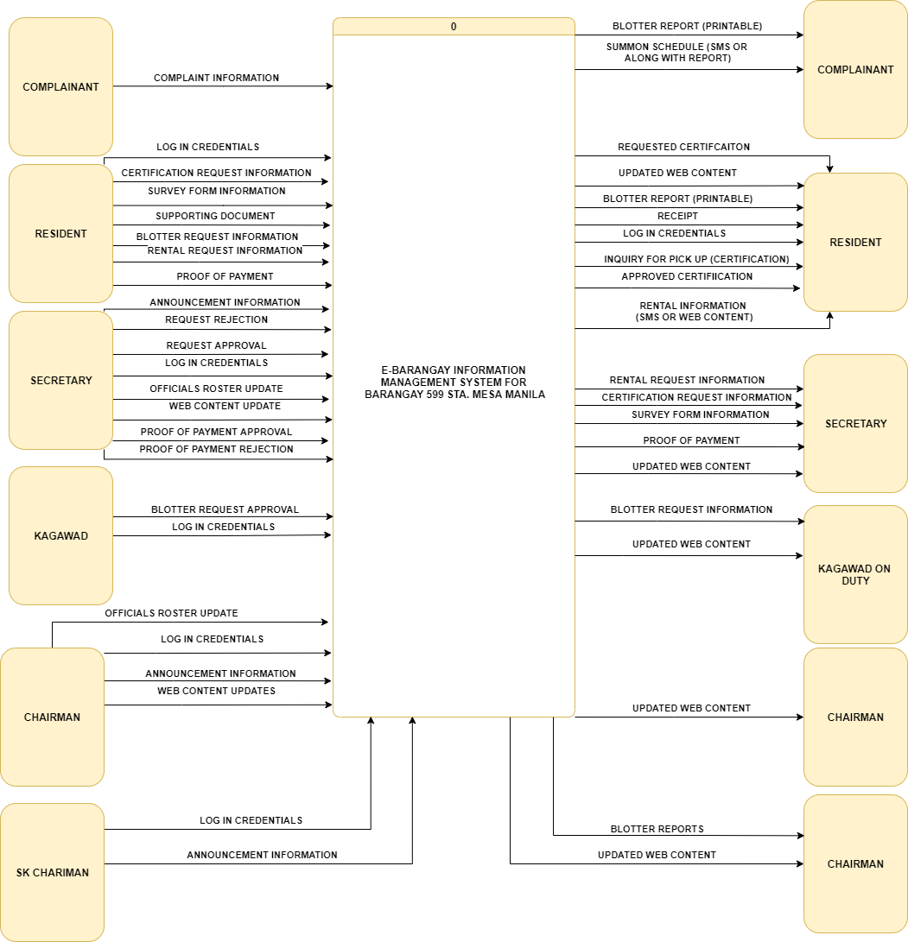

**Figure 3.2 Data Flow Diagram of the Proposed System (Level 0)**

The diagram presented above is he proposed system’s context level data flow diagram. This diagram presents the inputs and outputs that the proposed system will be processing. With the entities having their respective sets of possible inputs and of course receivables. The diagram has similar inputs from the currently implemented system. However, unlike the current system the proposed system is set to have lesser inputs coming from each entity. Given that the generating of certain reports and documents are to be made by the proposed system. Similar to the current system the stakeholders in the side of the barangay management is still to acquire the jobs they are assigned to. Secretary being the person to handle certification queries as well as, resident information updates and rentals; the blotter queries are still to be managed by the “Kagawad on duty”. The chairman will be given monitoring towards every transaction reason behind the chairman receiving only reports and the updates of the contents of the system. The stakeholders of the barangay are also given certain privileges when it comes to the modification of the content of the system. Certain stakeholders of the barangay also have the power to use the system to disseminate information or announcement.

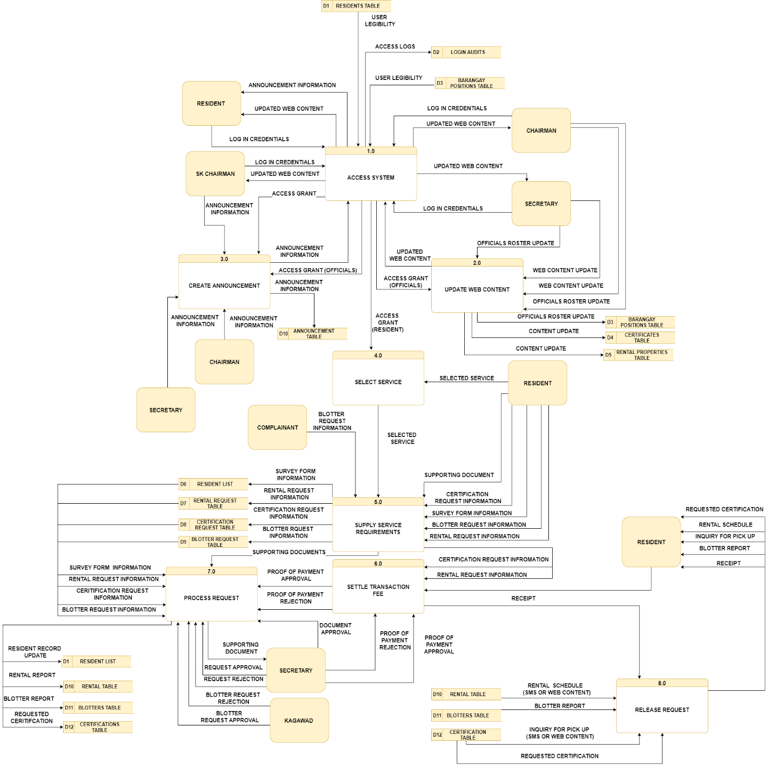

**Figure 3.3: Data Flow Diagram of the Proposed System (Level 1)**

The presented diagram above is the expounded version of its context level, the level 1 data flow diagram. In this diagram shows the correlation of the inputs coming from the stakeholders to its corresponding process. The data flow of the system starts with the accessing the system given that the data inputs and its processing is only possible if the stakeholder is logged in supplying the information regardless of the user type. After accessing the secretary and the chairman can create updates in the web content the resident and other stakeholders will be interacting reason why it is given the second processes in the sequence these updates shall reflect in the access system as these updates will be prompted to the successful log in attempts that the stakeholders will be making. Following it is the creation of announcements which the resulting output will also reflect in accessing the system for the residents will be prompted by these announcements as soon as the success of their log in is guaranteed. The secretary, chairman and SK chairman retained privilege in this process. Fourth process would be the processes that concerns the inputs coming from the resident of the barangay. These inputs could either be accepted online or through walk in. To start this string of processes the fourth process is for selecting a service to acquire. As soon as the desired service is identified then the following process is to receive the information necessary for that service and will be redirected to a data store allotted for requests these will be later be verified by the other stakeholders upon receival. Following it is the settlement for the fees of that service if any otherwise it proceeds to processing stage. Note that the release and generation of these requests are upon settlement. The following process will be the processing of the information which will call for the verification coming from either the secretary or the “Kagawad on duty” in which as soon as it is verified then the generating of the reports or document requested shall be executed by the system. Lastly, the release of these requests shall take place as long as the preceding processes are satisfied.

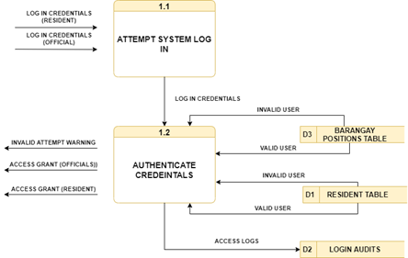

**Figure 3.4: Data Flow Diagram of the Proposed System (Child Diagram for Access System)**

A child diagram was constructed to provide in depth understanding in the following feature. The access system process is further explained here as it shows the authentication process that happens within that process wherein the system checks the credentials whether it be a resident or an official if the credentials provided coheres with the credentials in their respective data stores. Detection of an invalid credentials immediately prompts a warning for it otherwise the access grant is given and can now continue to other features provided by the system.

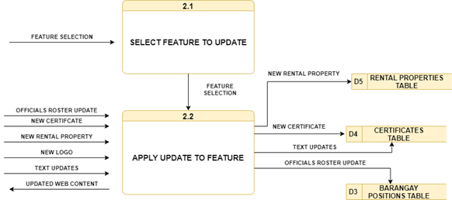

**Figure 3.5 Data Flow Diagram of the Proposed System (Child Diagram for Update Web Content)**

The web content applies to all the content text or media presented in the web system. This child diagram presented is specific for the web content update process. In here, the process gives the stakeholder the option of choosing a feature to edit and the following presented inputs are the possible media that can be added or used as an update. Each update or adding reflects to its respective data store as storing it here would automatically reflect it in the web contents of the system. As for the others it can be executed independently by placing the update in that feature. The system shall provide an option for that query.

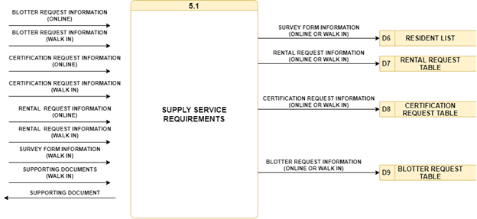

**Figure 3.6 Data Flow Diagram of the Proposed System (Child Diagram for the Supply Service Requirements Process)**

The system enables a lot for the stakeholders specially the residents as it gives them an option whether if they could process their query through walk in or through online. This is the reason why this child diagrams construction. To show the variation of these inputs properly. The inputs still lead to the requests data stores to be up for verification and processing.

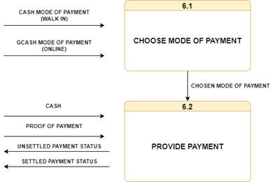

**Figure 3.7 Data Flow Diagram of the Proposed System (Child Diagram Payment)**

The payment method is one of the crucial parts of the system. To further explain this process is through the provided child diagram. Stated here the process concise of choosing a payment mode. When transacting walk in they have both options of either Gcash or cash payment. For online transaction Gcash is utilized. After that providing the payments is executed where in walk-in, they give the actual cash and if through online provides a proof of payment which could be sent through a file upload of the screenshot of amount transfer. Payment success could give them go signal for processing of their request otherwise could lead to rejection.

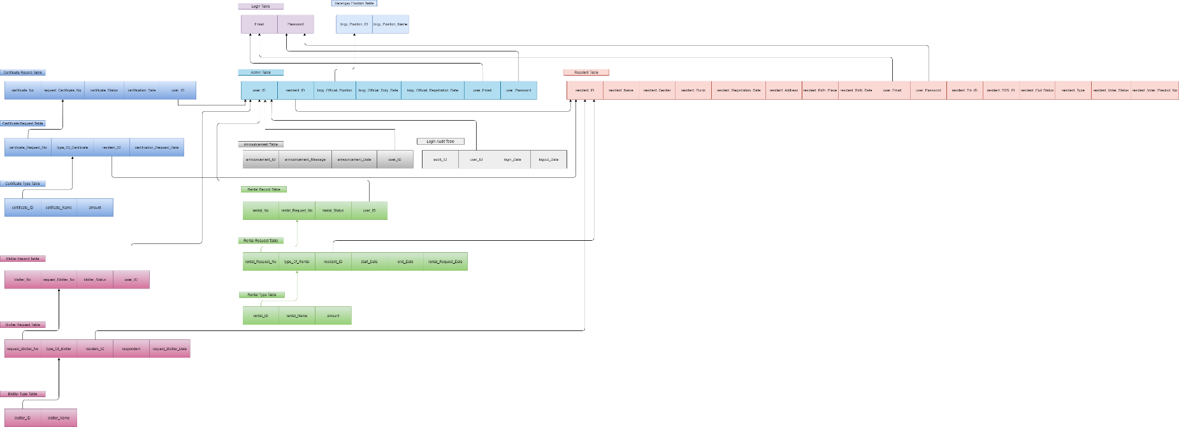

**Figure 3.8 E-R Diagram and Table Normalization**

|  |  |  |  |  |
| --- | --- | --- | --- | --- |
|  | **CONSTRAINTS** | **ASSUMPTIONS** | **RISKS** | **MINIMIZATION MEASURES** |
| T  I  M  E | The barangay officials will have too much to do to learn how to operate the system. | The barangay officials are willing to attend a training course on how to operate the e-Barangay System. | With a global pandemic happening, the barangay officials will be skeptical to attend a training course in addition to doing their daily operations/tasks in the barangay. | The barangay officials will attend an online training course and will be given a manual on how to operate the system. |
| M  A  T  E  R  I  A  L | The PCs in the barangay is limited in numbers and in specifications when it comes to running the system, along with the Internet connection which isn’t ideal. | The barangay is willing to finance the necessary materials (PCs). | In the case that the barangay refuses to finance/provide the said necessary materials (PCs), there will be difficulty in using the e-Barangay System. | The proponents, along with the barangay officials will find other ways to provide said materials. |
| M  A  N | The barangay officials will be given another responsibility, thus adding more work to the barangay officials. | The barangay officials are willing to attend a training course on how to operate the e-Barangay System. | Given that this is a new system, and the barangay officials are working with technology, the barangay officials may not learn how to Operate the System. | The most important barangay officials such as the Chairman, Secretary, Treasurer, etc. will only be required to attend the training course to use the e-Barangay System. |
| M  E  T  H  O  D | The Barangay officials will have difficulties in operating and understanding the methods needed to fully use the e-Barangay System. | The said methods provided to the barangay officials will make sure that the e-Barangay System runs at the most optimal and efficient way possible. | The Barangay officials refuse to learn the said methods to operate the e-Barangay System, thus not using it efficiently and optimally. | The proponents’ proposed solution is to conduct a training, requiring all the barangay officials about the methods to operate the e-Barangay System. |
| M  A  C  H  I  N  E | The PCs provided by the barangay, may not be up to par in specifications. Also, the internet connection may be a problem as the barangay is in an area where connections are not top of the line. | Not only does the usage of the PCs that will make the e-Barangay System run more efficiently, but it is also required for the e-Barangay System to run in the first place. | If updates are needed in the e-Barangay System, the barangay officials may have a hard time to do the maintenance themselves. | The proponents along with the barangay will seek to improve the internet connection with contributions and agreements such as sponsorships and outside help. This will not only be essential for the system, but also improve the overall quality of the connections in the barangay. |
| M  O  N  E  Y  /  B  U  D  G  E  T | One of the main concerns would be that the barangay itself lacks funding, resources, and financial stability to keep the system up and running. | The barangay officials and the council will withdraw their decision to fund the proposed e-Barangay System. | The withdrawal of the funds may lead to the incompletion of the proposed system. | The proponents will shoulder the first month’s expenses and fund the system itself and look for alternative solutions. |

**Table 3.1 CARM Board**

**CONSTRAINTS**

The proponents identified the possible problems/obstacles that may prove a challenge in developing the e-Barangay system. These include: TIME, MATERIAL, MAN, METHOD, MACHINE, and MONEY/BUDGET. While MAN and MACHINE are the core aspects in creating the system, the proponents agreed that MONEY/BUDGET is the most essential part in developing the system. All the resources/materials that the system would need roots from money, without the proper financing, the resources would not be sufficient thus putting the project to risk.

During our interviews with the client, we determined that most of the barangay officials that will be handling the system have experience with regards to handling systems like ours. This is important as the person that would use the e-Barangay system should be computer literate.

**ASSUMPTIONS**

The constraints were given proper assumption by the proposals.

1. The proponents will look for alternative ways to fund the development of the system should the barangay officials need help financially.
2. Time management and considerations with the help of the Gantt chart were used by the proponents in developing the system.
3. The interviews with the clients proved to be useful as they were willing to help the proponents in each step of the development of the system.
4. Materials and other factors were provided by the client/barangay officials.
5. The barangay officials that will use the system were willing to be trained to operate the system.

**RISKS AND MINIMIZATION MEASURES**

We can all agree that Time is one of the most, if not the most essential part in the development of the system. The tasks will prove to be a challenge once there is a discrepancy between the clients and the proponents due to lack of communication.

The constraints and assumptions must be defined and should not be left hanging as it will only jeopardize the development of the system if not taken care of immediately.

***Project Schedule***

|  |  |  |  |  |
| --- | --- | --- | --- | --- |
| **Legend** | | | | |
|  | **All** |  |  | **Morales** |
|  | **Dela Cruz** |  | **Sallan** |
|  | **Ledesma** |  | **Viray** |

**Table 3.2 Color coded legend for Gantt Chart**

The following figures are the diagrams constructed as guides for the project’s completion. The constructed figures are powerful scheduling diagrams that helps developers accomplish their projects. Gantt chart and PERT CPM diagram are created as both are likely aids in software development. Both diagrams lay out the important activities and its dependencies from each other.

The dependencies between the activities are specified as well as it shows the dependencies of each activity from one another. The following scheduling diagrams will be strictly followed throughout the project’s creation process. Each activity shall and will be accomplished during its specified duration. Compliance with this diagram is crucial and a must as some activities would be of much difficulty if started without having accomplished its preceding activity first; reason why the dependencies are emphasized.

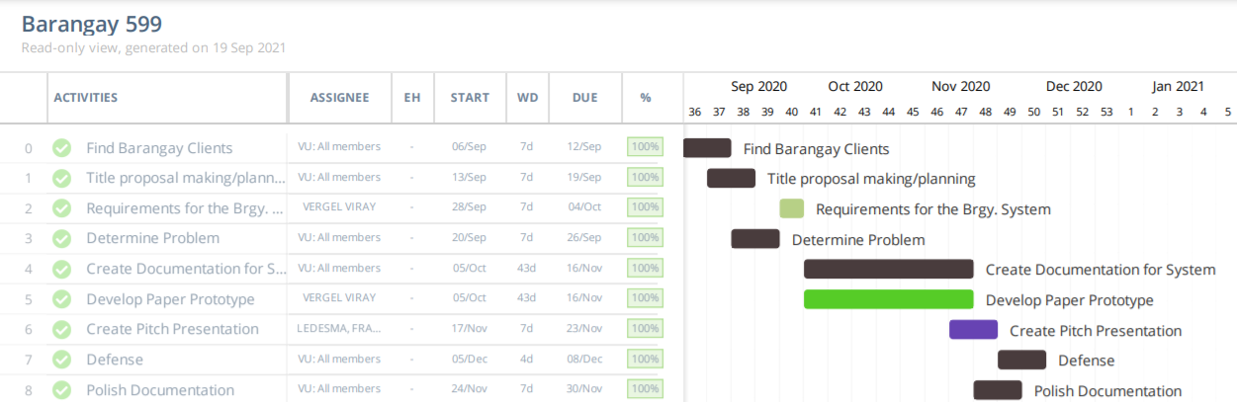

Project Schedule  
**Gantt Chart**

**Figure 3.9 Gantt Chart for MERIT**

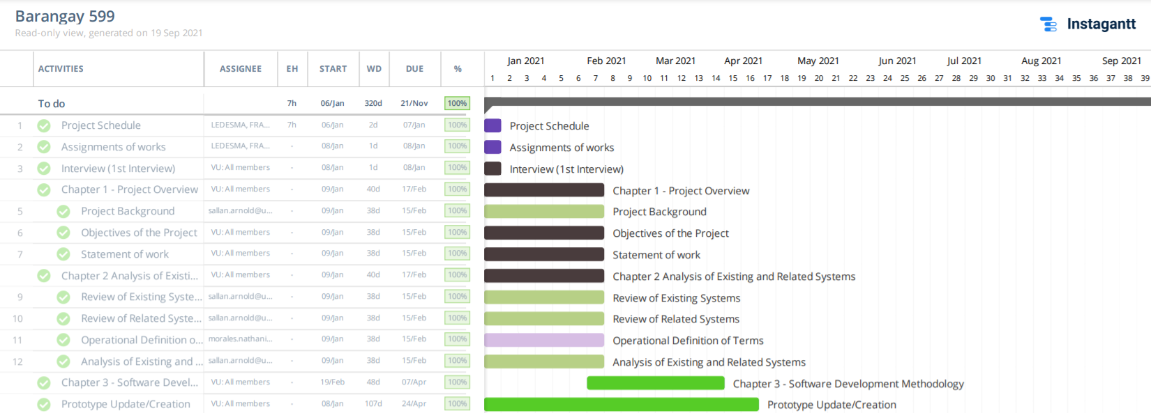

**Figure 3.10 Gantt Chart for CAPS A**

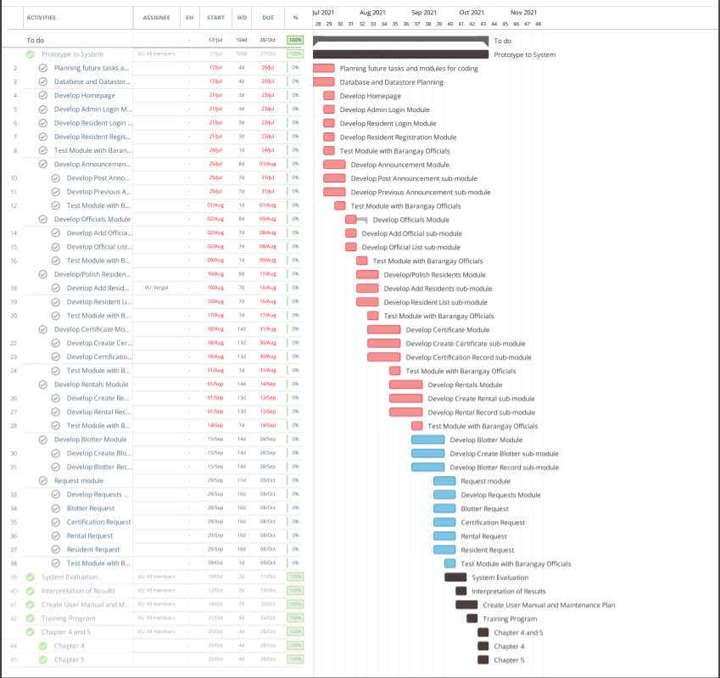

**Figure 3.11 Gantt Chart for CAPS B**

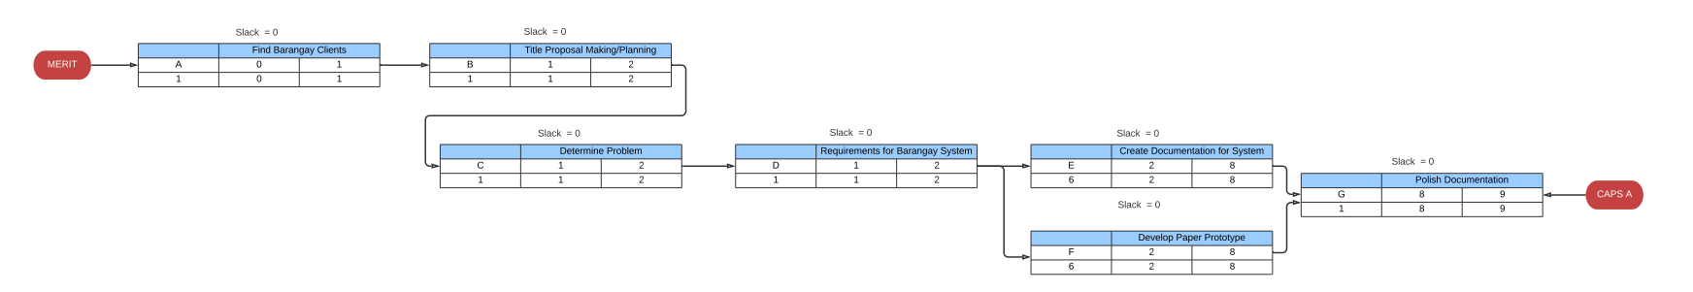

**Figure 3.12 PERT for MERIT**

**PERT**

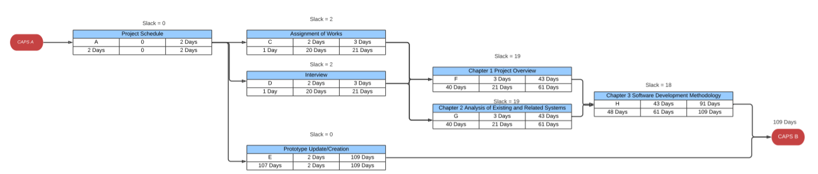

**Figure 3.13 PERT for CAPS A**

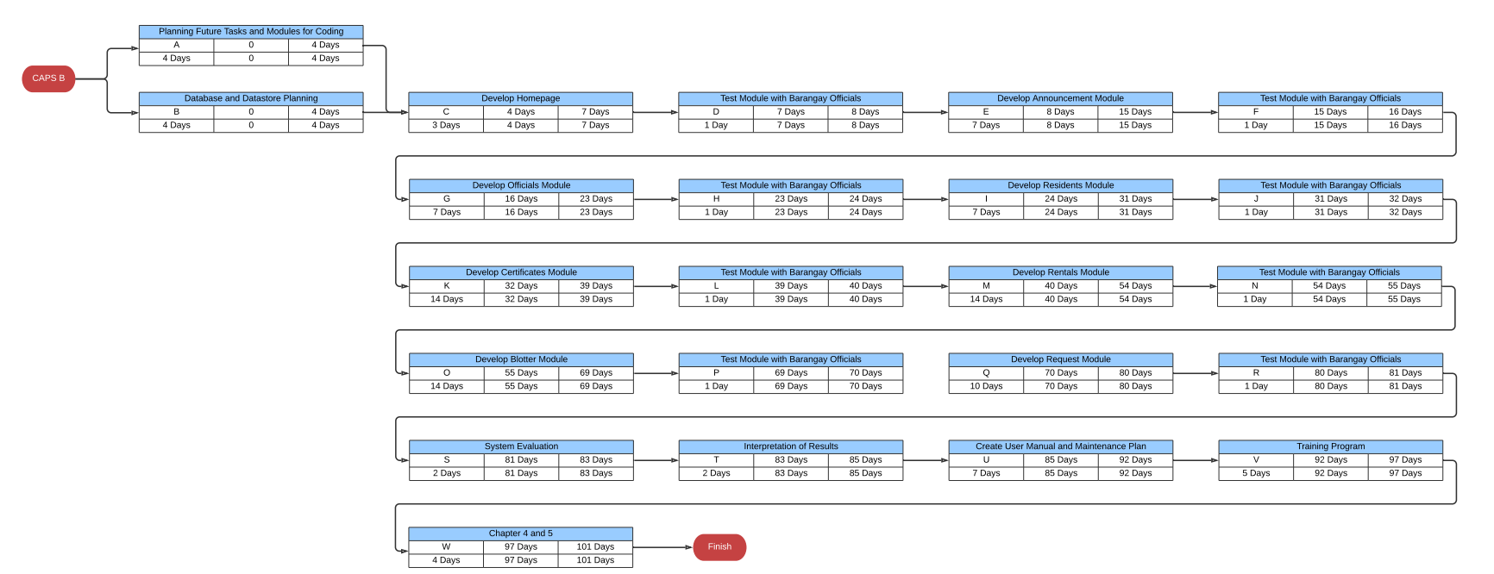

**Figure 3.13 PERT for CAPS B**

In Figure 3.9, the Gantt Chart for Merit. From finding the clients for the Barangay System, developing the first prototype of the system, and making and presenting the pitch.

The figure in 3.10 shows the Gantt Chart for CAPS A. Chapters 1-3 has been slightly touched upon. Revisions and additions to some chapters has been added. The chapters are also indicated in the chart.

**TESTING AND EVALUATING PROCEDURE**

Name: ______________________________________________ Date: ________

Position: ______________________________

The collection of data is for the purpose of recording the responses of the users of the system in the barangay and interpreting the information into data that can be used to evaluate the usability of the system. By signing this form, you are certifying that all information provided are true and correct and likewise authorizing the proponents to process the information. Should the form be accomplished by the person with the name above, said form will be kept in a secure location and will not be accessed by any person that is not concerned with the information in this form.

1. **INSTRUCTIONS:**

PLEASE RESPOND TO THE FOLLOWING EVALUATION DO SUCH THROUGH **ENCIRCLING** YOUR RESPONSE. DO FEEL FREE IN YOUR RESPONSE AS THERE IS NO INCORRECT RESPONSES; THIS IS **HOW YOU SEE OR EVALUATED THE SYSTEM**. **DO NOT LEAVE** ANY FIELD UNANSWERED. THANK YOU!

**Scale:**

**1 – Never 2 – Rarely 3 – Sometimes 4 – Most of the time 5 – Always**

|  |  |  |  |  |  |  |
| --- | --- | --- | --- | --- | --- | --- |
| **QUESTIONS** | | **RESPONSE** | | | | |
| **PERFORMANCE** | | | | | | |
| 1 | The software is free from bugs and hassles. | 1 | 2 | 3 | 4 | 5 |
| 2 | The software is responsive. | 1 | 2 | 3 | 4 | 5 |
| 3 | Navigations between tabs are quickly made and is accurate. | 1 | 2 | 3 | 4 | 5 |
|  | | | | | | |
| **RELIABILITY** | | | | | | |
| 4 | The information in the system is legitimate and credible. | 1 | 2 | 3 | 4 | 5 |
| 5 | The information that is placed into the system is normalized. | 1 | 2 | 3 | 4 | 5 |
| 6 | The users can operate the modules of the system easily. | 1 | 2 | 3 | 4 | 5 |
| 7 | The system delivers media resources and functions properly. | 1 | 2 | 3 | 4 | 5 |
| 8 | The website can be used anytime, anywhere. | 1 | 2 | 3 | 4 | 5 |
| 9 | The system has no errors. | 1 | 2 | 3 | 4 | 5 |
|  | | | | | | |
| **RESPONSIVENESS** | | | | | | |
| 10 | The system can quickly respond and evaluate user input. | 1 | 2 | 3 | 4 | 5 |
| 11 | The system can quickly cater to user needs. | 1 | 2 | 3 | 4 | 5 |
| 12 | The software has a way to accept feedback. | 1 | 2 | 3 | 4 | 5 |
| 13 | The software can respond to the client’s needed help. | 1 | 2 | 3 | 4 | 5 |

**Table 3.3 Testing and Evaluation Survey Questionnaire**

**BIBLIOGRAPHY**

Grönlund, Å., & Horan, T. A. (2004a). *Introducing e-Gov: History, definitions, and Issues.* ResearchGate. https://www.researchgate.net/publication/234008823_Introducing_e-Gov_History_Definitions_and_Issues

Zeb, J. (2012). *Survey of information technology use for municipal Infrastructure management.* ResearchGate. https://www.researchgate.net/publicatIon/280052872_

Survey_of_information_technology_use_for_municipal_infrastructure_management

Justo, J. J., & Morales, N.J (2017, April). *MANAGEMENT INFORMATION SYSTEM OF BARANGAY POBLACION CUATRO.* ACADEMIA. https://www.academia.edu/32776852/MANAGEMENT_INFORMATION_SYSTEM_OF_BARANGAY_POBLACION_CUATRO

Jain Palvia, S. C., & Sharma, S.S (2019). *E-Government and E-Governance: Definitions/Domain Framework and Status around the World*. GOVERNANCE 4.0. http://governance40.com/wp-content/uploads/2019/06/E-Government_and_E-Goverance_Definition.pdf

APARICI, M.M. A., & RUELAN, J.R. J. (2018, May). *WEB-BASED BARANGAY INFORMATION SYSTEM FOR MALITA, DAVAO OCCIDENTAL.* Scribbr. https://www.researchgate.net/publication/325465116_Web-Based_Barangay_nformation_System_for_Malita_Davao_Occidental

Antonio, L. (2020). *Enhancing Barangay Justice System Through the Development of a Web-Based Crime Monitoring Module.* SSRN. https://papers.ssrn.com/sol3/papers.cfm? abstract_id=3642023

Porio, E., & Sarmiento, E.-R. (2019, April 15). *Barangay*. Wiley Online Library. https://onlinelibrary.wiley.com/doi/abs/10.1002/9781118568446.eurs0016

Shoemaker, D. J. (2010, July 30). *Juvenile Corrections in the Philippines*, 24(1-2), 39-52. Taylor & Francis Online. https://www.tandfonline.com/doi/abs/10.1300/J076v24n01_04

CDC 25/7*.* (2021, April 6). *Your Guide to Masks*. Centers for Disease Control and Prevention. https://www.cdc.gov/coronavirus/2019-ncov/prevent-getting-sick/about-face-coverings.html

DOH. (2021, April 22). *COVID-19 TRACKER*. Department of Health. https://www.doh.gov.ph/covid19tracker

Jayme, L. J. (2020). *Barangay Management Information System.* HYBRAIN. https://www.hybrain.co/products/barangay-information-management-system

Imus, J.K.P., Magleo, E. D., Soriano, M. A. A., & Olalia, Jr., R. L. (2018, February 19). *Barangay Management Information System (BMIS) for Cities and Municipalities in the Philippines*. Barangay Management Information System. <https://www.ijcaonline.org/archives/volume180/number19/imus-2018-ijca-916441.pdf>

Pulumbarit, J. P., & Suarez, J. G. (2017). *Barangay Office Management System*. SEMANTIC SHOLAR. https://www.semanticscholar.org/paper/Barangay-Office-Management-System-PulumbaritSuarez/db515c6c6eafe4db4cd81a2def37b1473fcf7679

LADO, M.J. P., MALOLOY-ON, M. I., PEREZ, G.C., RIZALDO, P. K. M., & TACOCONG, S. A. (2018). *Computerized Information System in Barangay Poblacion Danao City Cebu Capstone Project 6 638*. SCRIBD. https://www.scribd.com/document/395852755/Computerized-Information-System-in-Barangay-Poblacion-Danao-City-Cebu-Capstone-Project-6-638-Converted

Carpio, C. O. (2020). *Barangay Management System*. ISSN (Online). http://ijmrap.com/wp-content/uploads/2020/07/IJMRAP-V3N1P78Y20.pdf

**APPENDIX A**

Sample Pictures from the Barangay Hall

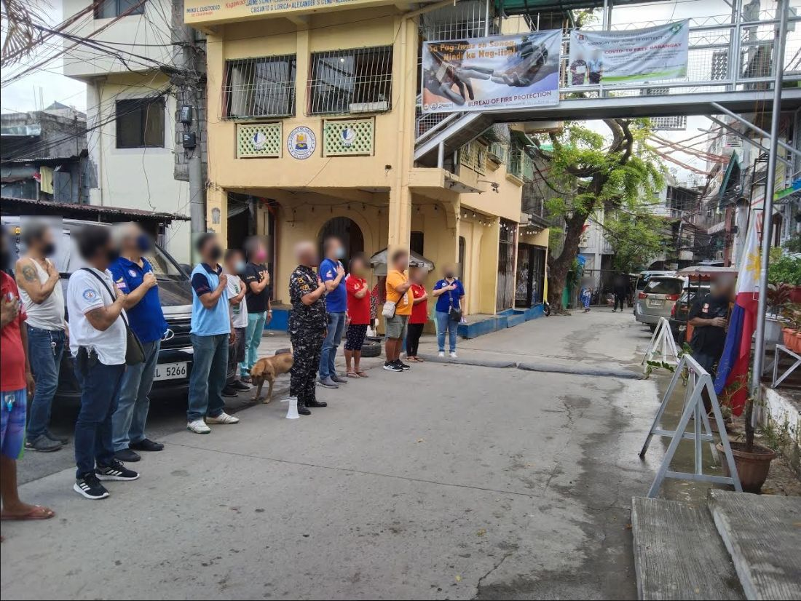

**Picture of Barangay Officials standing next to the barangay hall.**

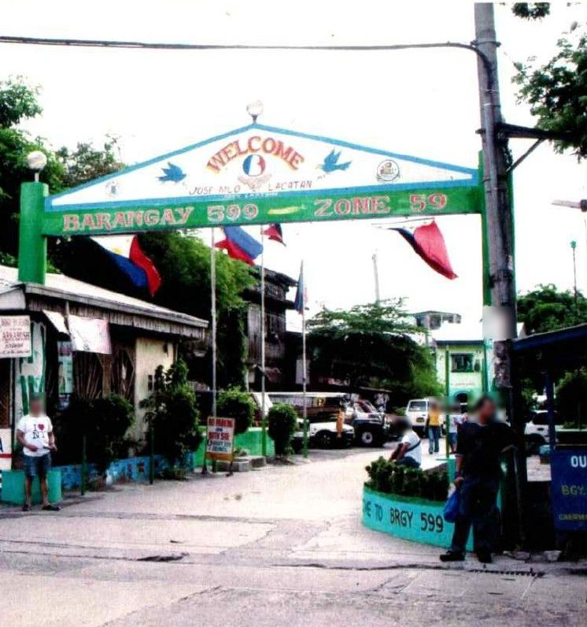

**Picture of the old Barangay 599**

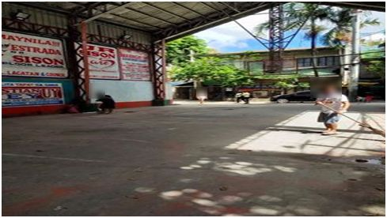

**Picture of the Barangay Basketball/Volleyball Court**

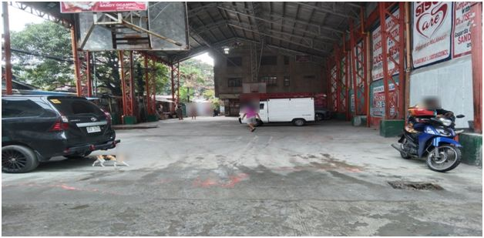**Picture of the Barangay Basketball/Volleyball Court**

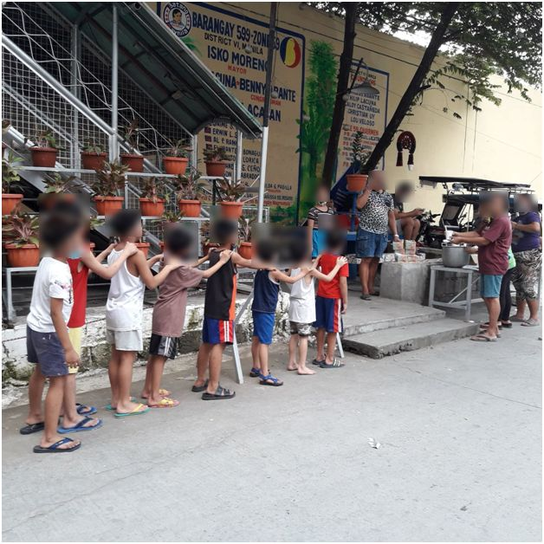

**Feeding program held by the Barangay**

**APPENDIX B**

Sample Forms from the Barangay

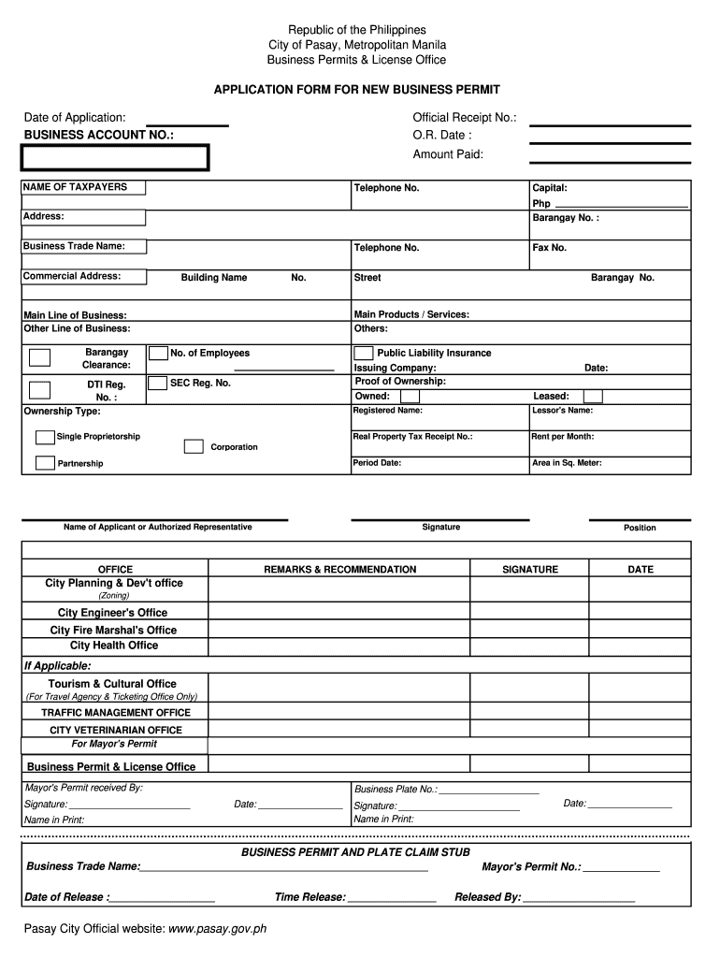

**Application Form for New Business Permit**

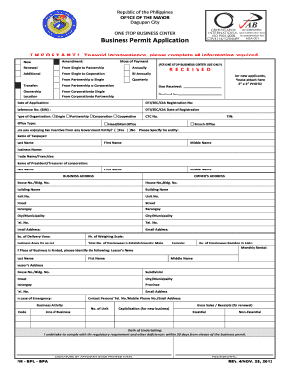**Business Permit Application**

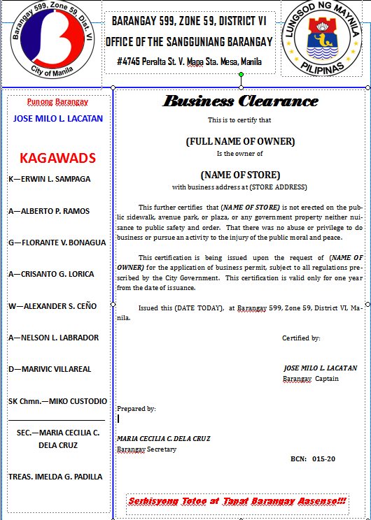

**Business Clearance Example**

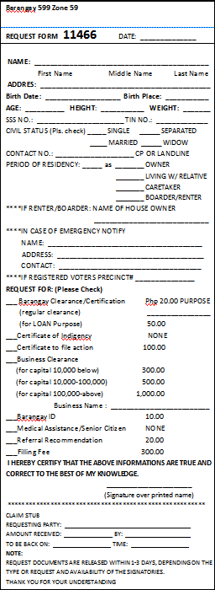

**Certificate/Form Request fill-up form.**

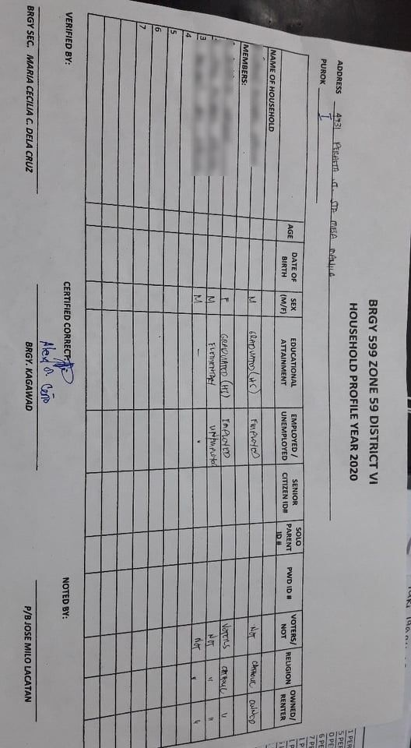

**Household profile form**

**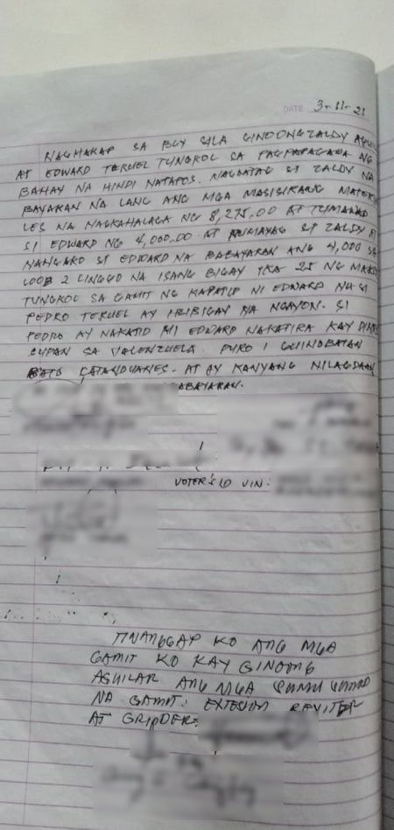  
Blotter Record Sample**

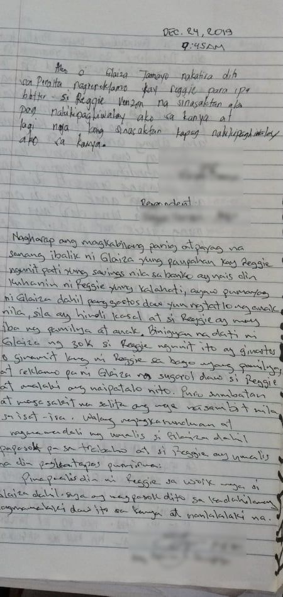

**Blotter Record Sample**

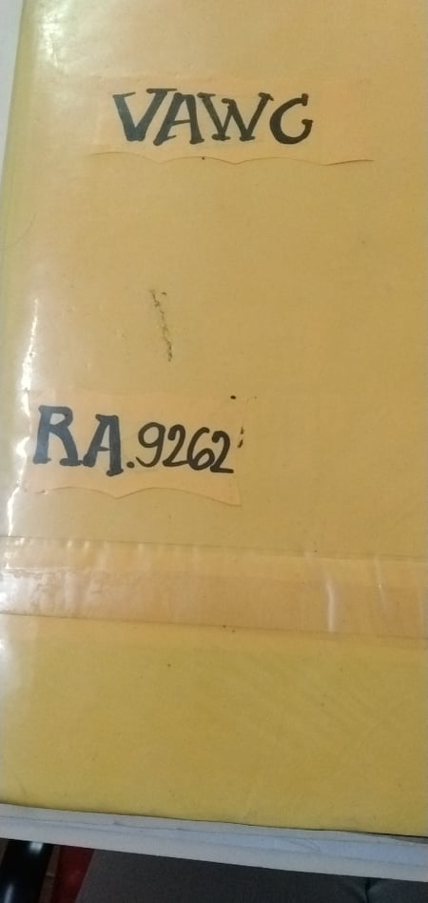

**Violence Against Women and Girls Sample**

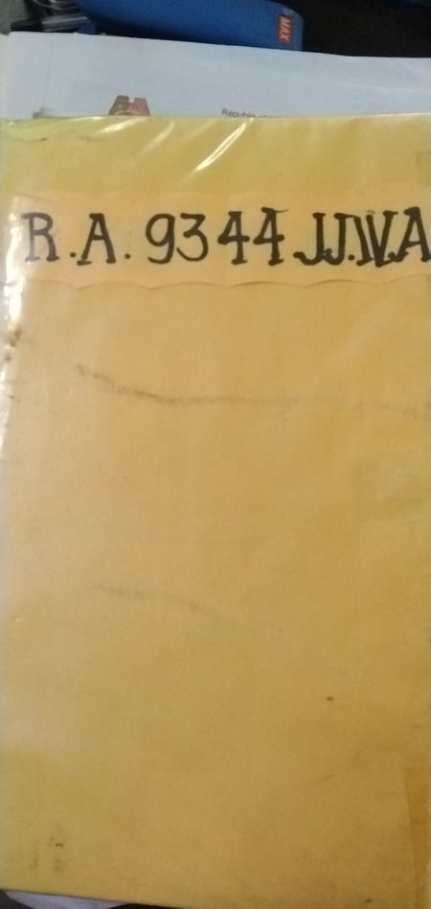

**Juvenile Justice and Welfare Act**

**APPENDIX C**

Transcripts of Interviews

TRANSCRIPT OF INTERVIEW (April 18, 2021)

0:20 SECRETARY: Game na ba?

0:21 LEDESMA: Nanjan na po kayo maam?

0:26 SECRETARY: Yes, good evening.

0:27 LEDESMA: Ayun, good evening po. So ngayon po nag meeting po para lang po makita niyo yung progress nung system, for ngayon lang po, UI lang po siya, kumbaga parang wala pa siya masyado functionality pero yung magiging design nung pinaka website tapos may lilinawin na rin po kami dun sa mga processes ng mga barangay, kasi po may mga diagram kami and also sa magiging flow ng system, so sa ngayon po yung system muna. Vergel ano, yung admin muna, pa log in.

1:15 DELA CRUZ: Pa present mo ulit si vergel.

1:16 LEDESMA: Hindi ba nakikita?

1:40 LEDESMA: Kita na?

1:41 DELA CRUZ: Oo.

1:42 LEDESMA: Ayan so, napansin niyo po may dalawa ano, since yung admin at resident. Since yung resident po magkakaroon din po ng account para po maaccess yung pinaka website ng barangay, so base po yun sa, diba po may binibigay kayo na handouts na nagpapatunay sila ng resident ng barangay, bali dun po makukuha yung basehan na kung bibigyan ba sila ng account o hindi. So dito po sa admin, kayo kayo po yan, mga barangay officials po, chairman, secretary, treasurer, kagawad and so on, so dito po hindi po masyado kagandahan yung design pero ito po yung pwedeng makita information, so sa ngayon po yung total officials is isa palang pero makikita po jan yung bilang na kung ilan po kayo nag ooperate ng barangay and then yung residents, yung total number of voters po sa barangay and yung male and female ng residents tas meron po yung covid na tracker, once na may nagpositive po ng barangay, madedetect po nung system or itratrack sila as covid positive then mag uup po yung number jan. So vergel yung announcements, ayan po pag gusto niyo po mag post ng announcements para makita ng residents, dito po kayo mag eedit, maglalagay ng text, sa ngayon po ayan palang po yung nakalagay, vergel pwede ba magsubmit jan tas makikita sa dashboard?

3:32 VEGEL: Ano?

3:34 LEDESMA: Pwede maglagay ng announcements tas para makita sa dashboard?

3:39 VEGEL: Sa ngayon hindi pa working yung database ng announcements.

3:44 LEDESMA: Sige sige. Yung next naman po yung, yung isa, yung isang announcements. Ayan so, ayan po yung mga naging announcements ng barangay, kumbaga meron po record, kung sakaling gusto niyo balikan yung past na announcements niyo or gusto niyo po iedit, for example may mali po dun sa announcements, pwede mag edit pwede rin magdelete tas next po yung sa officials. Ayan so kung need niyo po magdagdag ng officials, for example nagkaroon ng pinabago election, bago na yung officials niyo, so nanjan na lahat ng information na kailangan nila, next yung, pwedeng magdelete din jan. Officials list, so ayan po yung mga registered officials ng barangay, so pag inedit po, pwede ring magdelete ng official kung papalitan na po siya or hindi, next po yung residents naman, so dito po iaano na yung mga residents ng barangay, kung voters din po siya and may nasabi din po kayo na, kung resident siya dun by upa, for example nagrerent po siya ng kwarto or bahay tapos kung meron naman po siya lupa ganun, yun po yung resident type. Resident list nanjan din po, makikita din po tapos makikita din yung buong information nila base po dun sa mga info, ayan po so sa certificate naman po.

5:56 VERGEL: Hindi pa maayos yung certificate man.

5:58 LEDESMA: So yan na yung last? Ano yung sunod?

6:03 VERGEL: Oo sa ngayon, hindi pa maayos, wait lang.

6:18 LEDESMA: Ayan yung sa rental. Dito po sa rental ano yung, kunwari po, nabanggit dun po sa last meeting natin, for example po nag rent sila ng court or kahit ano facility ng barangay, since ang pagkakaintindi po naming wala po record, sa log book lang po nakalagay, meron po dito ID nung rinent na facility or property ng barangay tas pwede rin po isearch yung ID nila, yung rental number or biling number and then lalabas po kung ano yung details, tulad po nyan for example po lumabas po information nila kung ano yung, kung ano po yung nirequest nila for example po barangay clearance and then yung bayad and nag add din po kami ng receipt na option kung gusto po ng resident ng resibo.

7:33 VERGEL: Sa admin side yan palang nadedevelop ko eh pero ito naman yung makikita sa resident pero hindi pa makikita totally kung ano laman sa resident, makikita lang po yung mga navigations.

8:03 VERGEL: Ito sa admin pala, pwede ring palitan yung ano, kunwari pangalan nyan vergel, pwede ko palitan pangalan ko tsaka password, pwede rin magpalit ng password dito, kung sakaling may nakaalam ng password mo.

8:27 LEDESMA: Una po kasi default password, username lang ilalagay namin and kung gusto niyo po mas secure, pwede rin niyo po palitan yung password and username niyo. So yung sa resident naman.

8:46 SECRETARY: Question muna.

8:47 LEDESMA: Sige po.

8:48 SECRETARY: Yung sa may admin, pano kung ano, ako lang ba yung may access nun o may access din yung mga councils? Kay chairman.

9:03 LEDESMA: May access din po sila, alin po yung mga inaaccess nila?

9:09 SECRETARY: Yung pag eedit ng mga details.

9:11 LEDESMA: Ahh bali po hierarchy since kunwari po yung nakakataas lang yung pwede makakita ng ganto, sila lang po yung mga makakakita ng ganun. So hindi niyo po pwede palitan, for example po account ng iba, yung papalitan niyo hindi po pwede, sainyo lang po talaga and kung ano lang po nakikita ng account niyo yun lang po makikita niyo. Resident man.

9:51 LEDESMAL: Bali ayan po yung sa resident side, nandito po yung isang malaking kulay puti po ayan po yung announcements, yung magiging announcements na ilalagay ng barangay or nung admin, katulad mo nung Nakita natin announcements na editing page.

10:21 VERGEL: Wait lang. Bali sa ngayon kasi ito yung nadevelop ko sa resident wala pa totally yung mga buttons na toh, bali ang dashboard na yan, eto dashboard, eto announcement diba tas dito sa announcement pag pinindot yan, lalabas jan yung mga previous announcement kumbaga history ng announcement, para kunwari may nakaligtaan na announcement nung nakaraang araw, pwede nila balikan tas officials, ang makikita lang nila dito kung sino yung mga officials ng barangay. Request, dito makakapag request ng blotter, kunwari magpapa blotter sila ganun or magsesend sila ng certification request, eto yung record, makikita nila dito yung kung ano yung nasend nila blotter or certification request or kung may history sila pinaggawa certification.

11:32 LEDESMA: Kasi po nabanggit niyo po nung last meeting natin, hindi sila pwede kumuha ng barangay certificate ng dalawang beses sa isang taon po, tama po ba?

11:43 SECRETARY: Pwede naman.

11: 46 LEDESMA: Basta bawal magdouble yung mga forms, certificates ganun.

11:51 VERGEL: Dito sa rental, kunwari may magpapa schedule ng basketball, basketball court, makikita din jan yung parang create rental or reservation ganun, meron din jan yung rental records na kunwari nung nakaraang araw, nagpa reserve ako ng court, makikita ko yun dun.

12:22 LEDESMA: So goods na, ayan palang po yung laman ng system. So next naman po yung mga itatanong naming about dun sa yung parang flow lang po dun sa barangay, so rundown ko lang po ng mabilis, so yung resident po, pwede po sila magrequest ng apat na options for form request tulad po ng barangay clearance, business permit, complaints, yung resident details po and yung rental request po tapos lahat ng information na toh, mafoforward kay secretary or kay chairman base dun sa hiningi po nila so for example, si resident nag form request, so papasok po siya kay secretary and then yung ilalalabas po nung secretary is process request and then ifoforward niya po kay chairman? For example po ito po yung process form request and then once naapproved na ni chairman, binasa niya na po and then make sure na walang mali, lahat ng information tama, so iaapprove niya po yung approve request form or request information and then, so for example po kinuha ni resident is yung request or yung form na may bayad, yung payment po is papasok kay treasurer and then magbibigay po ng payment report pati po change kung may sukli man si resident, so once na nakuha na po yung approved request form and then yung payment, ibibgay na po kay resident yung request form o change, ganun po ba yun? May nakaligtaan po ba kami process?

14:37 SECRETARY: *Pag sa barangay kasi hindi naman ano, hindi naman involve si treasurer dun. Pag may request ang resident, kukuha lang ng form kay secretary and then gagawin ni secretary yung certificate tapos papapirmahan kay kagawad tsaka kay chairman.*

15:04 LEDESMA: Okay po so sino po naghahandle ng payment?

15:09 SECRETARY: *Ako, secretary.*

15:10 LEDESMA: So secretary na rin po.

15: 12 SECRETARY: *Oo*.

15:14 LEDESMA: So chairman, kagawad po ito.

15:18 SECRETARY: *Yes*.

15:19 LEDESMA: Sige po, next naman po is yung sa rentals, bali for example si resident po, yung verbal request lang po yung rental niyo, parang pupunta lang sa barangay and then papareserve po, kunwari basketball court barangay court?

15:40 SECRETARY: Oo.

15:41 LEDESMA: So ayan po, magsesend ng verbal request kay secretary, ichecheck po ni secretary dun sa log book kung available po yung property na hinihingi and then once na nakuha niya po yun, ichecheck niya rin po yung rental fee and then once nakuha niya na po yung appropriate amount na rental fee, ifoforward niya na rin po kay, dito po sa part na to, para malaman ni treasurer na tugma po or para malaman ng treasurer kung magkano hihingiin and then makukuha na po yung rental information, so for example kung magkano and kung ano hinihingi and then ilalagay na po sa log book and then once na nakuha na po lahat ng information, sasabihin na kay resident kung magkano yung kailangan niya bayaran and then iikot po uli kay treasurer and then ibibgay naman po yung change pati po yung, wala na po proof diba po? Na nagpapatunay na nirent nila aside po dun sa log book, bali change lang po if meron kay resident po or hindi na rin po kasama si treasurer dito?

17:05 SECRETARY: *Hindi rin kasama si treasurer*.

17: 09 LEDESMA: Sige po. So next naman po is yung sa blotter, dalawa po ibibigay ni complainant since pwede naman po hindi resident ng barangay yun diba? Yung nagpa blotter

17:30 SECRETARY: *Pag complainant naman, kagawad on duty and involved dun.*

17:40 LEDESMA: Ang nag aano po? Nagkukuha ng?

17:45 SECRETARY: *Ng details.*

17:47 LEDESMA: Ahh okay so hindi na po secretary, kagawad na po?

17:52 SECRETARY: *Ano umm log book sila, blotter log book tapos pag ano, pag nandun naman si kagawad pinapasulat na rin sa blotter log book*.

18:09 LEDESMA: Ahh okay po, so bali mo hindi na si secretary? Si kagawad nalang po talaga? Or kung sino po yung incharge sa araw na yun?

18:26 DELA CRUZ: Kung sino yung maglalagay ng details kung yung incharge ba?

18:33 SECRETARY: *Ahh yung complainant.*

18:38 LEDESMA: Hindi po yung magrerecord po.

18:42 DELACRUZ: Magrerecord yung ano, kung yung tao incharge ba dun sa barangay o ano.

18:47 SECRETARY: *Hindi kasi pag ano, pag may complainant, magsusulat sila dun sa blotter book and then babasahin ni kagawad on duty or minsan ako yung nagsusulat ganun, dipende kay kagawad on duty kung gusto niya magsulat or ako magsulat.*

19:13 LEDESMA: Okay po, so edi

19:21 DELA CRUZ: Kung sino yung ano, yung kagawad na on duty kung ayaw naman magsulat, yung secretary yung maglalagay ng details.

19:41 LEDESMA: Okay po, edi medyo skip na muna natin tong blotter form, next naman muna natin yung is yung form request, so si resident meron po siya dalawang output nanaman, yung request at yung payment kung meron po so once na magrequest form, clearance, sainyo rin po ifoforward yun tama? And then yung details po nung request form, ichecheck pa po kung resident po ba sila para kung illegible po sila makapag request ng form na yun?

20:37 SECRETARY: Oo

20:38 LEDESMA: Tapos, once na maditermine po yun, idedetermine niyo po kung ano klaseng clearance yung gusto nila nila then once na makuha po yun aalamin din po kung magkano and then yung pinaka last is yung proprocess na po yung hinihingi clearance or form or document po, ipapasa na po yun kay chairman tas si chairman po mag aapprove o magdedecide kung iaapprove po ba yung form and then once na iapprove yung document, ipapasa po yun uli sainyo and then and output nun approve certificate tapos yung approve, amound payable kung meron man and then ipapasa po yun and then assume ko nalang po na hindi kasma si treasurer? Kayo nalang po ulit yun?

21:43 SECRETARY: Yes

21:45 LEDESMA: Okay, since wala na po yun, so yung payment po dederesto nalang sainyo and then yung requested document ibibigay kay resident then yung change kung meron man po, tama po ba?

22:00 SECRETARY: *Tama*.

22:06 LEDESMA: So ayun lang naman po. Sallan ikaw na yung next.

22:12 SALLAN: Umm good evening po maam. In relation lang po sa kanina po, regarding po dun sa treasurer po, sino po yung nag iistore talaga, nagiistore, lets say kinikita nung barangay

22:29 SECRETARY: Collection ng mga fees?

22: SALLAN: Opo yung mga ganun po, halimbawa nakatanggap kayo ng bayad mula sa clearance, sino po mag iistore nung pera na yun? Kung hindi po si treasurer?

22:40 SECRETARYY: *Ako. Secretary.*

22:42 SALLAN: Ahh okay po, secretary na po talaga. Okay po.

22:48 SECRETARY: *Iba yung hinahandle ni treasurer, siya yung naghahandle ng budget ng barangay.*

22:54 SALLAN: Okay po, so kung income generation po, sainyo po napunta yung pag iistore ng pera? Bali ganun po?

23:02 SECRETARY: *Oo*

23:03 SALLAN: Okay po. Proceed nalang po ako dun sa iprepresent ko po. Ang iprepresent ko naman po is yung prinopropose namin na system, bali yung projected na umm flow po nung system na prinesent sainyo kanina, so parang yung pinaka finish product po niya, ganto po yung magiging flow niya, so prepresent ko lang po yung diagram namin dun, yung framework namin.

23:32 LEDESMA: Kung may tanong po kayo, tanong niyo nalang po si kim.

23:40 SALLAN: Wait lang po.

23:52 SALLAN: Nagprepresent na po ba ako?

24:00 SECRETARY: Okay.

24:05 SALLAN: Ayan po, nagzozoom po ba? So ito po yung parang pinaka layout niya, ito po yung magiging parang ano po pinaka technicalities nung system na ipapakita namin tsaka yung prinopropose naming sa barangay niyo po which is barangay 599 so it is the e-barangay management system for barangay 599, so yung technical terms po natin magrurun po siya thru PHP programming language tapos gagamit po kami ng webhosting server in which na mag iistore po nung mga information o nung mga data na eexchange po ng point of view niyo po as management of the barangay and the resident po which is yung mga tao naman po sa barangay niyo po,so gagamit din po tayo ng SQL so other than that po proceed na po tayo dun sa flow po. So ito po yung mga recieveable nung barangay niyo po yung maaaring marecieve niyo dun po sa context na in the context of our proposer system, so since po ito ay gagamit ng internet, automatic po gagamit po tayo ng device na kaya magconnect sa internet at sa browser, okay po? So pinapakita po dito yung computer o yung tablet or yung cellphone since magkakaroon po tayo ng responsive design meaning pwede po siya magamit sa kahit anong uri ng device, mapa cellphone o tablet o kaya computer thru the internet po, so ito po yung marerecieve niyo po na magmumula po either sainyo po, mga collaborations po sainyo ng mga barangay at ang ganun na rin po sa ibibgay niyo po mga tao po, mga resident po ng barangay na gumagamit din po ng e-barangay system, so ito po, unang una po yung updated web content, since bibiyan namin kayo ng kakayahan or ng privilege po para mapalitan halimbawa po yung logo ng barangay, madagdagan yung mga properties na pwede irent tsaka po yung halimbawa po nagkaroon po kayo ng bago facility na pwede niyo ipagamit, sisiguraduhin po namin maayos yung user interface po niya para mas madali maunawaan agad tapos since magkakaroon po tayo ng schedules ng rental of course, so sa point of view niyo po makikita niyo po yung update, halimbawa po nagamit po ito, narentahan na po itong basketball court, makikita niyo po na hindi po siya available muna so maiinquire po yung mga possible na manghihiram or magrerent po na hindi pa po available, since naman po ito blotter request since may kakayahan magrequest ng blotter ang mga resident through the e-barangay information system, yan po ito po, papasok po yan dito sa system natin at ilalatag po niya sainyo po point of view kaya po ayan makikita po nung officer in charge nun sa oras na yun, kung sino man po sa management view po, makikita niya po yun at may kakayahan po siya tignan kung valid yung request niya blotter, kaya po masasala niyo po yun at maiiwasan natin yung mga nangtritrip po, kapag po naverify niyo po yun, kung valid naman po yung blotter request niya pwede niyo na po iapprove siya and then papasok na siya ulit dito sa system natin then through the internet and then ito po siya, blotter details na po siya, since legible naman po siya, valid na po siya, naverify na po ni office incharge so papasok po siya sa system, magrereflect po siya sa system then marerecord sa data storage or sa database, sunod naman po, updated schedules of blotter, given naman po, meron tayo mga summons schedules after magkaroon ng blotter, naverify po, may specific na araw po na binibigay para sa schedule ng isang summon, na pag uusapan sa barangay diba po yung kaso na yun, makikita niyo po jan, makikeep in track niyo po yun na para mas mapadali po yung trabaho ninyo para po hindi na po tayo magrely dun sa blue book or dun sa log book na sinasabi po kanina so next naamn po, meron po tayong mga intances na nagpapalit ng apilyedo ni resident, marerecieve po yung ng system, ilalatag po ulit, inonotify po ulit kayo yung updated na resident data in whice makukuha niyo po yun, marerecieve niyo and kung valid po ulit, pwede po ulit siya magreflect, ipapasa niyo po ulit through the internet and then ayan po, next naman po proof of payment, since po mag uutilize po tayo ng gcash according to the development that we consolidated po, ang gagamitin nalang po natin ay isang proof of payment, isang litrato or isang screenshot na nagpapatunay na nakapagbayad po ito si gantong tao through gcash at makikita din po yun dito and makakapag generate po tayo ng receipt or ng resibo po pag po naipakita na valid po yung proof of payment niya through gcash ayan po so papasok po siya dito, kukuha po tayo ng receipt, mag gegenerate po si system at pwede na po ireturn yun, ipakita or ibigay dun po sa resident dun sa nagbayad po at sa form request naman po, last but not the least po, sainyo point of view po is ito po yung mga request para sa mga clearance or sa mga certifications na hinihingi ng isang residente, so ito po makikita niyo po yung request jan, yung form request po may finifill up as pinapakita po nila in the future updates po and then meron po sila mga detalye na ilalagay. Sabihin nalang natin po na valid yung request niya edi.

31:35 LEDESMA: Ulitin mo yung sa part na ilalatag, nag dc ka kasi konti.

31:40 SALLAN: Ano? Saang part?

31:43 LEDESMA: Latag, yung ilalatag

31:46 SALLAN: Ayweh? Dito sa updated schedules rental?

31:52 LEDESMA: Oo.

31:56 SALLAN: Ay sige, sige po, ulitin ko nalang po, So dito po sa, since magkakaroon po tayo ng mga properties na diba paparentahan po natin, kapag po halimbawa ginagmit po, currently is rented ng isang resident or ng isang individual or currently po hindi available yung property nay un, halimbawa po sira or may problema po dun or ECQ sabihin na natin ganyan, kailangan po baguhin yung status niya, so hindi siya pwede rentahan at magrereflect naman po yun ulit pabalik sainyo sa point of view po niyo bilang property pwede rentahan so yung schedules po ng rerentahan din, makikita po nyan na kung availability neto kung kelan po siya rerentahan given na nagrerenta po. Yung blotter request naman po, ayan po meron po kakayahan si resident na maglatag ng or magrequest, magfile ng blotter through the system so meron po yun detalye na ilalatag po dun o ilalagay tapos po marerecieve niyo po yun tapos yung blotter request po yun meron po kakayahan para maverify if ever legible po yung blotter request na binigay sainyo po, if ever po maayos po siya at legible po siya, ipapasok niyo na po ulit dito, iaaprove po yun, meron po kayo option para iapprove siya or icancel siya and then if approve po siya papasok po siya through the system then to the internet, blotter details na po siya since legible po siya, and then since kasma na po dito sa blotter details yung magiging summon schedule niya na nagenerate niyo po or yung napag desisyonan, ito na po yung mga updated schedules blotter since meron po tayo mga summons diba po na isinasagawa kapag nagbloblotter tayo ng isang individual, since po nasa point of view po tayo ng management ng barangay, mas maganda po natratrack niyo mga scheduling ngayon, special po summon po ito, mas mapapdali rin po yung pagtratrack niyo po dito kessa po magrely tayo dun sa papel po and then yung sa log book po sa ngayon, mas mapapdali po yung readability tsaka po yung convience po. Tapos po yung sa resident data, meron po tayo dito na pagkakataon na in which nagpapalit po ng data yung si resident or meron po bago residnent na dumadating so ito po yun, papasok po yun dito yun if ever through the system po or sabihin na naitn na walk in, papasok pa rin po sainyo yung resident data sa point of view po ng management ng barangay at meron po kayo Karapatan na gamitin po yung add or edit yung resident data para ipasok po ulit sa system pero kung yun ay legible ulit yun and may kakayahan naman po idetect yung mga minor na lets say legibilities dun po sa data and kapag po naverify na po siya, maipapasok na po ulit siya dun sa system and magrereflect na po ito sa data storage at maaari gamitin pa po sa mga iba mga module, sunod po yung form request, ito po yung pagrerequest ng clearance po at tsaka ng mga documents po or yung mga certification po, so dito sa form request na toh, may kakayahan na po si resident na magrequest throught the system ng isang certificate, pagpasok po dito, marerecieve niyo po yung request na yun, papasok po siya sa management of the barangay then meron po kayo option para iaapprove siya o para icancel kung ang tao na po ito ay legible kumuha ng certification kasi po makikita niyo po dun sa data ng resident nung nagpasa nung request na yun given na may ififill up siya form bago siya makakuha ng certificate, so yun po yung form na po yun , pag fill up niya, may kakayahan po kayo na suriin pa po ito katulad po ng dati however mas mabilis po dito, isang click lang po at yun po maggegenerate po tayo agad ng isang certificate kapag po legible yung or valid pa rin po yung form request niya kung pwede pa po siya mag form request as a resident ayun po papasok po siya dito yung approve po tapos, yan po approval, since approval po young sinend niyo dito, si barangay management po yung maggegenerate nun so pagpasok po niya dito, magrereflect po siya dito, bibgyan naman yan ng inquiry para po mapick up yung form request, maarin din po yung form request na yun ay PDF or walk in pick up kaya po inquiry nilagay namin jan next po yung proof of payment, since meron po tayo babayadan or in generating or mga income generating fields dito sa ating barangay like yung clearances po, yung rentals po, binigyan po namin ng option, ng payment method si through the barangay information management system so sa proof of payment nalang po hinihingi po kasi po gagamit po tayo ng gcash dito so si resident po, magsesend nalang po siya ng sabihin po naitn ng screenshot or kaya picture po na nagpapatunay na nagbayad po sila at successful po yung transer ng pera through gcash, papakita po sainyo yung proof of payment at kung Nakita niyo na po yung proof of payment, may kakayahan na po kayo na iapprove siya at ibibgay yung nirequest niya, maybe in rental o kaya naman po is yung sa form request, maggegenerate na po ng resibo si e-Barangay management system kaya po ayan po, approval po yung papasok sakanya, pwede rin po pumasok sakanya yung receipt po tapos irereflect po niya yun dito papunta, babalik po dito sa residents view, pwede po niya iprint yun o kaya screenshot lang po na nagvavalidate na nagbayad po siya so, ayun lang din naman po, eto po yung sa residents view naman po is yun na rin po yun eh, yung maaari nila ibigay or maihingi or mairequest po sa barangay through the e-Barangay system po, eto po pala, meron din po tayo dun sa announcement pero naipaliwanag na po ito kanina, yung mga pinopost niyo po announcement ipapasok lang po dito sa e-Barangay management system and then marerecieve po siya ni resident through the system po, ayan po announcement, yung announcement po maaari po nila mareceive through either SMS yung sa text po or sa web content po, kaya po bibigyan po yung option, para din po maginquire yung mga tao yung mga walang access sa internet kaya po meron po tayo text given na majority po ng mga tao ngayon is meron na po kanya kanyang cellphone po other than that, wala naman po, yan lang po yung buong layout, maraming Salamat po.

40:56 SECRETARY: Okay. Thank you.

41:00 LEDESMA: Edi bali yun lang po yung babaguhin naming, yung hindi na po kasama si secretary, ay si treasurer dun po sa ano, sa pinaka process nung pagbayad po. So si secretary nalang po talaga yung naghahandle overall.

41:17 SECRETARY: Oo.

41:19 LEDESMA: Sige po. Meron po ba kayong suggestion or parang comments po or need niyo po iclarify sa pinakita po namin.

41:30 SECRETARY: Umm sakin okay lang naman yung process na ginawa niyo, dipende nalang siguro sa approval ng councils and chairman pa din.

41:44 LEDESMA: Ayun po, buti napaalala niyo, yung about po dun sa proposal namin, meron po ba news about po dun?

41:52 SECRETARY: *Umm, bali pag uusapan pa lang namin kasi sa ngayon medyo busy pa kasi kami dahil sa lockdown dahil tumataas yung covid ratings sa barangay namin, meron pa kami barangay assembly, probably by next week siguro kaya hindi pa namin maano yung proposal ninyo.*

42:27 LEDESMA: Sige po. Thank you po. Wait lang po. Ayun nga po so about po dun sa budget po noh, meron po ba possibility na iwidthraw or hindi pumayag or sumang ayon yung barangay po?

42:50 SECRETARY: *Sa tingin ko kung may payment yan, not sure ako kung iaapprove yan dahil parating sagot kasi walang budget.*

43:04 LEDESMA: Sabagay po pero if ever naman po, ayun sige po, goods lang naman po. So anything else po? Ay eto po pala, meron po ba clear picture ng barangay hall? And group picture niyo po as barangay officials and councils para po ilagay po dun sa system, para po mas maganda tignan yung system and base po dun sa pinakita, pinaka front page ng barangay, diba po barangay hall niyo po yun, maaarin po ba namin makuha yun? Para po ilagay.

43:51 SECRETARY: Sige ano umm sesend ko nalang kay kim sainyo, picturan ko muna. Gusto niyo ba may different before after picture ng barangay?

44:07 LEDESMA: Panong before after po?

44:09 SECRETARY: Kasi hindi ganun dati eh.

44:11 LEDESMA: Ay sige po, mas okay po

44:13 SECRETARY: Oo, before and after ng barangay tapos yung barangay council, meron naman kami ano umm yung group picture na portrait namin.

44:27 LEDESMA: Sige po. Kelan po ulit namin kayo makausap if ever meron kami mga tanong.

44:37 SECRETARY: Try ko nalang Tuesday or Wednesday.

44:46 LEDESMA: Sige po. Okay po. Goods. Anything else po?

44:57 SECRETARY: Inform ko kayo, try ko mag brough up, tignan ko kung mabrough up ko tomorrow kung hindi kasi yun nga may assembly kami itatackle tomorrow kaya medyo matatagalan yung meeting.

45:14 LEDESMA: Sige po. Maraming Salamat po. May tanong pa kayo guys? Sallan, vergel, ulo.

45:25 MORALES: Wala naman.

45:26 SALLAN: Thank you po maam

45:29 LEDESMA: Maraming Salamat po sa oras niyo maam, thank you po.

45:32 SECRETARY: Welcome.

TRANSCRIPT OF INTERVIEW (April 25, 2021)

0:09 LEDESMA: Bali ayan po, may mga tatanong lang po kami sainyo para po linawan lang yung flow ng magiging system namin. Vergel yung ano.

0:29 VERGEL: Yung akin na?

0:31 LEDESMA: Oo

0:39 VERGEL: Eto po, umm, dun po ba sa lugar niyo, ilang purok meron kayo?

0:47 SECRETARY: Ano yon?

0:48 VERGEL: Ilang purok po meron sa barangay 599?

0:53 SECRETARY: *Sampu*

0:56 VERGEL: Sampu, umm, may iprepresent po ako sainyo.

1:05 LEDESMA: Matanong ko lang po, bawat purok po, may individual po na parang official na nagmamanage nun?

1:15 SECRETARY: *Oo, meron.*

1:16 VERGEL: Yung purok leader

1:17 SECRETARY: Oo.

1:18 LEDESMA: Pwede po namin makuha yung listahan?

1:22 SECRETARY: Listahan ng purok leader?

1:25 LEDESMA: Opo, kung ano purok po hinahandle nila.

1:29 SECRETARY*: Ahh, sa ngayon kasi purok leader parang hindi sila existing eh, ang naghahandle sa ngayon yung mga kagawad.*

1:41 LEDESMA: Kumbaga kung sino nalang po yung malapit dun sa purok? Siya nalang po yung nag aano?

1:45 SECRETARY: Oo.

1:46 LEDESMA: Ahh sige po.

1:49 VERGEL: Okay po, umm, eto po ipapakita ko po yung dashboard sa system po.

2:01 SECRETARY: Sige.

2:15 VERGEL: Kita na po ba?

2:17 SECRETARY: Okay.

2:19 VERGEL: Sa ngayon po yan lang po nakalagay sa dashboard po sa system, tatanong ko lang po, kung ano ano po ba yung kailangan niyo makita sa dashboard?

2:49 SECRETARY: Ahh, kailangan po ba talaga ilagay yung total residents covid?

2:55 VERGEL: Ahh, para lang po matrack pero pwede naman po siya alisin.

3:00 LEDESMA: Kung ano lang po yung need niyo makita as barangay official, kung ano po yung madalas na ginagamit niyo na information po, nabanggit po samin na need niyo daw po yung range, kunwari po total number ng tao from age 10 to ganto ganyan po.

3:21 SECRETARY: *Ahh okay. Pwede naman yan kaya lang meron mga times na kailangan yung total number ng senior citizen, may bracket ng 1 to 5 years old ganun.*

3:38 LEDESMA: Ayun po, so bali total number of senior citizen po?

3:42 SECRETARY: Oo.

3:43 LEDESMA: Meron po ba sila information na binibigay sainyo na nagpapatunay na senior citizen sila?

3:50 SECRETARY: *Ahh, once na nag birthdate sila ng ano, nagbirthday sila tapos ipapakita sakin yung birth certificate nila kasi kailangan din nila yun ipresent sa city hall.*

4:06 LEDESMA: Ahh bali meron po edad na, kunwari po nasa 60 na po sila classified as senior citizen na sila?

4:19 SECRETARY: Oo.

4:21 LEDESMA: Anong edad po yun?

4:22 SECRETARY: *60*

4:23 LEDESMA: Ahh 60, tama pala yung hula ko, so bali once na naging 60 po, classified as senior citizen na sila?

4:29 SECRETARY: Senior citizen.

4:30 LEDESMA: Ahh okay, thank you po. Ano pa po?

4:34 SECRETARY*: And then, para makakuha sila ng senior citizen ID, fifill up sila ng form kasi meron kami form na galing na senior citizen office, ififill up nila yun tapos pag kumleto na ifill up yung mga details ng form, bali pinipirmahan pa yun ng senior citizen president tapos pag napirmahan na, email ko naman yun sa senior citizen city hall ganun, ganun ang flow nila*

5:11 VERGEL: Umm, sa barangay po ba nakukuha yung form nay un?

5:17 SECRETARY: Actually galing yun sa senior citizen office sa city hall and then pophotocopy ko lang.

5:30 VERGEL: Pwede po ba malaman yung mga age range po ng kinukuha niyo po information, kunwari po 0 to 5, 10 to 19.

5:43 SECRETARY: *0 to 5, yung 0 to 5 kasi ano, yun yung for vaccination tapos ay hindi, 0 to 9 years old tapos 10 to 15 then 16 to 24 ata yun, 25 to 35, 36 to 50, then 50 to 65 then 65 to 70 then 70 above na.*

6:47 LEDESMA: Okay po, san niyo po ginagamit yung info na yun?

6:50 SECRETARY: *Ginagamit, for example merong vaccination 0 to 19 years old tapos hindi ko kasi masyado kabisado yung ano, yung details nun tapos* *pagdating ng 10 years old hanggang kung ano yung adolescent age tapos kung sino yung adult, kung sino yung senior citizen, yun lang.*

7:33 LEDESMA: Sige po thank you.

7:36 VERGEL: Bali po ang ilalagay ko po sa dashboard is yung for vaccination, adolescent, adult tsaka senior citizen, 4 po?

7:48 SECRETARY: Oo.

7:50 VERGEL: Okay po. Eto naman po, pagdating naman po sa resident information, eto po resident type, 4 lang po ba yung resident type po? House owner, caretaker, rental or boarder tas living with relatives po, 4 lang po ba yun?

8:16 SECRETARY: Oo.

8:17 VERGEL: Okay po, lastname, firstname, middlename, birth of place, birthdate, address, contact, PIN number, SSS number, age tas kung voter o hindi, civil status, single, married, windowed, separated, yun lang po ba yung

8:40 SECRETARY: *Siguro sa voters, voters precinct.*

8:43 VERGEL: Po?

8:44 SECRETARY: *voters precinct. Precinct number.*

8:51 VERGEL: Ahh okay po, voters precinct number, ayun lang po ba yung

9:00 SECRETARY: *Kasi yung sa voter, yes or no lang sasagot mo dun then precinct number.*

9:04 VERGEL: Okay po, sa record niyo po ba yung mga resident dun eh may email na po ba sila?

9:14 SECRETARY: Alin?

9:15 VERGEL: May email po ba sila nakarecord sainyo?

9:18 SECRETARY: *Hindi naman naming hinihingi yung email account*.

9:26 VERGEL: Okay po, sa ano po, pagdating po sa rentals, anoa no po ba yung pinaparent niyo po bukod po sa basketball court, parking, daycare, barangay hall.

9:45 SECRETARY: Um, *daycare.*

9:48 VERGEL: Bukod po sa 4.

9:51 SECRETARY: *Tapos, yung library, may library kasi eh pero hindi existing yung library ginagawang mortual.*

10:04 LEDESMA: Yung library ginagawang mortuary?

10:08 SECRETARY: Oo.

10:15 LEDESMA: Aside po dun, ano pa po?

10:22 SECRETARY: Tables and chairs.

10:24 VERGEL: Yun lang po?

10:26 SECRETARY: Oo, yun lang

10:28 VERGEL: Okay po

10:34 SECRETARY: Ay, walang rental pala yung tables and chairs.

10:37 VERGEL: Po?

10:38 SECRETARY: Walang rental, rental wala.

10:42 VERGEL: Ay hindi po narerentahan yun?

10:43 SECRETARY: Hindi.

10:45 LEDESMA: Pati rin po yung library hindi rin po?

10:47 SECRETARY: *Yung library, nirerent yon kapag ano, kapag yun nga ginagawang mortual.*

10:56 VERGEL: Okay. Eto po sa pag create po ng certificate, eto lang po ba yung mga kailangan?

11:05 SECRETARY: Pag mag? Magrerequest ng certificate?

11:09 VERGEL: Certificates po. Opo

11:13 SECRETARY: *Hindi ko na hinahanap kasi hinahanap yung resident ID eh, dun nalang ako nagbabase sa sinusulat nilang form*.

11:25 VERGEL: Ano po, papalit po natin ng name nalang po, bali ang mangyayari po jan, kapag sinearch po yung name, may lalabas po dun na suggestion po kung kanino pangalan po yun tapos kapag po clinic yun, pipili nalang ng certificate tapos kapag po nasave na po, pwede na po siya magprint.

11:46 SECRETARY: *Ang certificate kasi, usually nilalagay nila sa certificate, name, address then kung saan gagamitin yung certificate.*

11:57 VERGEL: Kailangan pa po ng reason?

11:58 SECRETARY: Oo.

12:01 LEDESMA: Meron po ba kayo example nung reason po.

12:03 SECRETARY: Na?

12:04 LEDESMA: Ano po yung mga kadalasan nilalagay na reasons?

12:11 SECRETARY: *Employment, bank open account tapos kasi dun naman sa certificate, makikita namin yung proof of residency eh so for example, kung gagamitin sa employment, employment requirements slash proof of residency and then nilalagay din namin dun kung may pending din siya o wala ganun.*

12:44 VERGEL: Pero po sa mga pag create po ng certificate, ayan lang po ba mga kailangan? Ay ayan lang po ba yung iniissue ng barangay?

12:53 SECRETARY: *Oo ayan lang.*

12:54 VERGEL: Eto lang po? Kung ano lang po yung nasa form niyo po, yun lang po?

13:00 SECRETARY: Oo kung ano lang yung nasa form yun lang naman.

13:03 VERGEL: Okay po.

13:04 LEDESMA: May tatanong lang po ako dun sa ano sa pag payment, for example po parang nag request po ako ng certificate na kailangan ng bayad, yung mangyayari po ba dun, magbabayad ako kasama yung form request ko and then makukuha ko yung papel or ibibigay ko muna yung form request ko tapos magbabayad ako and then tsaka sakin ibibigay yung nirequest ko po form?

13:31 SECRETARY: *Ang mangyayari kasi minsan pag pumupunta sa barangay, wala sila dalang pera, so hindi muna nila binabayaran yung ano yung certificate, magagawa yung certificate and then pagbalik nila, dun lang nila cliniclaim and then dun lang sila magbabayad.*

13:47 LEDESMA: Okay, gets po. Thank you po.

13:51 SALLAN: Pero maam, legally po, hindi po pwede talaga, yung pag eexchange kung walang bayad, kung legal po yung pinag uusapan po.

14:00 SECRETARY: *Oo kung legal yung pinag uusapan, babayaran talaga yon.*

14:05 SALLAN: Sige po maam, thank you po.

14:07 VERGEL: Kasi po maam, sa system po namin, na ginawa po namin, kailangan po ng proof of payment muna kung online po, kung online po siya magrerequest, magsesend po si resident ng proof of payment through gcash, yung screenshot po, bago po yung makapag submit po ng request, kasi po maam, legally speaking po, kailangan po talaga ng payment para po makapagrequest, kaya ayun po naisip namin sa system. Pagdating po ba sa blotter, ano po ba yung nangyayari, simula po sa pagreport hanggang matapos po yung issue.

14:57 SECRETARY: *Pag nagpa blotter siya, meron kasi time na nagpablotter pero blotter, as in blotter lang tapos meron naman time na gusto nila makausap yung ano, yung tao and then nasosolve din right away, meron naman time na gusto nila ischedule kunwari ayaw nila makipag schedule sa tao, kung sino yung naghandle for example ngayong araw na to, si kagawad number 1 yung naka duty so the following week siya ulit yung maghahandle dun sa nagcomplain.*

15:50 VERGEL: Okay po

15:53 SECRETARY: *Tapos pag hindi nassetle for example, for the following week, pag nakapag tatlo reserved hindi nasettle yung ano, that’s the time na kailangan na ng lupon tagamapayapa and then magfifile sila ng case pag hindi pa rin naayos yung case nung tagamapayapa*

16:26 VERGEL: Bali po may type rin po na blotter lang, usap lang or magfifile po ng case?

16:37 SECRETARY: *Pwede rin, ang rule namin dun, kung blotter, as in blotter lang sa log book lang, pero kung cocomplain mo talaga siya, gusto mo kasuhan siya, magfifile siya, magbibigay siya ng 3 original copy ng complain form ay ng complain letter.*

17:03 VERGEL: Ganun lang din po ba sa pag gustong kausapin lang?

17:09 SECRETARY: *Hindi, pag gusto kausapin lang, log book lang.*

17:13 VERGEL: Log book lang din po yun?

17:14 SECRETARY: Oo, logbook lang.

17:21 VERGEL: Sa ano po, sa roles, ay sa roles, sa mga barangay official po, diba po pagdating po sa chairman eh sakop niya po lahat, I mean parang, nakakapag announce po siya, pagdating po sa system ah, nakakapag announce po siya, nakakapag add ng residents, officials nakakapag issue ng certificates, rentals, blotter, ayun po, pagdating po sa secretary, ano ano po ba yung hinahandle niyo.

17:57 SECRETARY: *Actually, ang chairman hindi siya nakikielam sa mga ganyan, sa system hindi siya nakikielam.*

18:06 VERGEL: Ano lang po ba ang sakop ni chairman?

18:08 SECRETARY: *More on command lang si chairman.*

18:09 VERGEL: More on command.

18:10 SECRETARY*: Command, signing.*

18:15 VERGEL: Yung ibang ano po, position po sa barangay?

18:22 SECRETARY: *Barangay officials, ganun din, signing lang din sila*.

18:31 VERGEL: Kunwari po, ay ikaw po ba as secretary, nakakapag announce ka po sa residents po.

18:39 SECRETARY: Public address?

18:41 VERGEL: Announce po, makakapag announce.

18:45 SECRETARY: Through public address, nakakapag announce ako.

18:49 LEDESMA: Like yung parang nag iikot po kayo ng naka megaphone or pano po ba yung process ng pag aannounce?

18:58 SECRETARY: *Megaphone ang public address pero pag yung parang nag iikot na, kailangan may kasama ako kagawad.*

19:06 LEDESMA: Ahh bali dalawa po yung way ng pag ano po, pag address niyo po, una naka megaphone and yung isa po.

19:13 SECRETARY: Public address, yung trompa.

19:16 LEDESMA: Po?

19:17 SECRETARY: Trompa.

19:20 VERGEL: Ahh okay po. Kasi po sa system po, anong posisyon po ba ang nakakapag announce sainyo? Secretary and kagawad lang po ba?

19:32 SECRETARY: *Secretary, kagawad, chairman.*

19:34 VERGEL: Tatlo po?

19:35 SECRETARY: Oo.

19:36 LEDESMA: Si treasurer, wala na po?

19:41 SECRETARY: *Oo. Si treasurer is more on legal documents tungkol sa budget ng barangay.*

19:53 LEDESMA: Ahh wala na tayo dun.

19:55 VERGEL: Sa pagdating po ng ano, sa posisyon po sa barangay, chairman, secretary, kagawad, treasurer lang po ba meron?

20:08 SECRETARY: May?

20:12: VERGEL: Chairman, secretary, treasurer at kagawad lang po ba ang posisyon?

20:19 SECRETARY: *Merong din SK chairman*

20:22 LEDESMA: Ano po ginagawa ni SK sa barangay po talaga.

20:28 SECRETARY: *SK, ang mga kasama nila na nagmemeeting, kung ano yung mga marerecommend niya rin.*

20:44 LEDESMA: Parang, parang middleman po tuwing meeting?

20:52 SECRETARY: *Ahh hindi kasi, SK chairman more on sports, pang kabataan.*

21:10 LEDESMA: Ahh so yung kayo po yung pinaka chairman, panglahat and then si SK chairman specific, sports lang po?

21:21 SECRETARY: Oo.

21:22 LEDESMA: Okay, so hindi na rin po siya nakakapag announce ng sarili po niya, hindi po siya nakakapag public address.

21:31 SECRETARY: *Nakakapag public address siya, siya ang ano more on online.*

21:40 LEDESMA: Ahh yung sa social media po?

21:42 SECRETARY: Oo. Facebook ganun

21:47 LEDESMA: Facebook um, tanong ko lang po, facebook ano pa po yung iba po social media po, facebook.

21:54 SECRETARY: Ayun lang, facebook lang.

21:56 LEDESMA: Sige po.

22:00 VERGEL: Bali po, pagdating po sa system, si chairman po ba, diba po si chairman po nahahandle niya po lahat, nakakapag add po siya ng resident.

22:11 SECRETARY: *Si chairman hindi siya ano, pag sa system kasi hindi siya nakikielam si chairman.*

22:20 VERGEL: Kahit po announcement?

22:22 SECRETARY: *Oo. Sasabihin niya lang sakin kung ano yung dapat iannouce.*

22:28 VERGEL: Okay po. Bali po, kayo po talaga sa lahat, yung naghahandle.

22:34 SECRETARY*: Oo, sa lahat.*

22:45 SALLAN: Pero maam ano po, may say po si chairman, may say po si chairman in terms po sa lahat, halimbawa po sa approval, sa pag sign po, halimbawa po sa blotter, may power po siya mag approve? Tsaka po dun sa magrerelease ng clearances or certifications, meron po siya powers in terms sa ganun?

23:11 SECRETARY: *Si chairman naman kasi usually ano pumipirma ng mga certificate, lahat yon, siya talaga.*

23:22 SALLAN: Yung sa blotter po ba dumadaan po ba kay chairman yun?

23:28 SECRETARY: *Hindi na dumadaan kay chairman ang blotter, ang blotter kasi more on council ang nagsosolve, back up lang si chairman.*

23:40 SALLAN: So bali ang proseso po ng blotter po, naka limit lang po kay kagawad?

23:48 SECRETARY: Oo.

23:51 SALLAN: Ahh sige po, Salamat po. Nag popop out lang siya chairman pag yung talagang hindi na masolve nung council.

24:17 VERGEL: May kakayahan po ba si kagawad sa pag add po ng resident? Diba po secretary lang po.

24:26 SECRETARY: Ang alin?

24:27 VERGEL: Yung mag add po ng resident sa record po.

24:34 SECRETARY: *Ahh hindi, iniiform nung mga councils kung sino yung mga dadagdag sa area niya.*

24:50 LEDESMA: So pag inform ni kagawad kung sino po Nakita niya nadagdag, iaapprove pa po ni council kung nadagdag po ba talaga etong resident na to?

25:02 SECRETARY: *Makikita yan, kunwari meron nag complain na, kunwari kailangan niya ng hanapin ng list ng mga residents niya, dun niya makikita kung sino mga wala.*

25:54 VERGEL: Bali po pagdating po sa online system, ang gagawan nalang po ng account or sa pag access ng system, secretary, kagawad, yung kagawad po para lang po sa announcement and blotter lang po tas SK chairman po para po sa announcement?

26:16 SECRETARY: *Kasi pag sa system, kailangan talaga naka private yung mga ano eh, yung mga details ng, kasi diba meron tayo data privacy na tinatawag, so isa lang talaga dapat ang may access sa system.*

26:37 VERGEL: Sa system po kasi may ibat ibang point of view po, kunwari si kagawad, ang tanging makikita niya lang po sa system is pag post ng announcement and pag process po ng blotter, yun lang po.

26:50 LEDESMA: Opo, yung mga information na hindi na niya, kunwari po yung pag pirma ng ganto ganyan, hindi na niya po makikita yun, kunwari po sa secretary po since yun po yung sa trabaho niyo, kayo lang po makakakita nung part nay un.

27:09 SECRETARY: Ahh okay.

27:12 VERGEL: Kasi po kunwari po, eto po ipreresent ko is, eto naman po yung point of view ng residents, eto lang po diba yung nakakakita po ng announcement, ng kung sino sino po yung mga official, nakakapagsend po ng request tsaka po yung record niya po sa pagrerequest, yun lang po yung nakikita niya.

27:46 LEDESMA: Resident yan diba man?

27:48 VERGEL: Oo, resident.

27:52 LEDESMA: Ayun pa pala po, nakakuha na po ba kayo ng example ng pictures ng barangay po?

27:59 SECRETARY: Ay oo nga, nakalimutan ko sorry.

28:02 LEDESMA: Sige lang po, pasend nalang po through kay kim.

28:07 VERGEL: Maam sa resident side po ng system.

28:11 SECRETARY: Picture ng barangay, sa loob ng barangay?

28:15 LEDESMA: Kahit ano po, isa po maayos na picture, labas ng barangay and mga pictures niyo po as officials, mga ginawa niyo po projects ganun.

28:28 SECRETARY: Ohh. Teka.

28:34 LEDESMA: Ano yung tatanong mo vergel?

28:35 VERGEL: Sa resident side, ano lang, makikita din po ba nila yung total official, kung ilan po yung barangay official, kung ilan yung resident.

28:46 SECRETARY: Eto lang yung pinicturan ko, ayan lang, kita niyo?

28:52 LEDESMA: Opo.

28:54 SECRETARY: Send ko nalang kay kim ah tapos.

29:02 LEDESMA: Ano yun vergel? Tanong mo ulit.

29:05 VERGEL: Sa dashboard po ng residents, makikita rin po ba nila yung mga etong mga total total or hindi na nila pwedeng makita yan?

29:19 SECRETARY: Ayan pwede ba ano

29:23 VERGEL: Ano po?

29: 25 SECRETARY: Ahh total number, pag sa total number naman wala problema pero yun nga yung sa mga details ng mga tao

29:36 VERGEL: Hindi na po nila makikita yun.

29:37 SECRETARY: Oo. So yan, pwede naman.

29:41 VERGEL: Eto po sa ano, sa official list po, information po ng barangay, makikita po nila yung posisyon, yung name.

29:52 SECRETARY: Dapat hindi rin.

29:53 VERGEL: Hindi na po nila makikita tong mga to? Kahit yung pangalan lang po and posisyon tsaka po time of duty

30:06 LEDESMA: Or yung contact number po since need nila tawagan.

30:09 VERGEL: Opo ganun po.

30:10 LEDESMA: Yung address po pwede naman po tanggalin.

30:14 SECRETARY: Ng constituents.

30:14 LEDESMA: Opo. Kasi po for example, pwede naman po tanggalin yan if sa tingin niyo hindi naman po needed, sa point of view po namin, need po ilagay yung contact number since kung may concern po ganto ganyan.

30:35 SECRETARY: Siguro mas maganda kung barangay nalang.

30:38 LEDESMA: Ahh barangay nalang?

30:39 SECRETARY: Oo.

30: VERGEL: Barangay position, official name, time of duty nalang po?

30:44 SECRETARY: Oo.

30:44 VERGEL: Okay po.

30:57 VERGEL: Pagdating po sa ano, sa point of view naman po ng admin, ng official po, makikita po nila to, eto po contact number, address or hindi po? Sa residents po, kunwari po eto po unang resident si marithe Ledesma, makikita po ng admin yung address, mobile number and email?

31:35 LEDESMA: Kayo po yun sa side niyo po yan

31:38 SECRETARY: Sa side namin pwede naman.

31:39 VERGEL: Okay po. Wag lang yung sa bawat individual

31:43 SECRETARY: Wag lang sa oo, wag lang sa constituents.

31:48 VERGEL: Opo

31:59 VERGEL: Kapag po nagpalit po ng position sa barangay po, kunwari po next election, iba na po yung chairman, pagdating po sa system sino po ang pwede magpalit nun? Si chairman po ba o si secretary?

32:13 SECRETARY: Si secretary pa rin and then ituturn over niya lang dun sa papalit.

32:18 VERGEL: Okay po.

32:21 SECRETARY: Papaturn over lang

32:45 VERGEL: Ulitin ko lang po, yung total puroks po jan sa barangay niyo is 10?

32:51 SECRETARY: Oo, 10

32: 53 VERGEL: Makikita po sa dashboard yung total adolescent, total adult, total senior citizen tsaka po yung 9 and below

33:04 SECRETARY: Oo mas maganda.

33:06 VERGEL: Sa resident, resident information, dadagdag lang po yung voters precinct number.

33:23 SECRETARY: Oo.

33:27 VERGEL: Sa bawat position po ng official, ang SK chairman po ang nakakapag announce, tama po ba?

33:37 SECRETARY: Oo, nakakapag announce din siya.

33:39 VERGEL: Si secretary po, pwede po lahat pwera lang sa blotter?

33:44 SECRETARY: Oo.

33:45 VERGEL: Si kagawad, announcement and blotter po?

33:48 SECRETARY: Oo.

33:52 LEDESMA: Meron po ba kayo listahan na kung saan nakasulat yung presyo ng mga services po for example yung gantong form or magkakasama po yung facilities ganto ganyan

34:07 SECRETARY: Ahh pag jan sa price list, wala kami listahan nun.

34:11 LEDESMA: So edi parang pano niyo po nadedetermine kung magkano

34:14 SECRETARY: Um, ang meron lang na listaha yung sa certificate, yun lang.

34:19 LEDESMA: Opo yung nakuha po namin is para sa form po?

34:23 SECRETARY: Oo yun lang

34:25 LEDESMA: So ano po, ulitin ko lang po, ano po yung mga pwede rentahan, yung may bayad.

34:32 SECRETARY: Basketball court, yung kuryente, tubig sa mortuary, dun sa may library, sa daycare, then meron pa ginagawang mortuary tapos yung basketball court, yun lang, tatlo lang naman.

35:00 LEDESMA: Pwede po ba namin malaman yung bawat corresponding price po nila?

35:06 SECRETARY: Hindi ko ano eh, hindi ako yung nag aano dun.

35:17 SALLAN: May listahan po.

35:23 SECRETARY: Listahan ng?

35:27 SALLAN: Kung sakaling may presyo yon, meron po ba listahan yun tsaka po maam if ever po nag rent po ako, halimbawa po nag rent po yung isang tao, nirerecord po ba yun? Nirerecord po yun dun sa parang isang record book.

35:44 SECRETARY: Hindi ko pa naeencounter, mula nung umupo ako.

35:50 SALLAN: Okay po. Pero yung previous po, meron po kaya?

35:56 SECRETARY: Wala.

36:00 SALLAN: Ahh wala rin po sige po thank you po. Bali ano po yun maam, verbal lang po?

36:16 SECRETARY: Oo.

36:21 LEDESMA: Vergel pakita mo nga yung sa resident, yung bago mag log in. Eto po maam, kaya po kami naghihingi ng picture po kasi papalitan po namin yung Malaki picture niya ng ganto kasi po medyo awkward po yung pagkaka position niya so kung meron po sana mas okay na picture aside dito, yun po sana ilalagay namin.

36:51 SECRETARY: Meron kaya lang nakalimutan ko nandun siya, yung picture niya is from luma tsaka bago.

37:05 LEDESMA: Okay lang po basta po ano anything na medoy gitna, medyo center.

37:11 SECRETARY: Oo. Meron, wala dun yung mga officials, ano lang talaga siya as in

37:21 LEDESMA: Barangay Hall lang talaga.

37:22 SECRETARY: Oo, barangay hall lang.

37:23 LEDESMA: Sige po thank you po.

37:29 SECRETARY: Naghahanap kasi ako eh pero wala eh panget eh. Kailangan niyo ba yung ano, simula 1st floor hanggang 3rd floor ganun?

37:52 LEDESMA: Okay lang po, mas maraming pictures mas okay po.

37:57 SECRETARY: Sige, magpipicture nalang ako bukas pero sesend ko pa rin kay kim yung ano yung dating picture tsaka yung ngayong picture, mga building.

38:12 LEDESMA: Sige po thank you.

38:15 SECRETARY: Okay. Pati ba yung ano pati ba yung daycare, yung senior citizen ano, pati library, kailangan niyo ba ng picture?

38:34 LEDESMA: Opo opo mas okay po kasi po kung makikita niyo po dun sa dashboard, patingin po yung dashboard vergel, yung kulay blue tsaka kulay red po, papalitan po dapat yan ng pictures para po makita ng residents o ng admin kung ano po yun, so for example po etong total officials, pwede po jan yung picture niyo officials ganyan.

38:55 SECRETARY: Okay. Ano ko nalang kay kim tomorrow ah.

39:11 LEDESMA: Opo maam thank you po.

39:13 SECRETARY: Okay.

39:32: LEDESMA: May mga tanong pa kayo?

39:36 VERGEL: Ako wala na, okay na ako.

39:39 LEDESMA: Ayun goods naman din.

39:40 SALLAN: Wala na ako man.

39:42 LEDESMA: Ikaw tan?

39:45 MORALES: Wala pa naman.

39:46 LEDESMA: Sige po. Putulin na po namin dito maam, alam mo namin na gusto niyo na rin magpahinga. So kelan po namin ulit kayo makausap po?

40:03 SECRETARY: Pag may question na uli.

40:05 LEDESMA: Sige po basta po 9pm onwards po noh?

40:08 SECRETARY: Oo.

40:09 LEDESMA: Sige po, maraming Salamat po maam

40:12 SECRETARY: Sige.

**APPENDIX D**

Revision list of Panelists

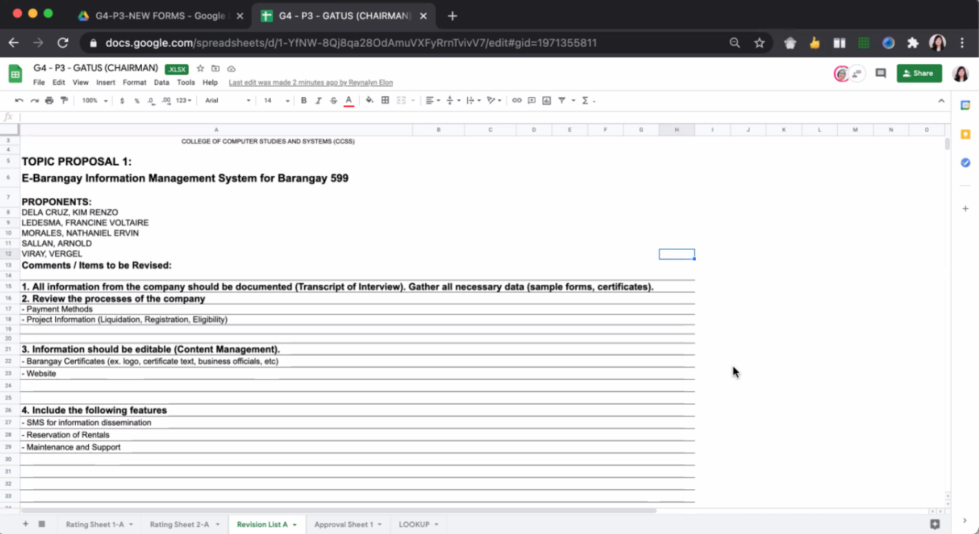

**Revision List**

**APPENDIX E**

Turnitin Similarity Index Result

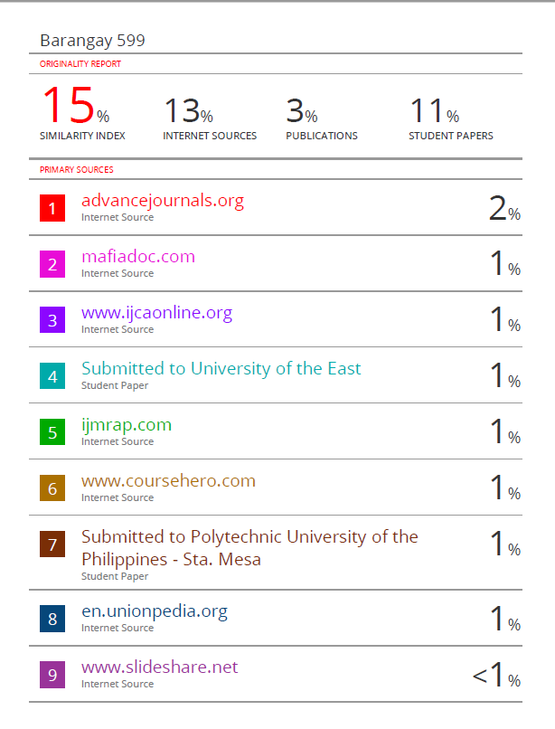

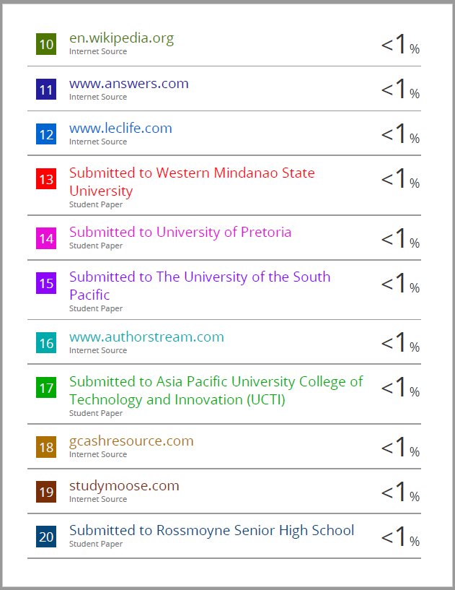

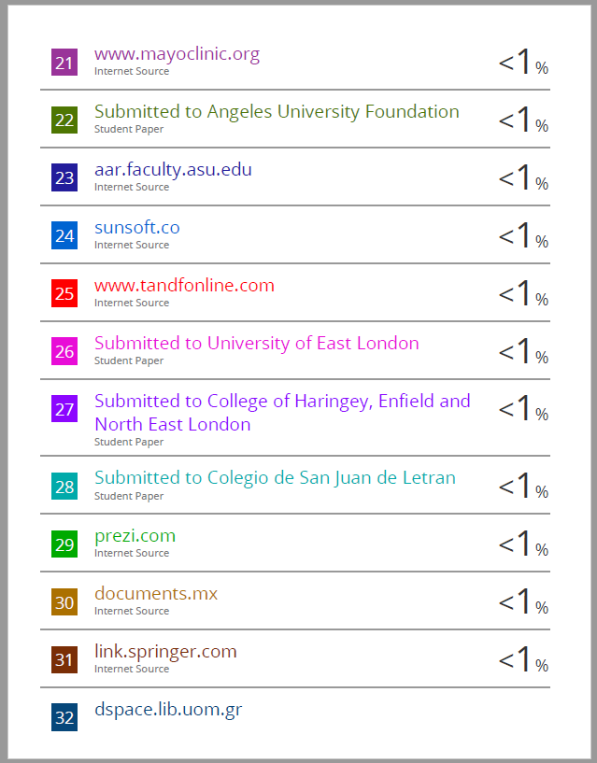





**APPENDIX F**

Screenshots of System Prototype

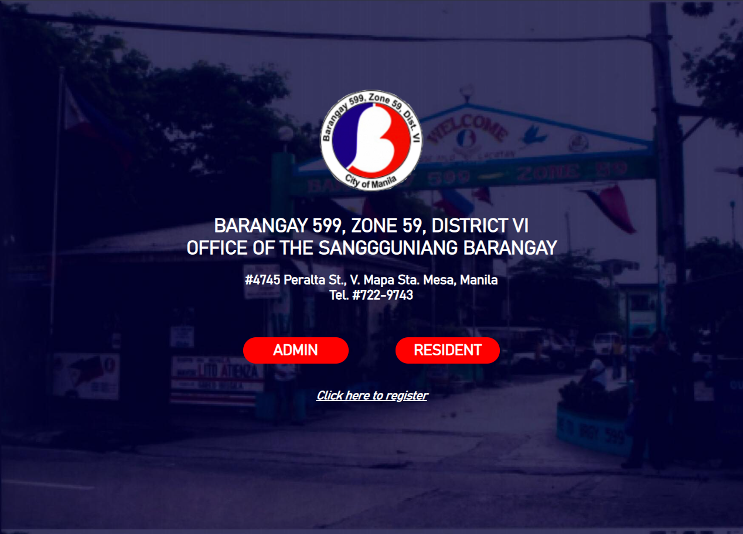

**Homepage of System Prototype**

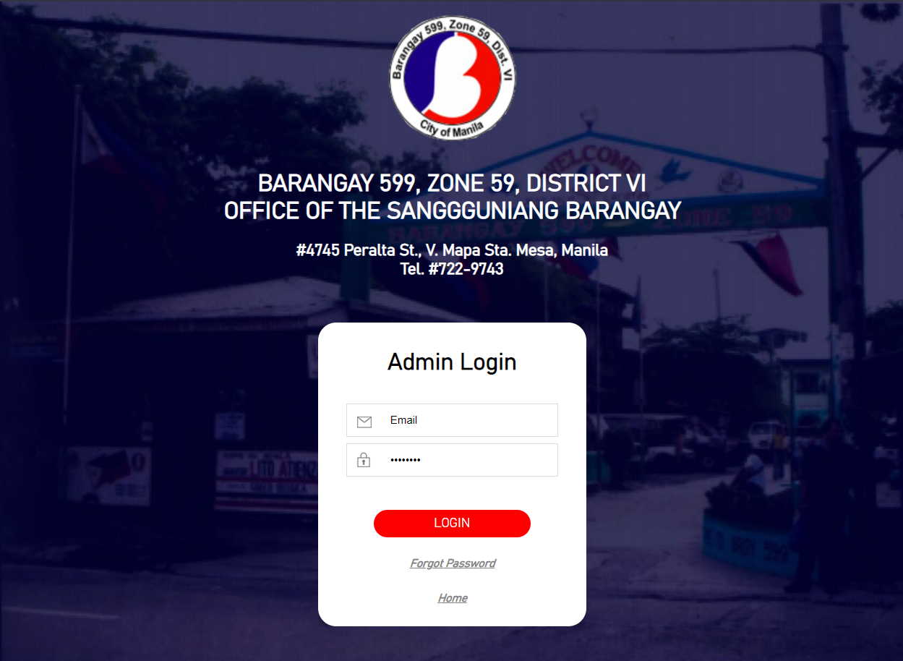

**Admin Login Page**

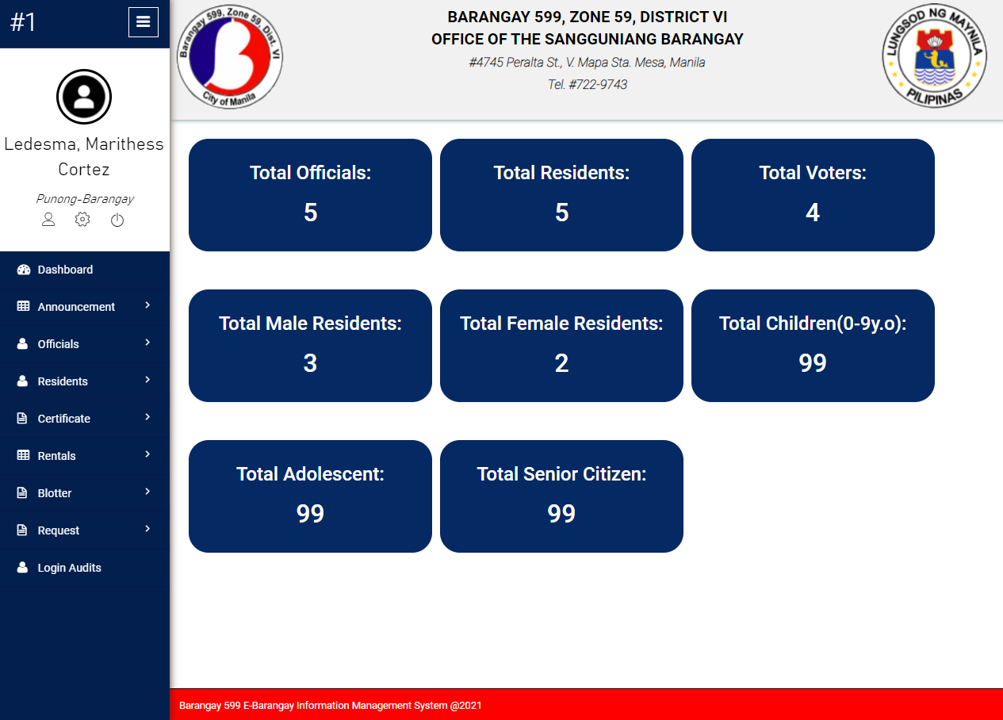

**Dashboard of System Prototype**

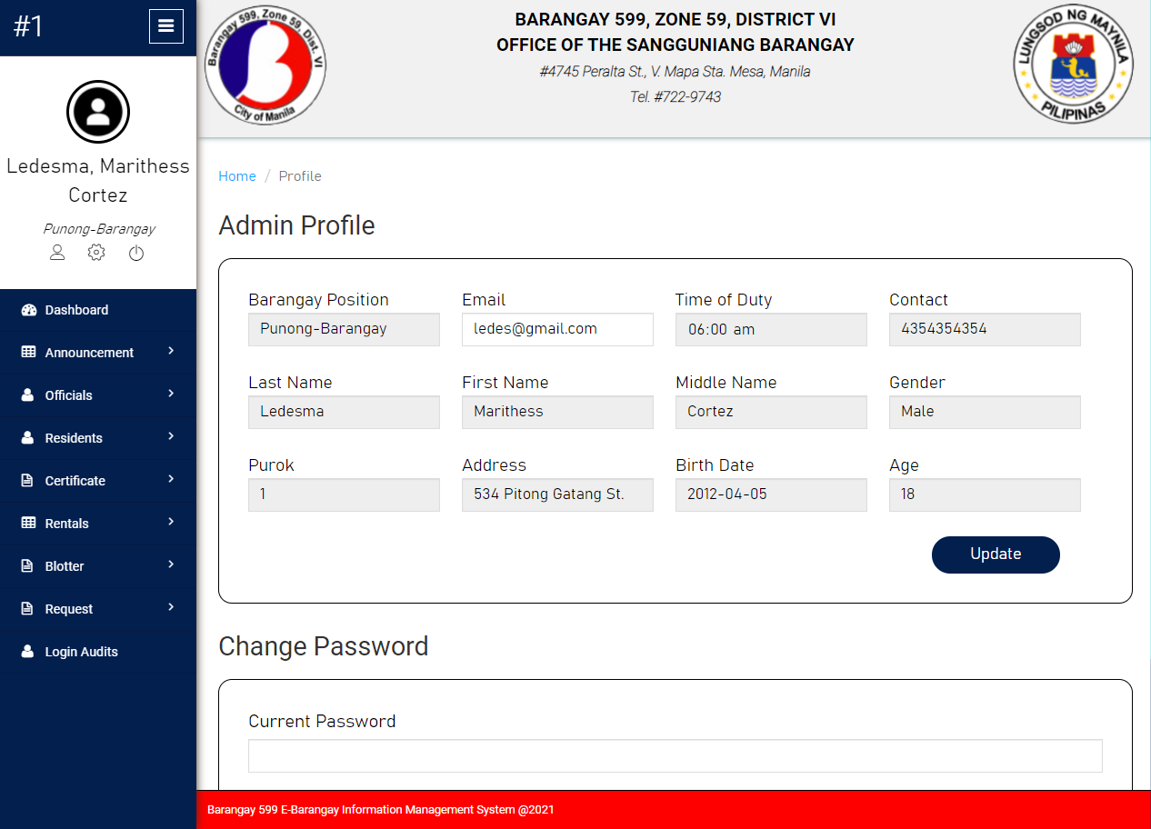

**Admin Profile of System Prototype**

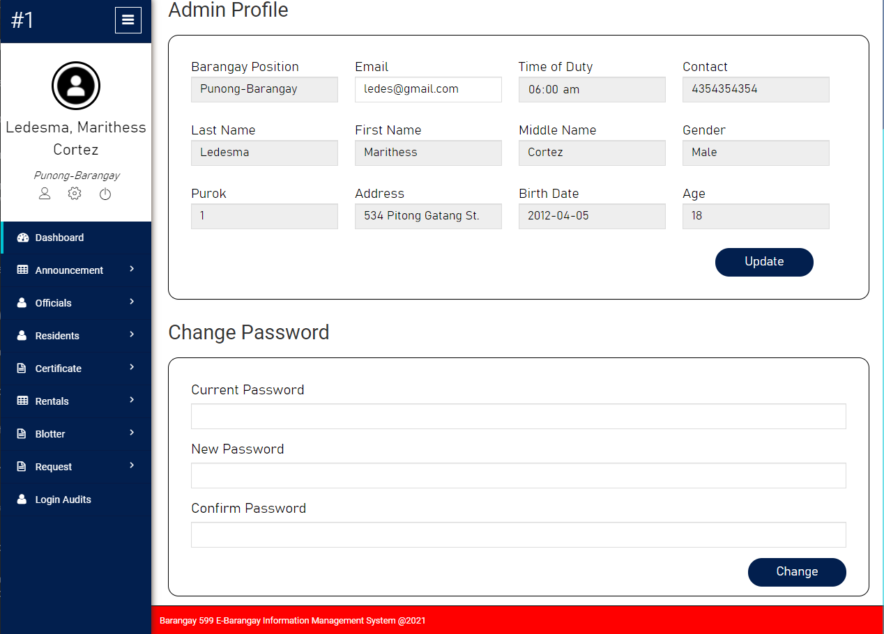

**Admin Profile of System Prototype**

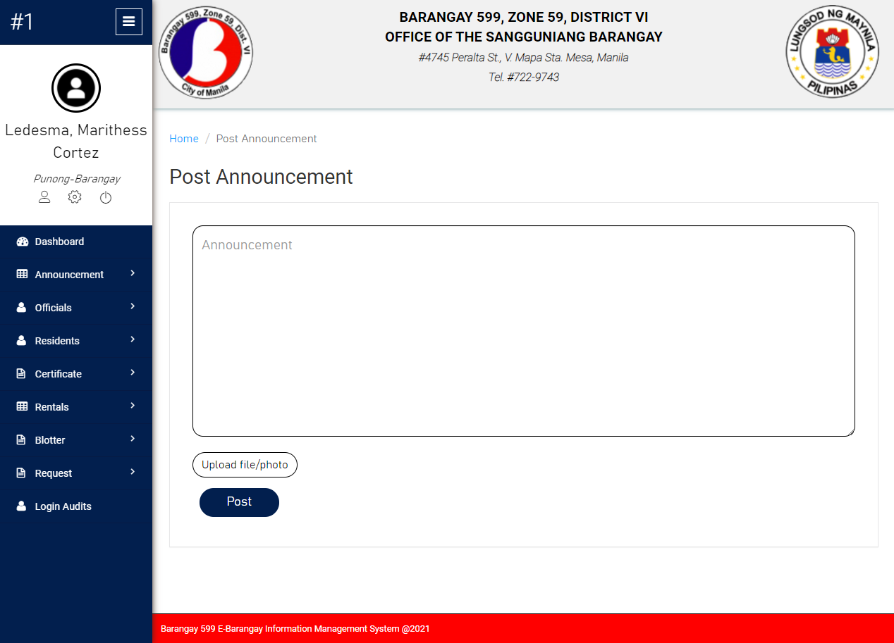

**Announcement Module of System Prototype**

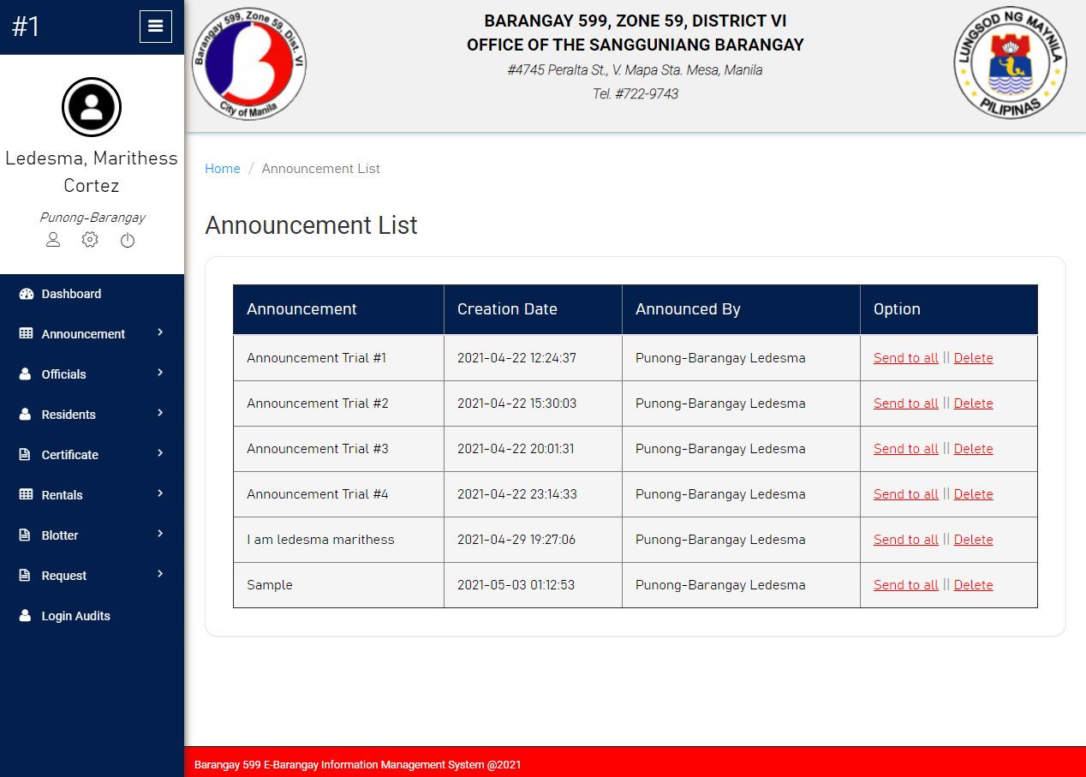

**Announcement List of System Prototype**

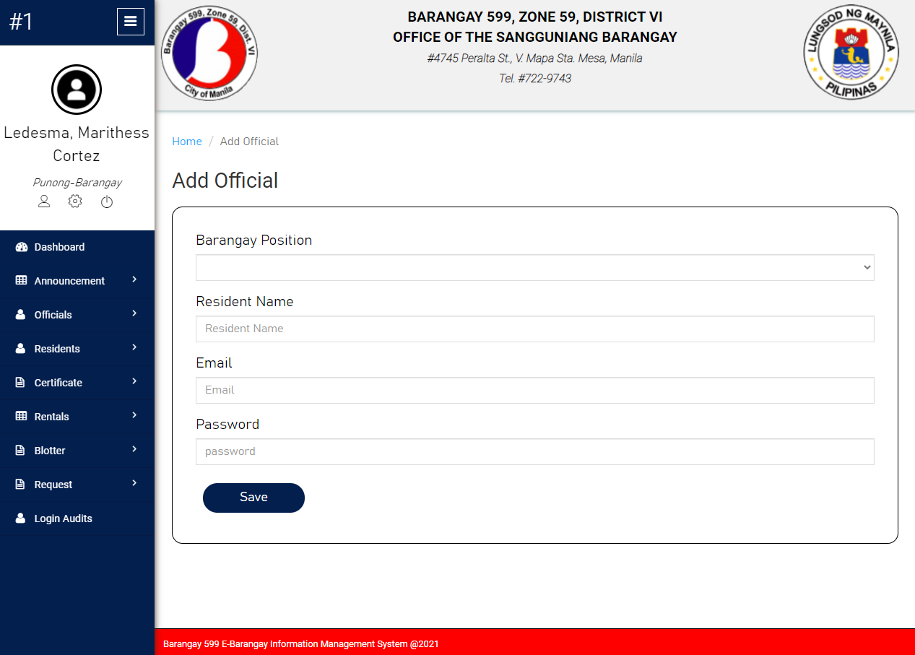

**Add Official Module of System Prototype**

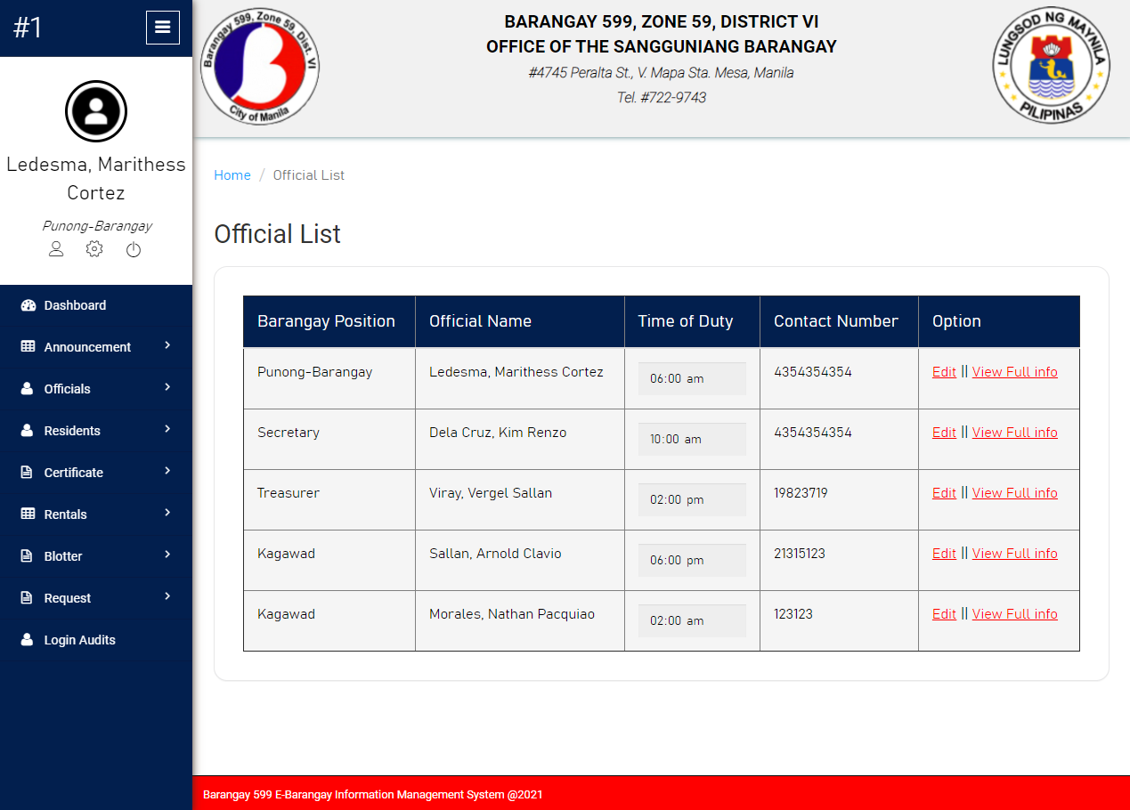

**Official List Module of System Prototype**

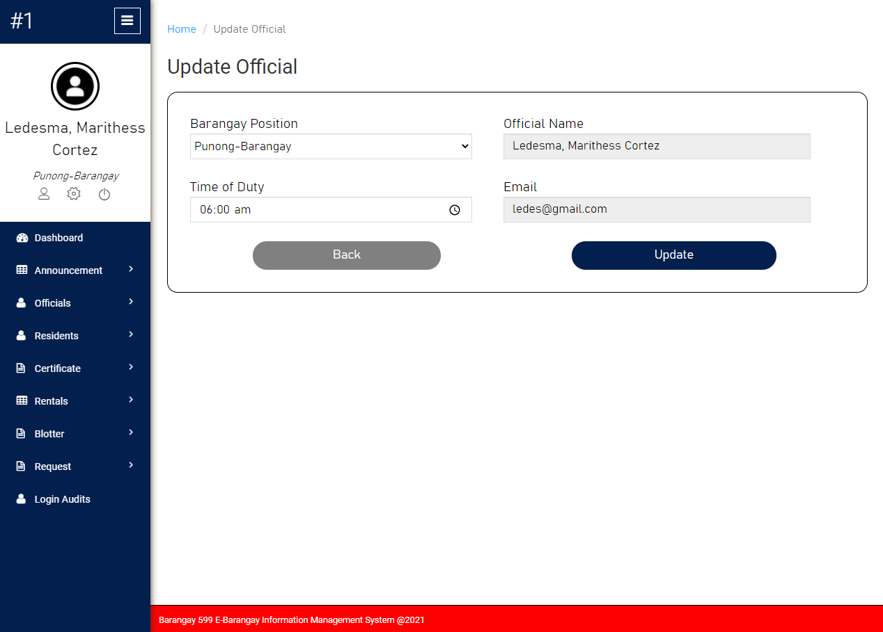

**Update Official Module of System Prototype**

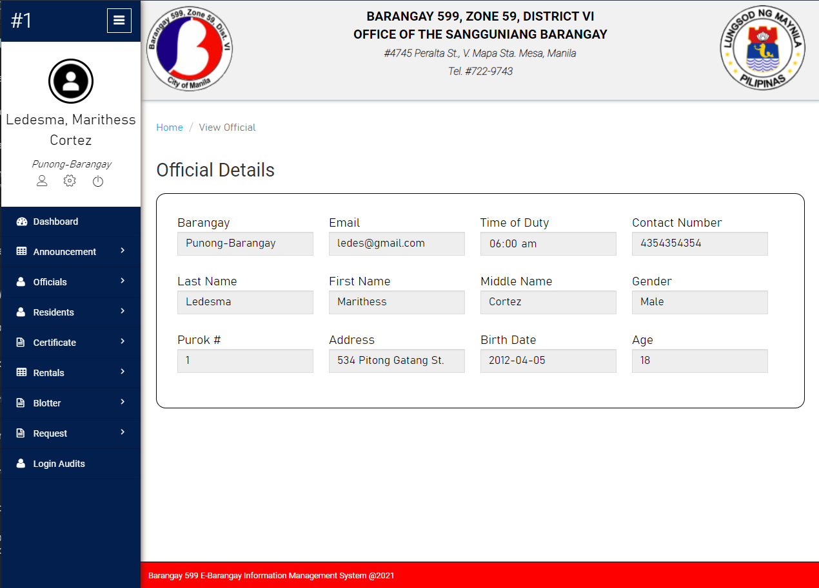

**Official Details Module of System Prototype**

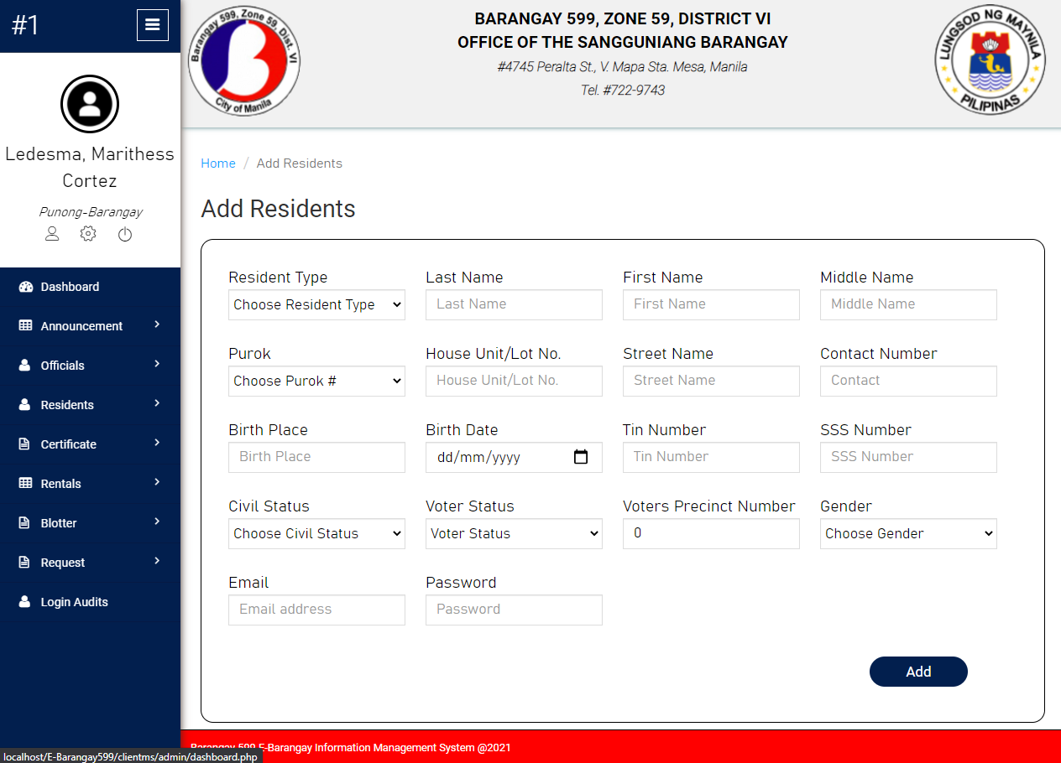

**Add Residents Module of System Prototype**

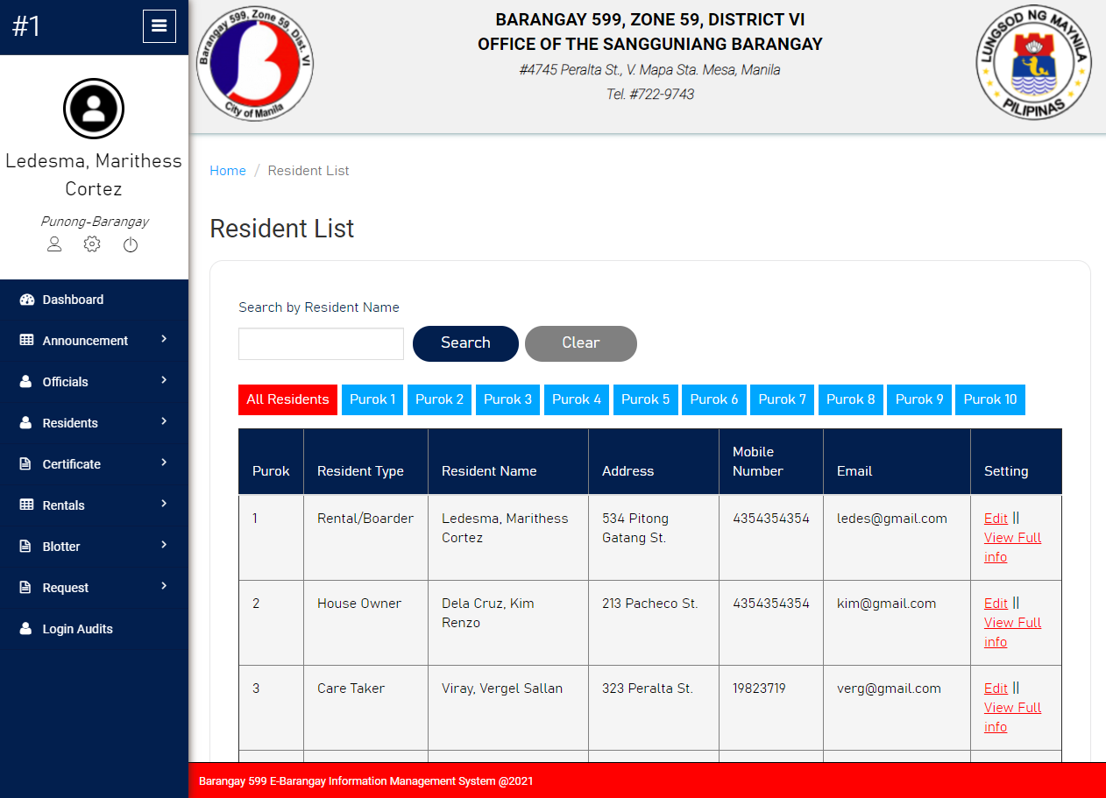

**Resident List Module of System Prototype**

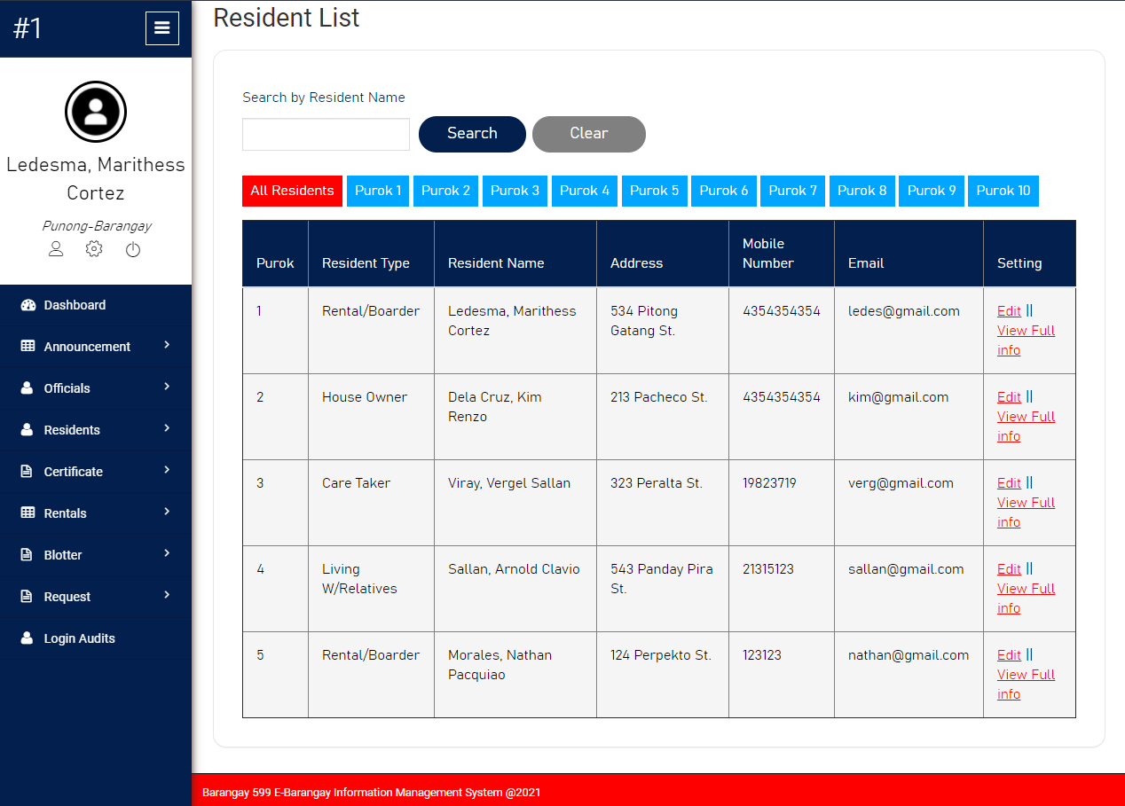

**Resident List Module of System Prototype**

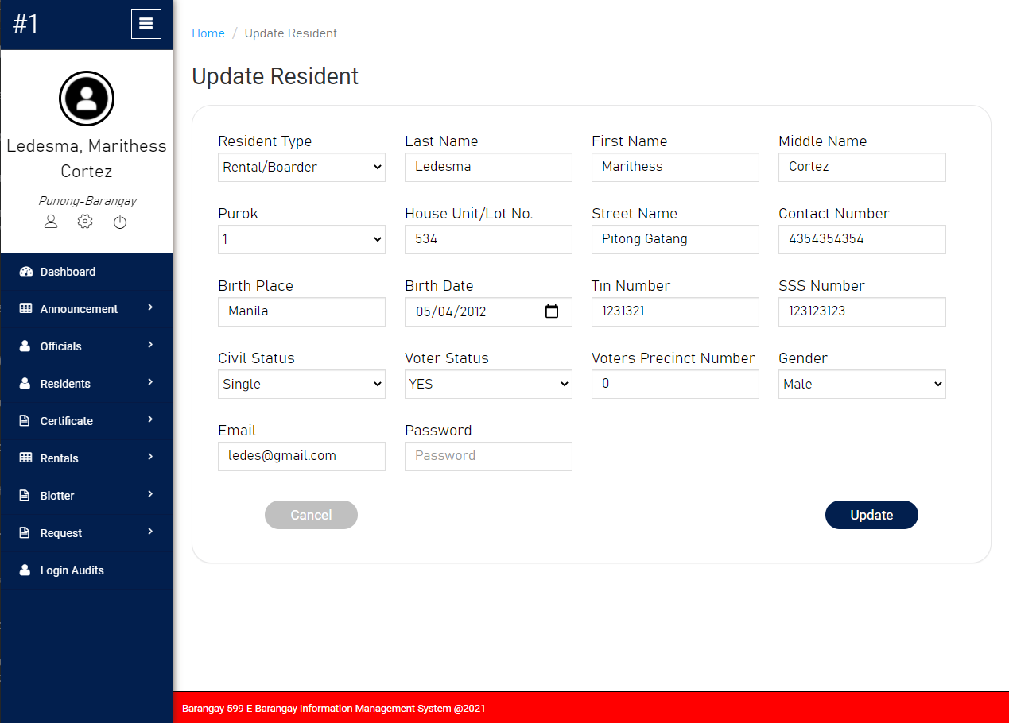

**Update Resident Module of System Prototype**

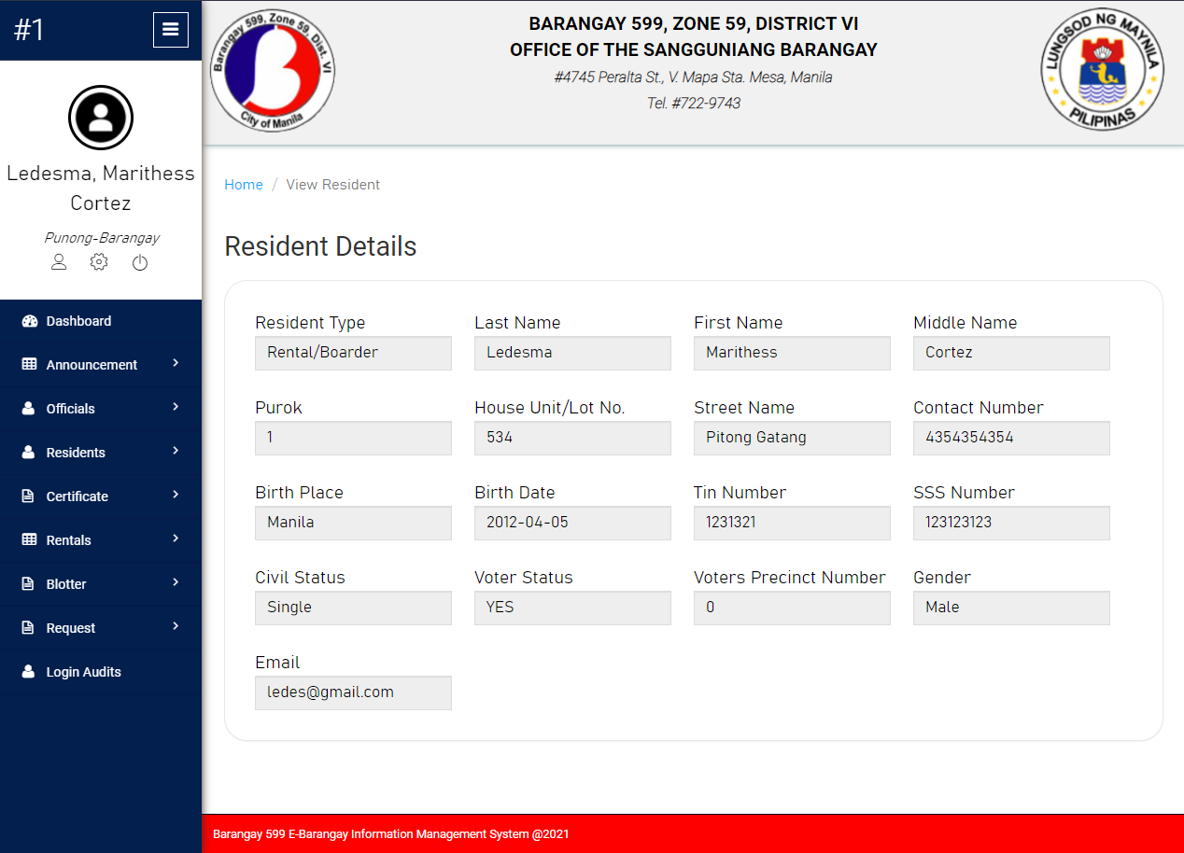

**Resident Details Module of System Prototype**

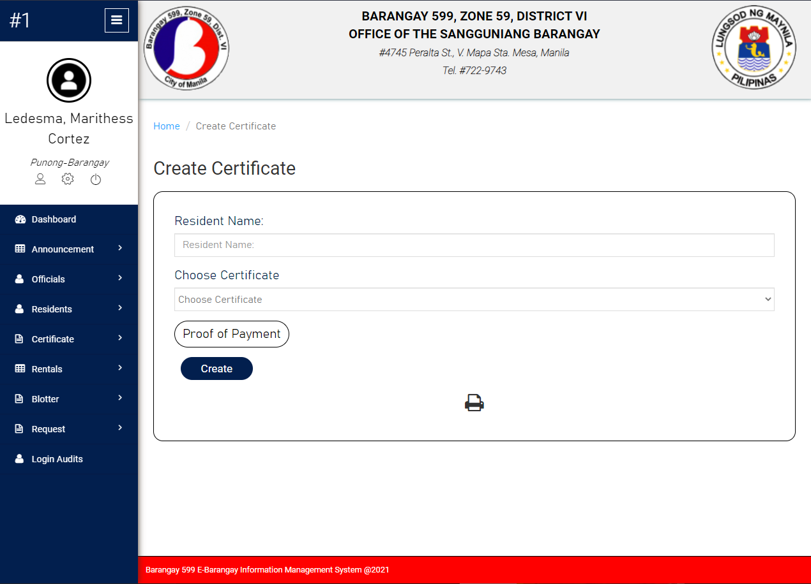

**Create Certificate Module of System Prototype**

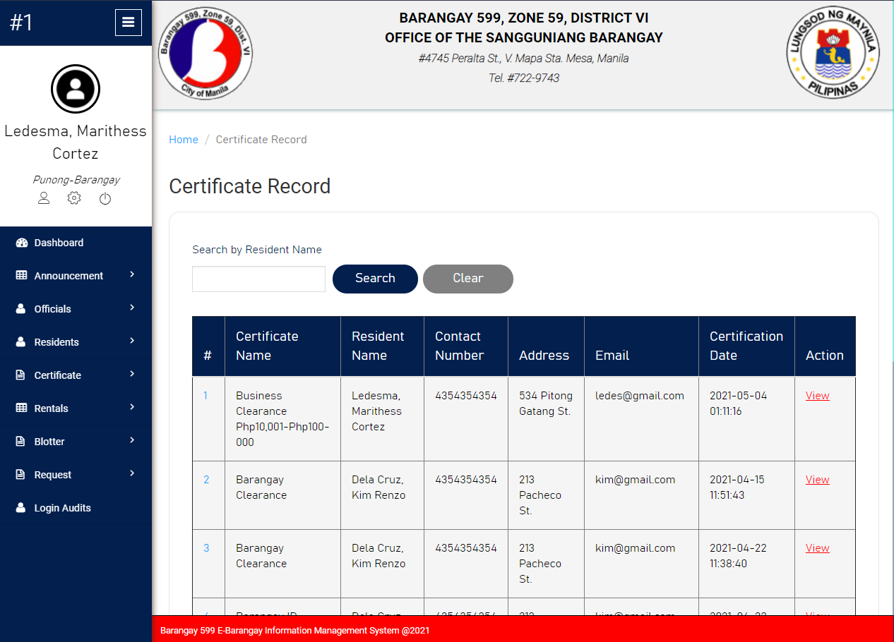

**Certificate Record Module of System Prototype**

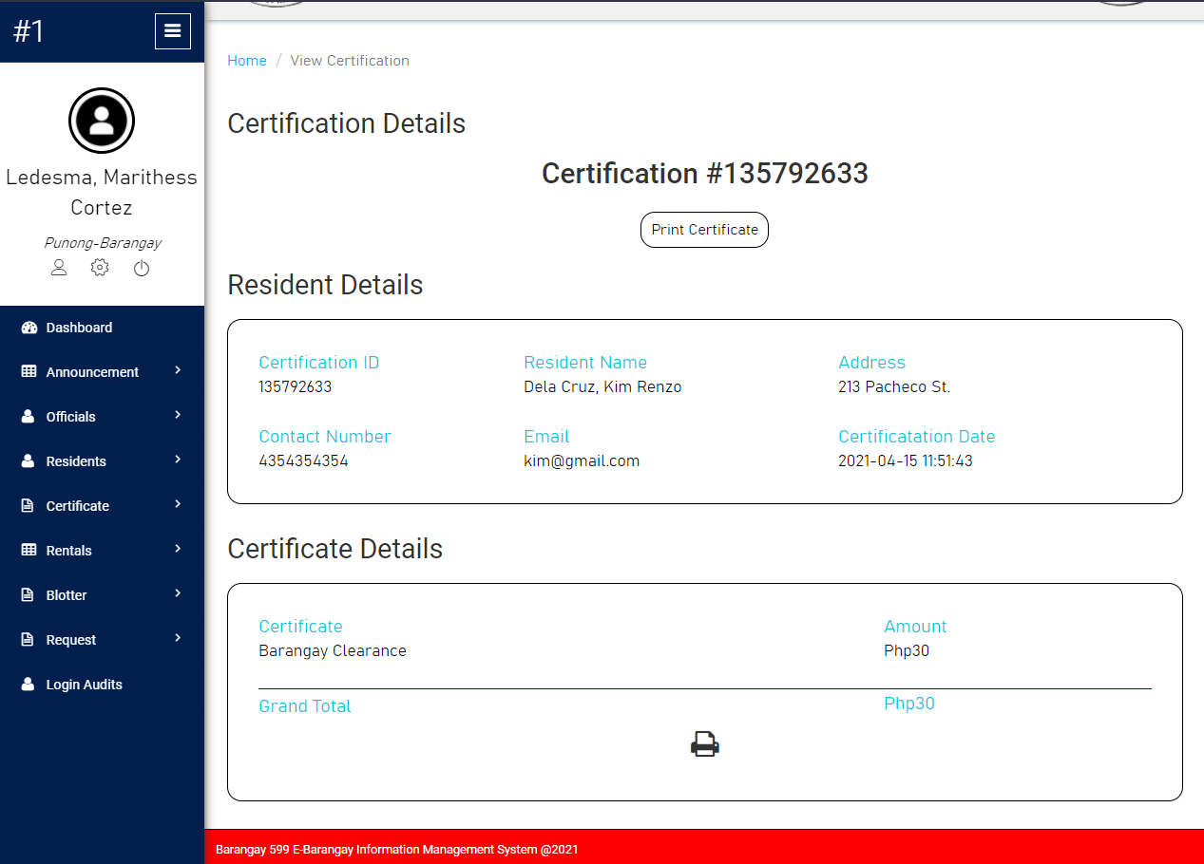

**Certification Details Module of System Prototype**

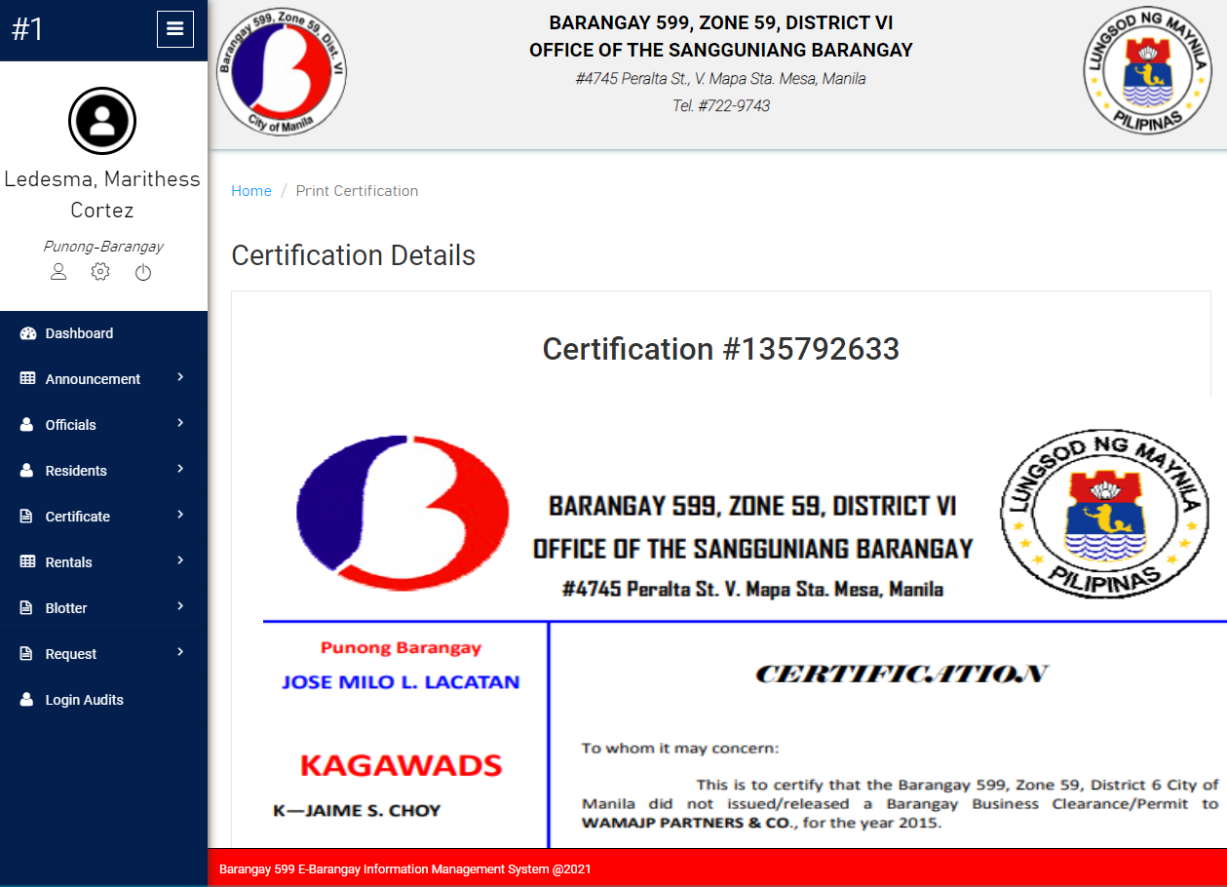

**Printable Certification Module of System Prototype**

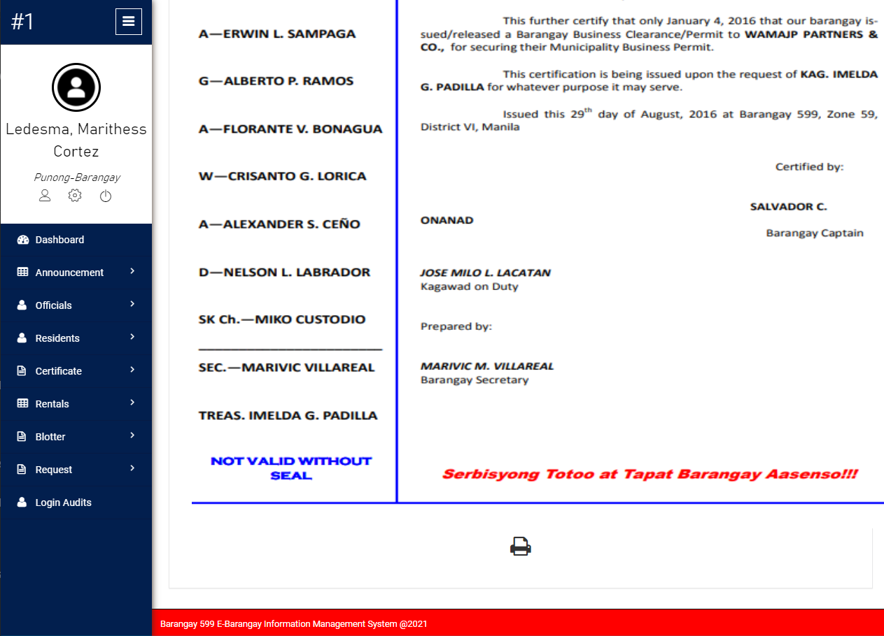

**Printable Certification Module of System Prototype**

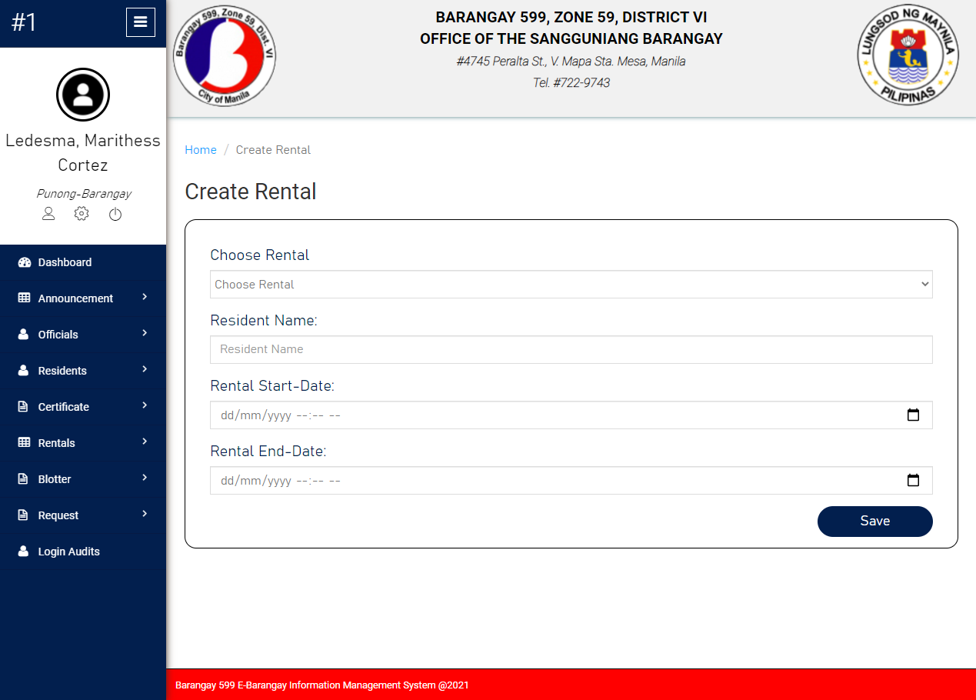

**Create Rental Module of System Prototype**

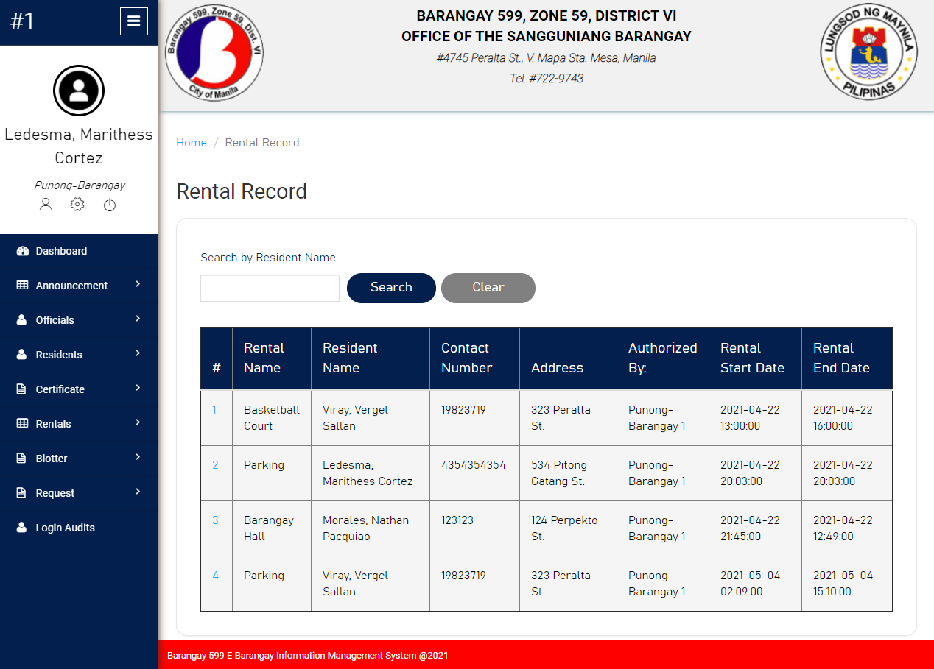

**Rental Record Module of System Prototype**

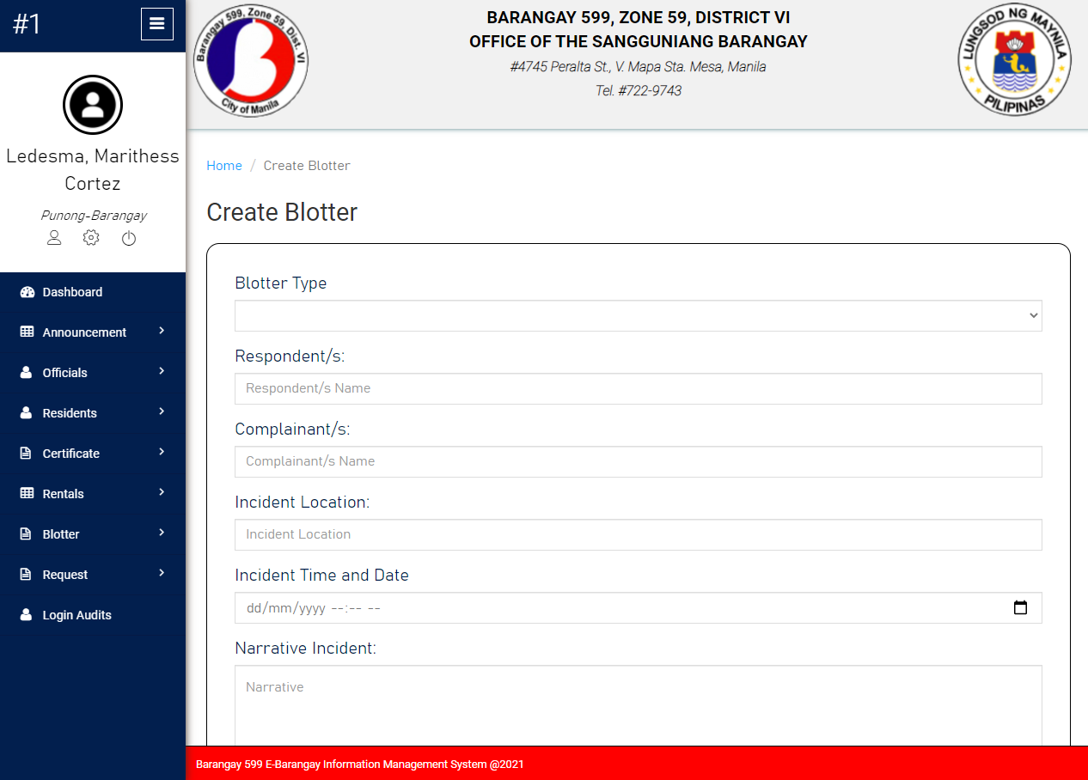

**Create Blotter Module of System Prototype**

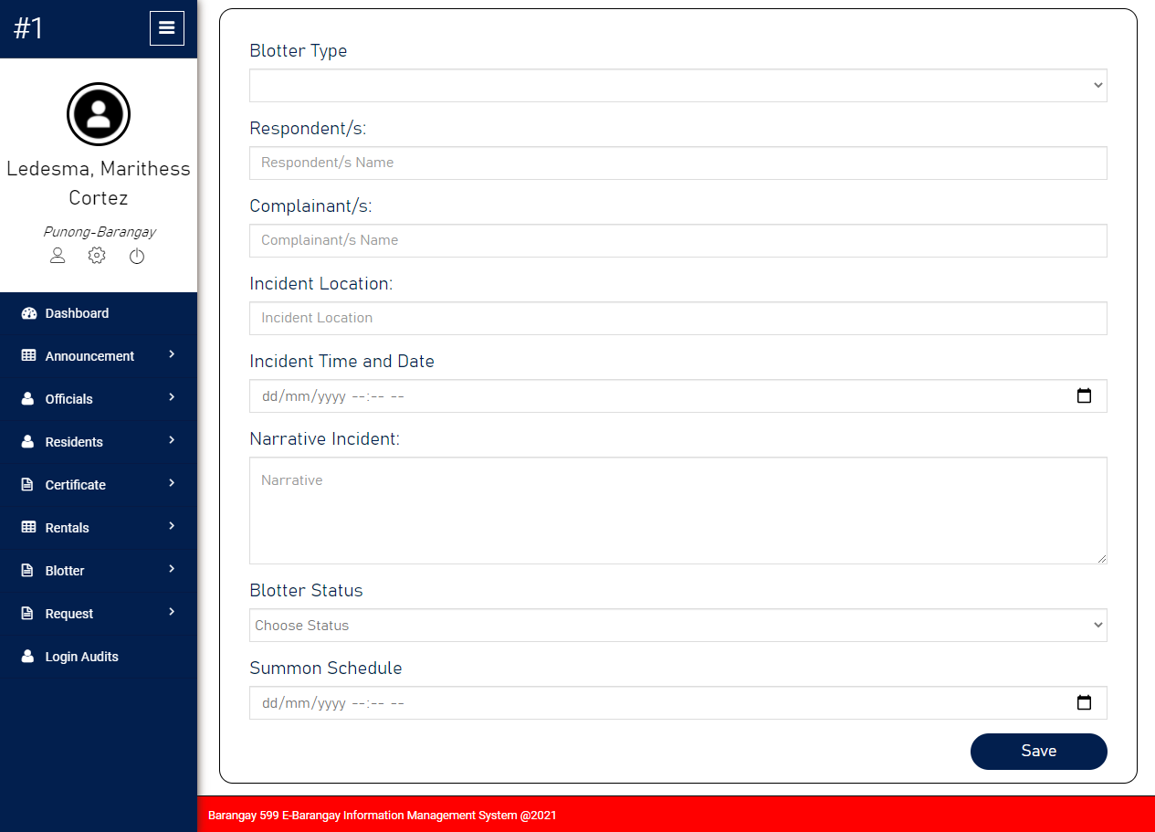

**Create Blotter Module of System Prototype**

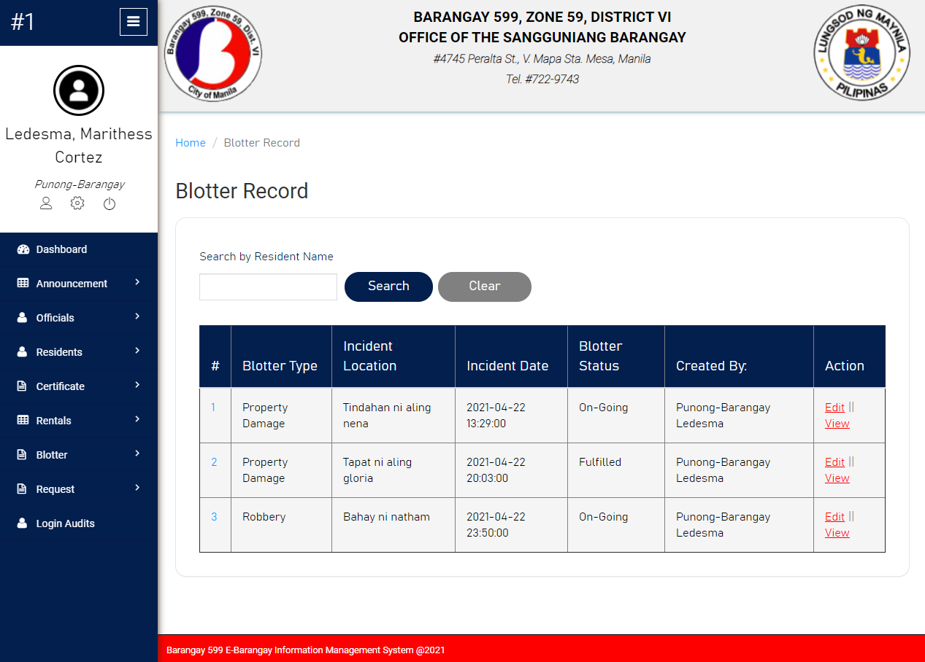

**Blotter Record Module of System Prototype**

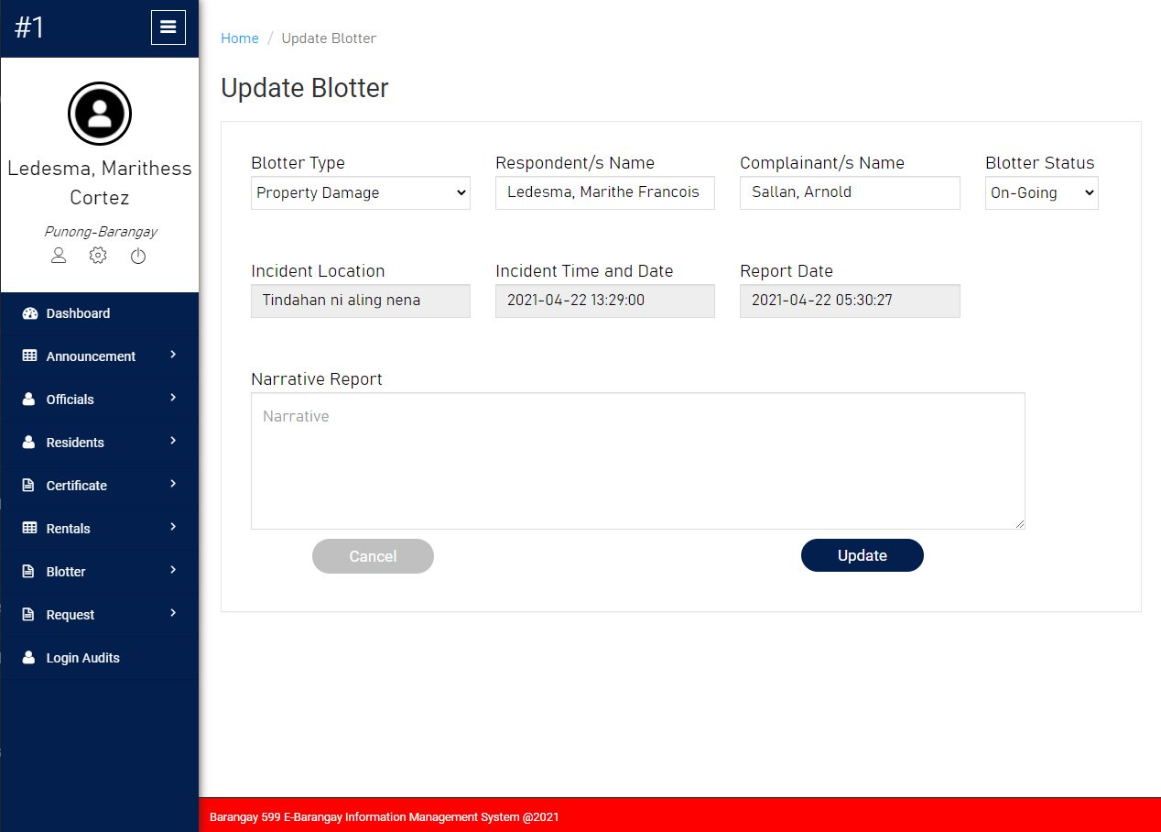

**Update Blotter Module of System Prototype**

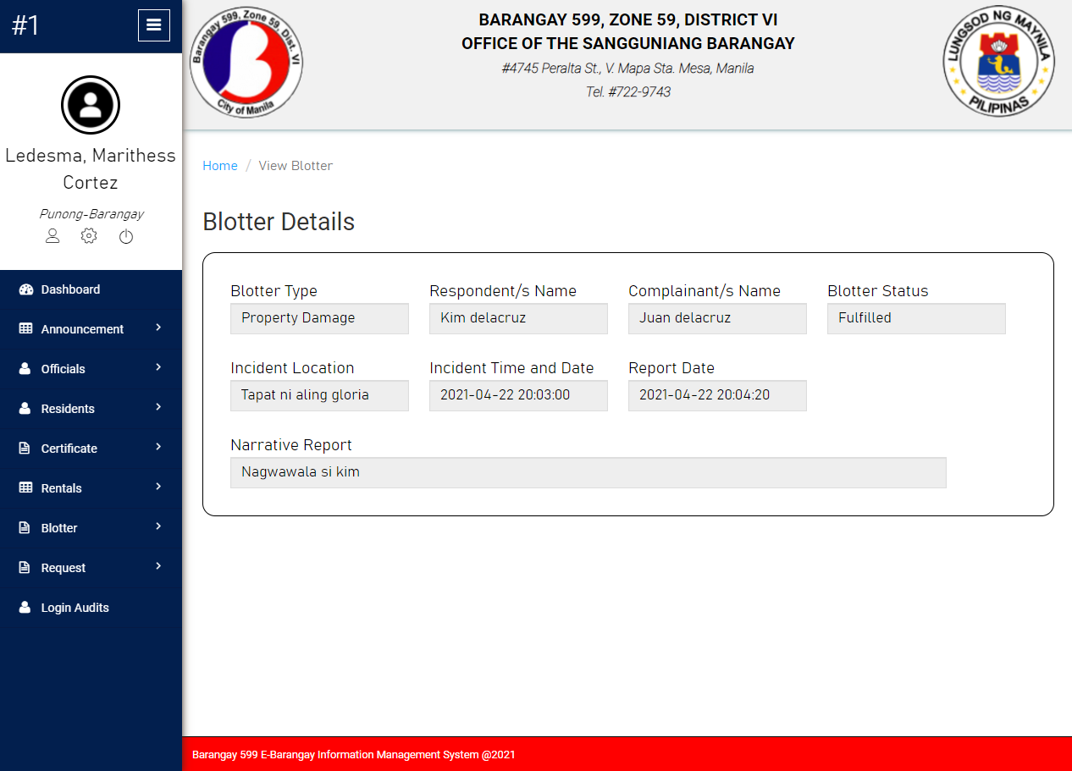

**Blotter Details Module of System Prototype**

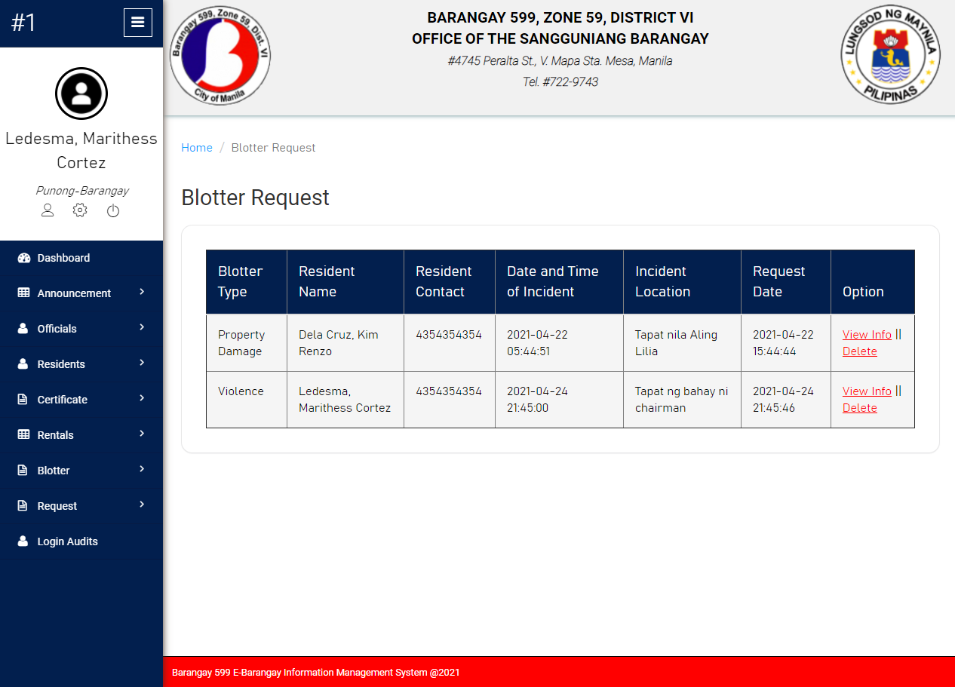

**Blotter Request List Module of System Prototype**

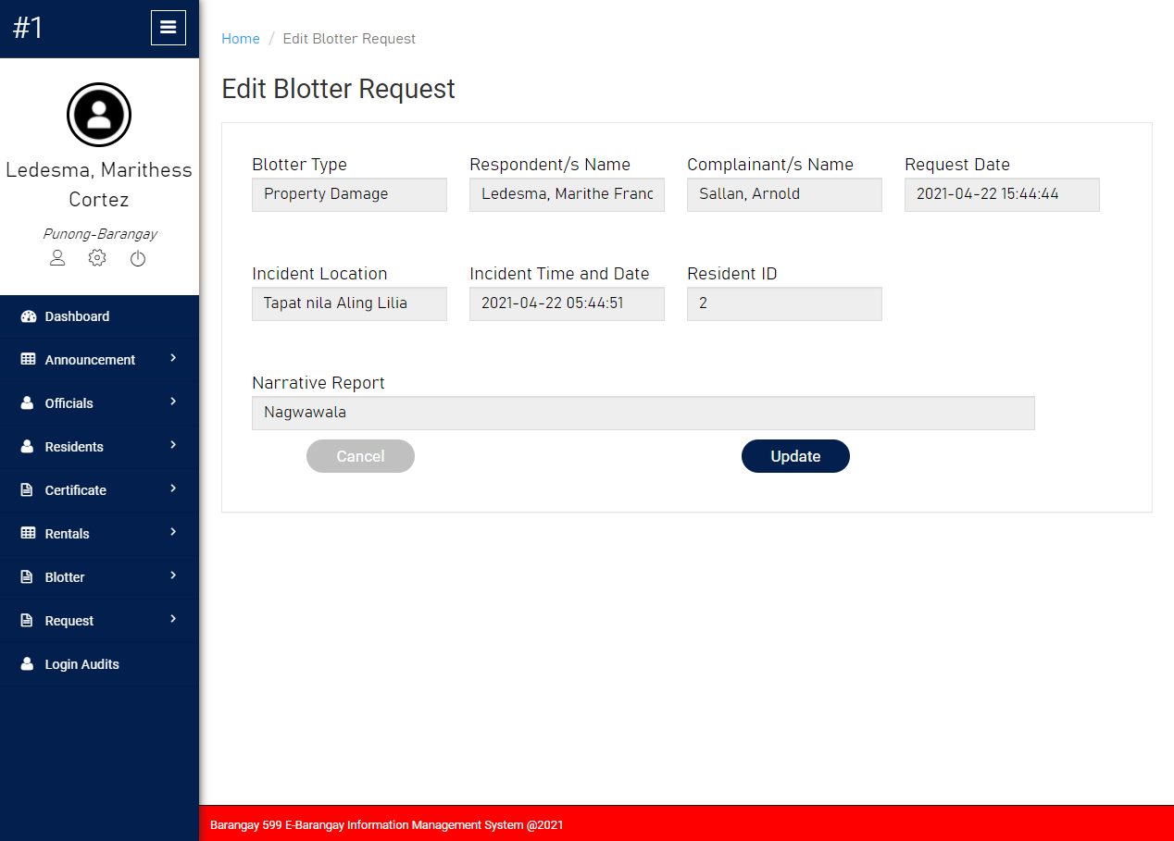

**Edit Blotter Request Module of System Prototype**

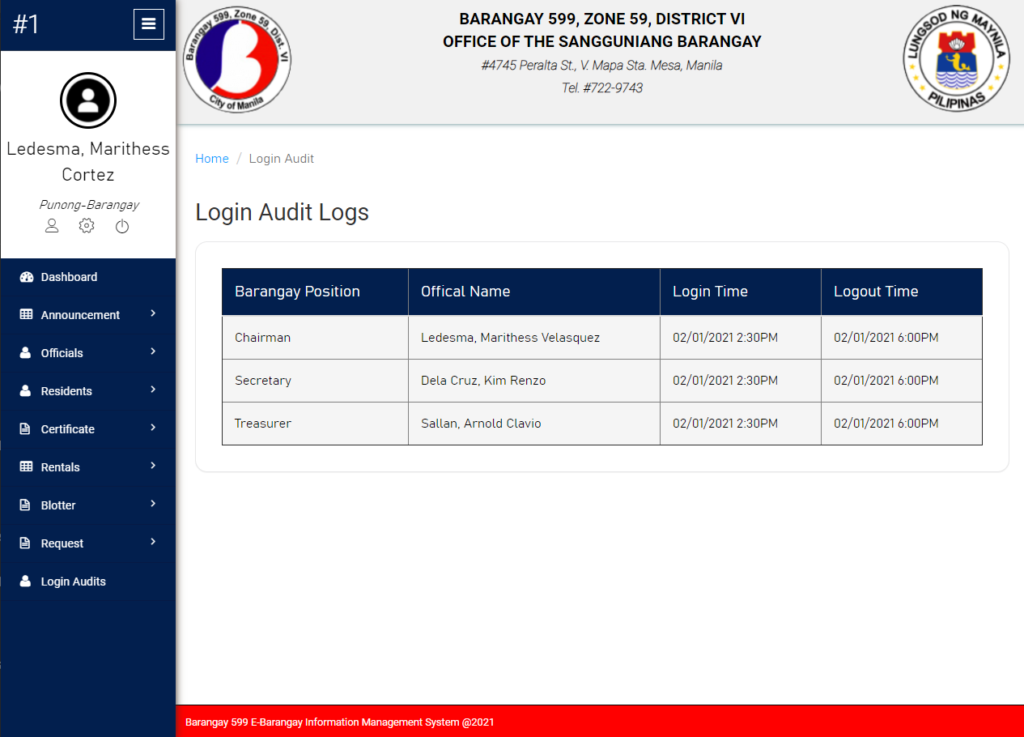

**Login Audit Logs of System Prototype**

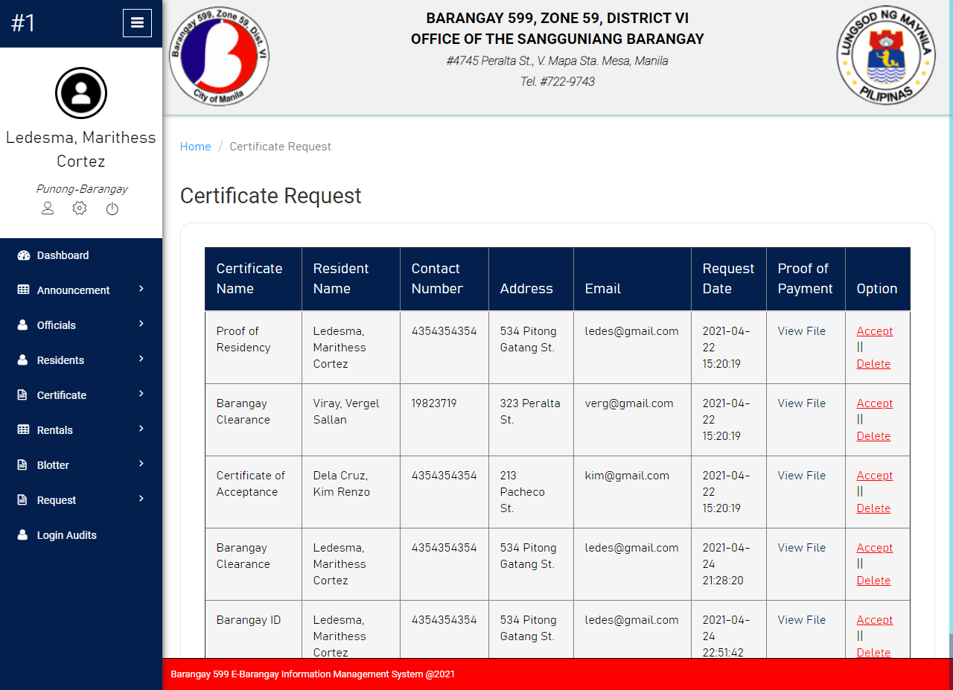

**Certificate Request List Module of System Prototype**

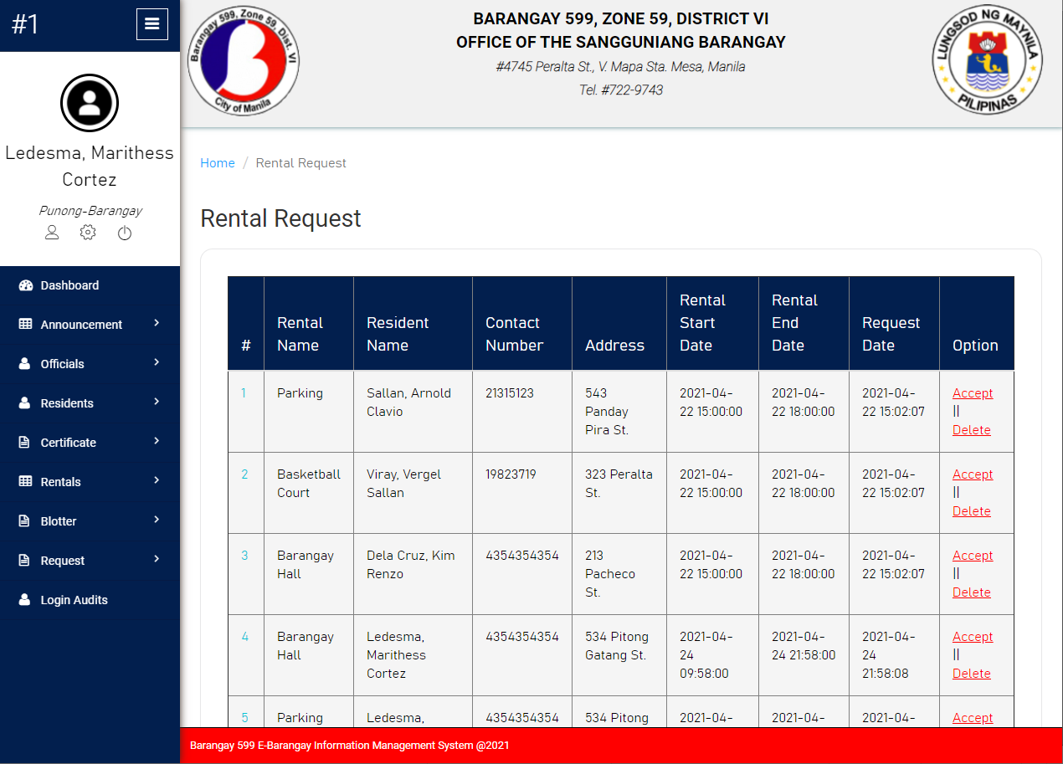

**Rental Request List Module of System Prototype**

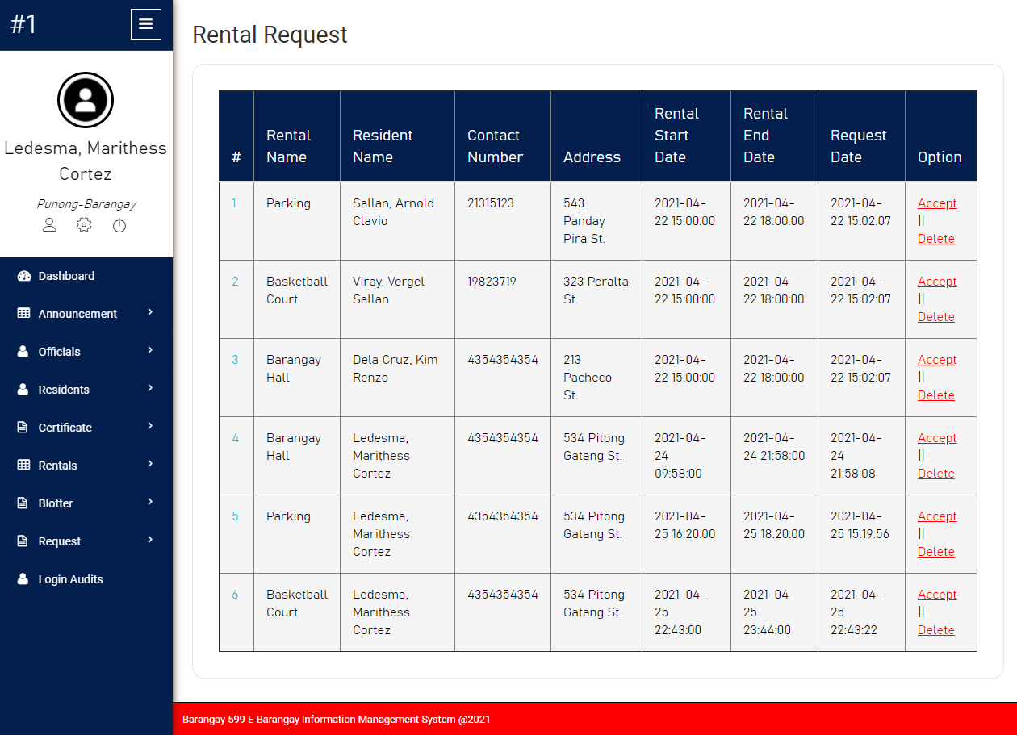

**Rental Request List Module of System Prototype**

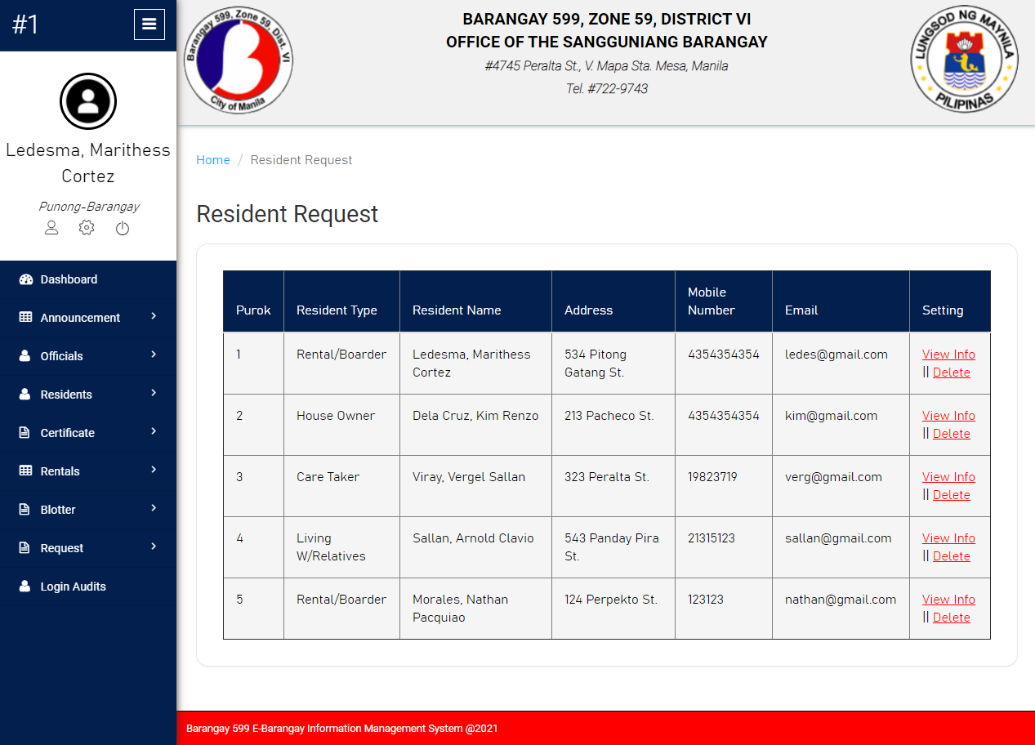

**Resident Request List of System Prototype**

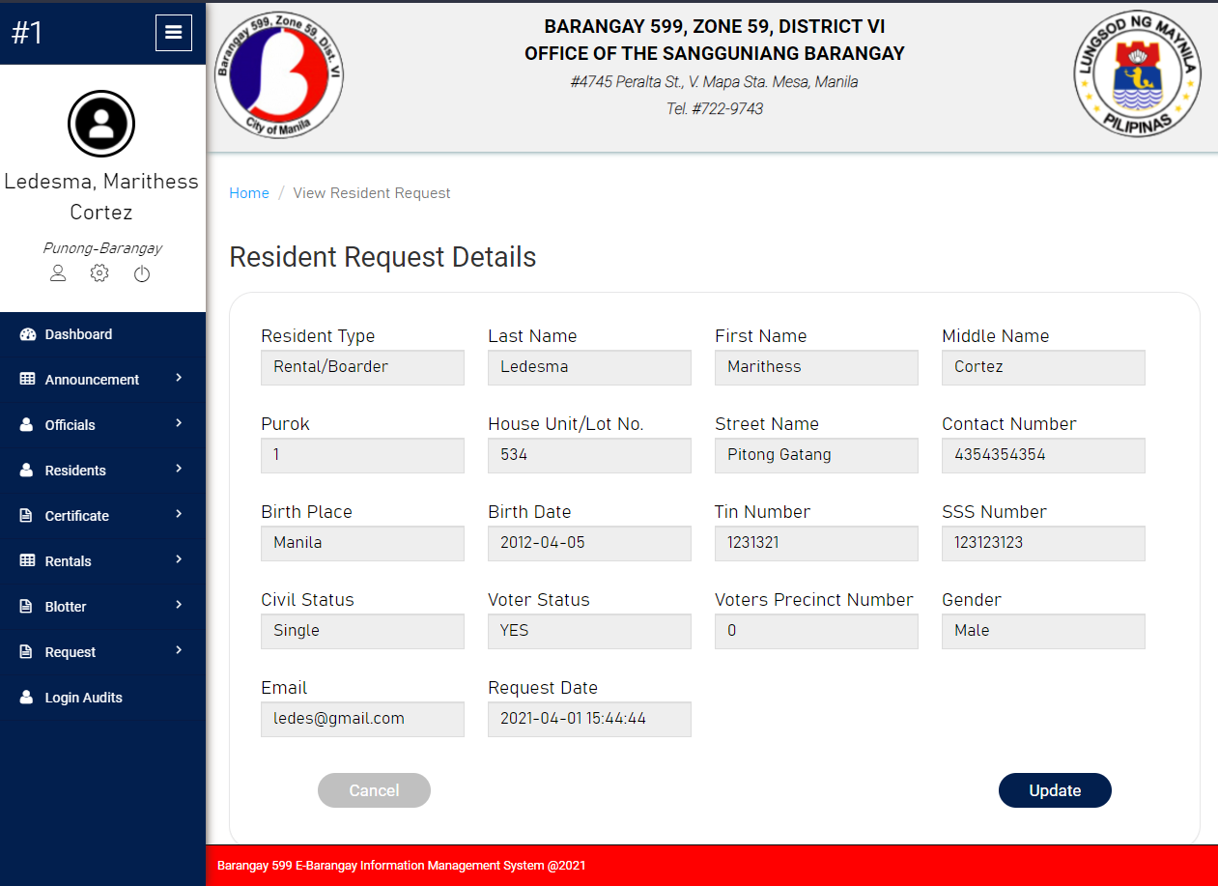

**Resident Request Details Module of System Prototype**

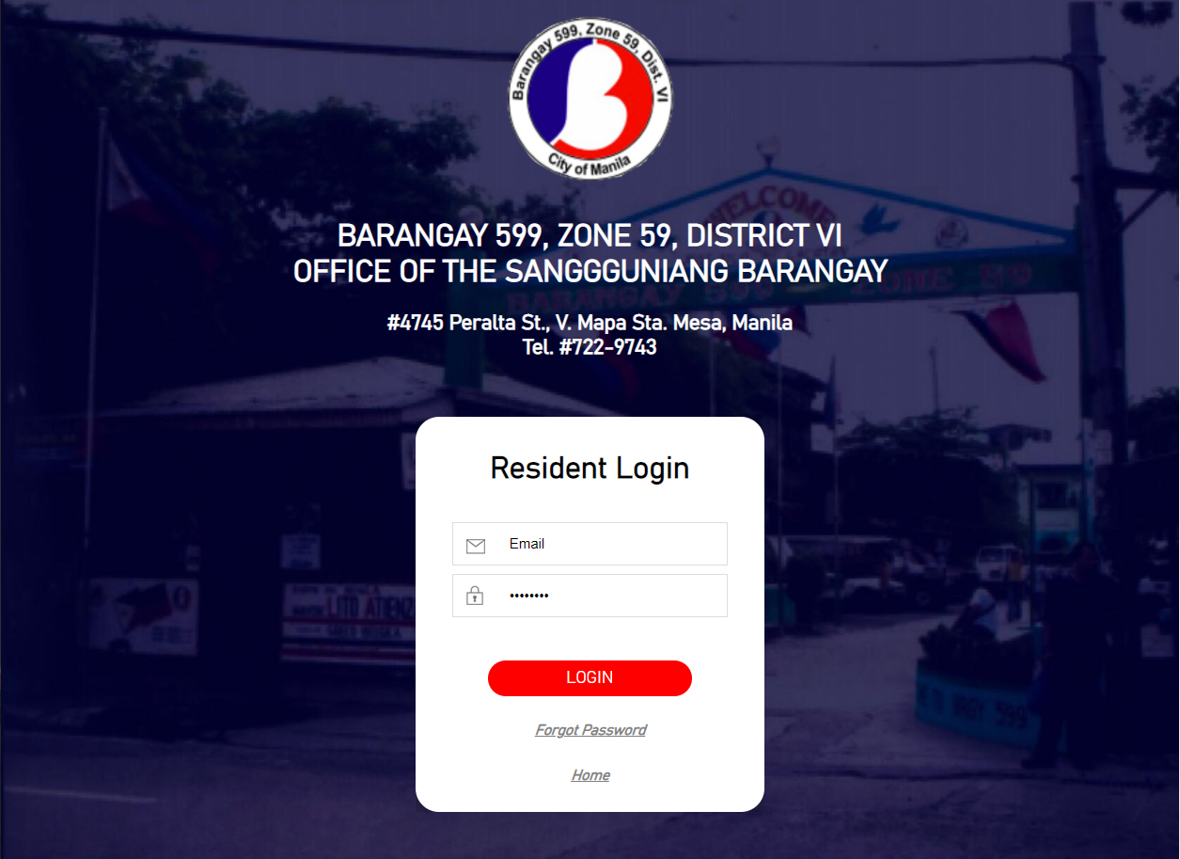

**Resident Login Module of System Prototype**

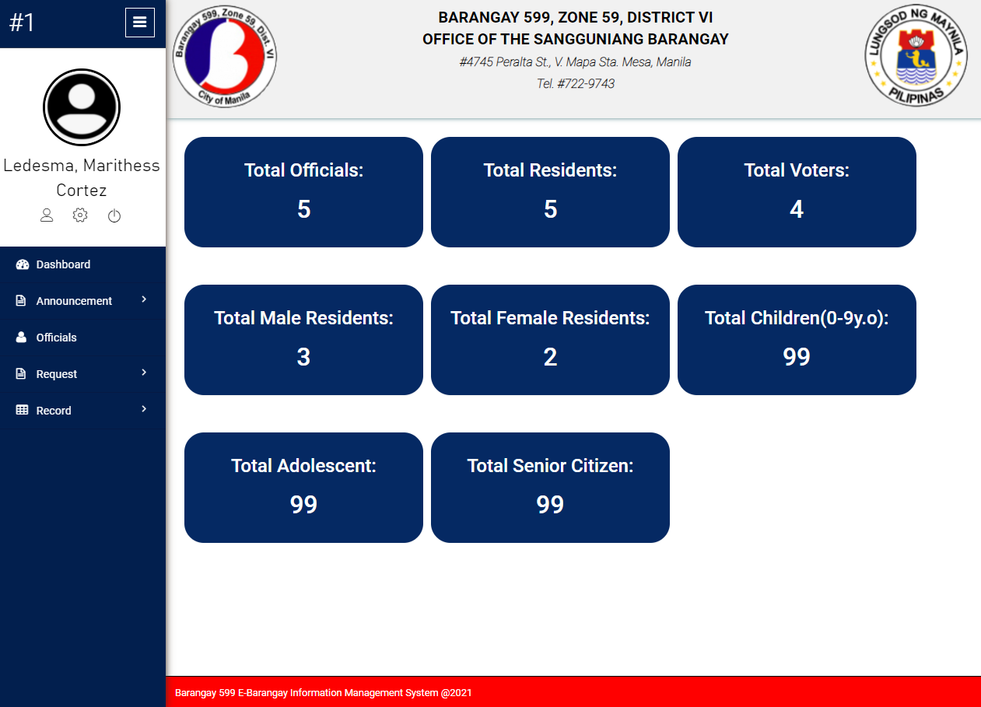

**Resident Dashboard Module of System Prototype**

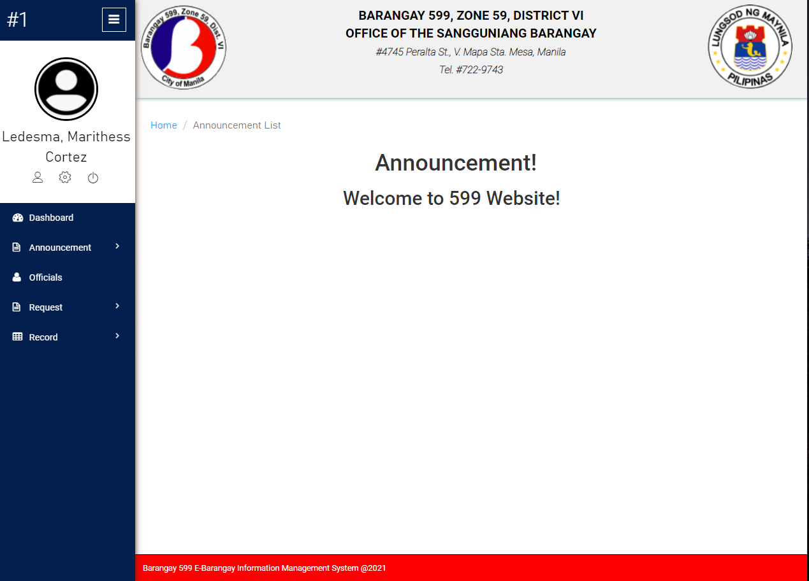

**Resident Announcement Module of System Prototype**

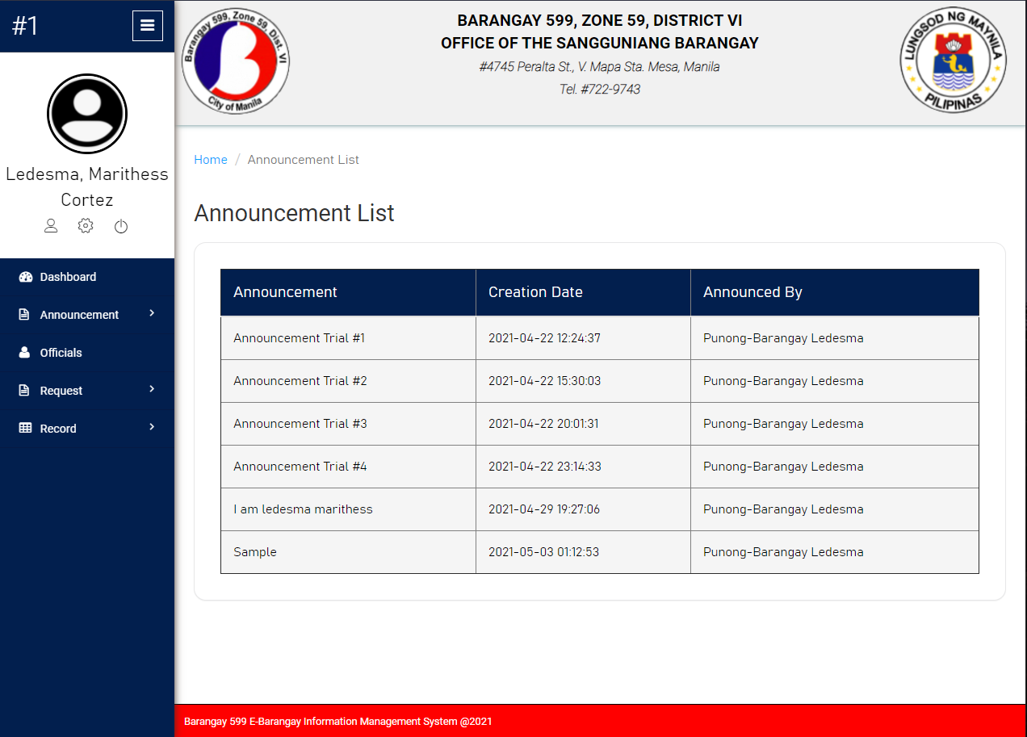

**Resident Announcement List Module of System Prototype**

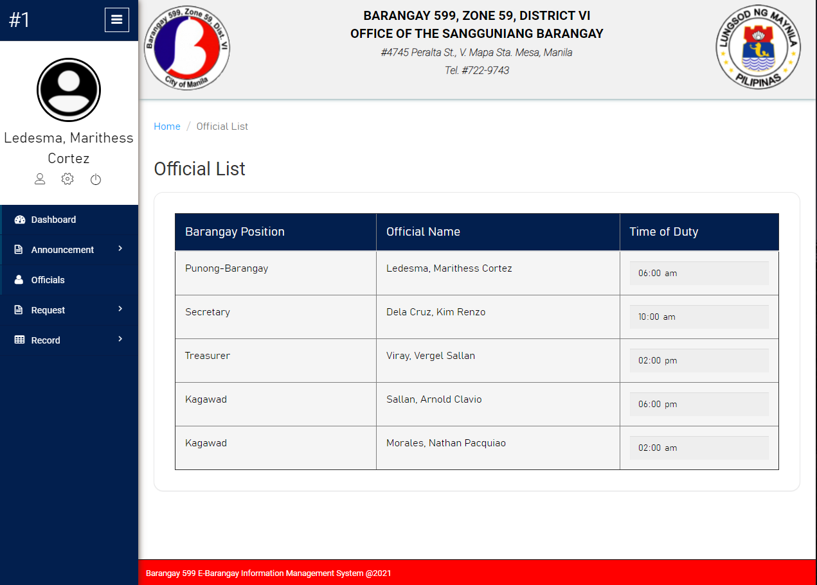

**Roster of Officials of System Prototype**

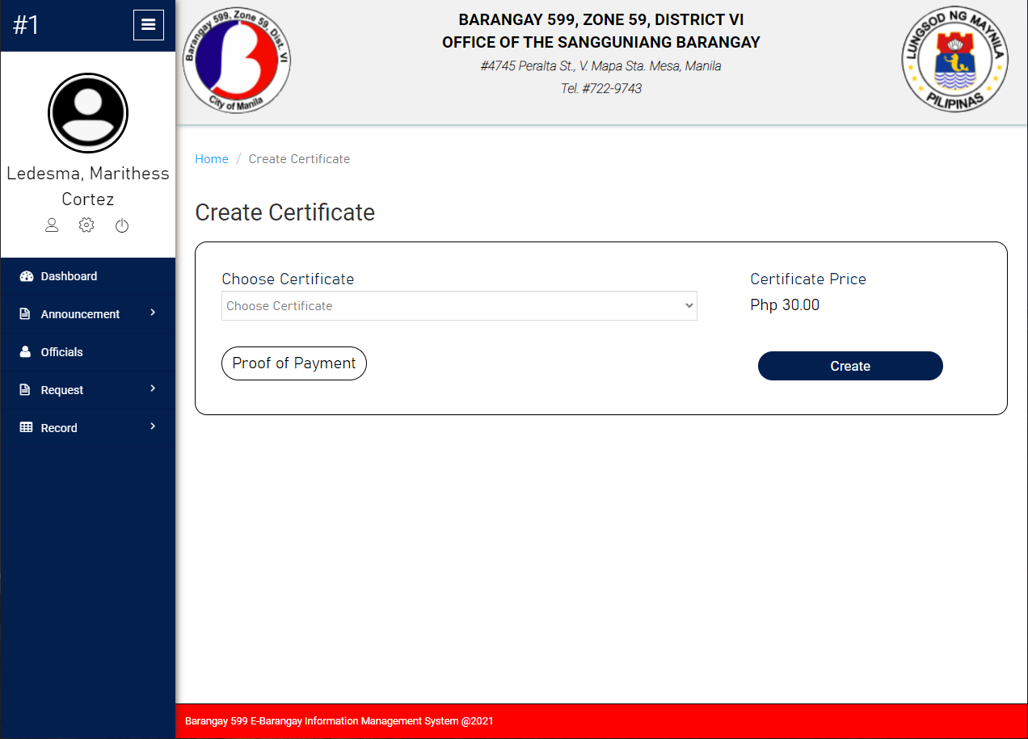

**Create Certificate Resident Side of System Prototype**

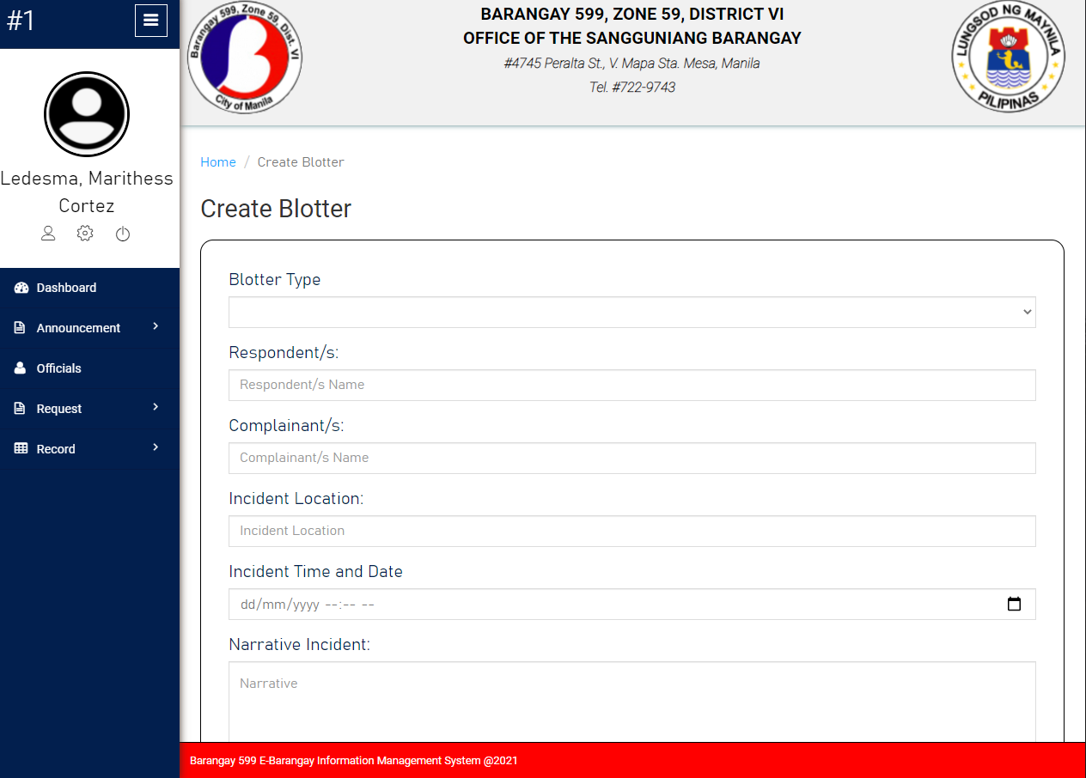

**Create Blotter Resident Side of System Prototype**

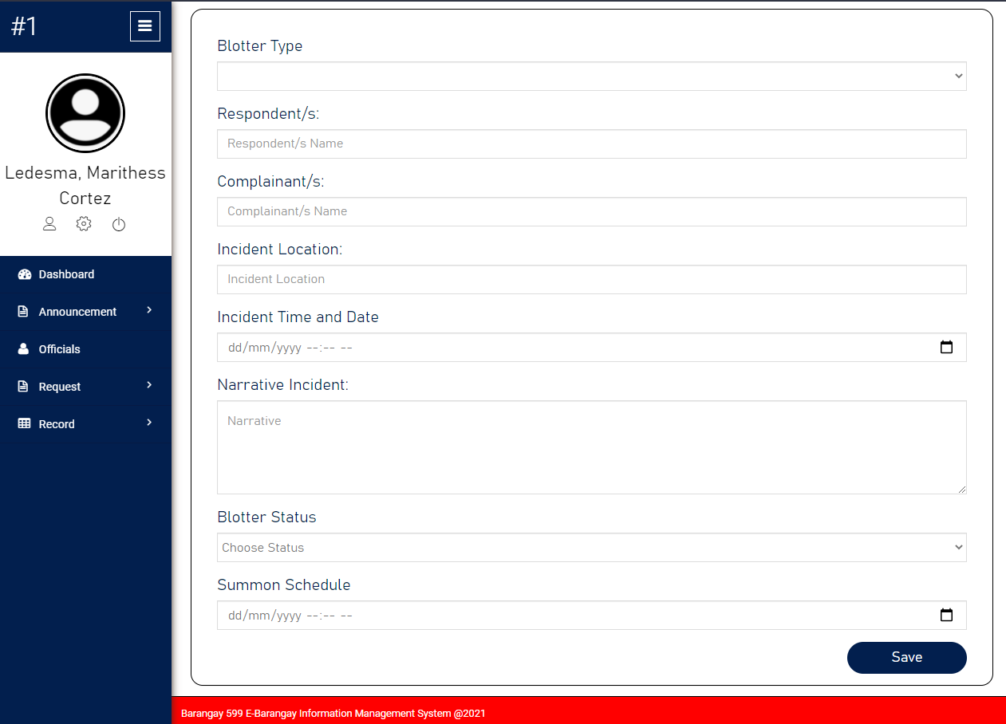

**Create Blotter Resident Side of System Prototype**

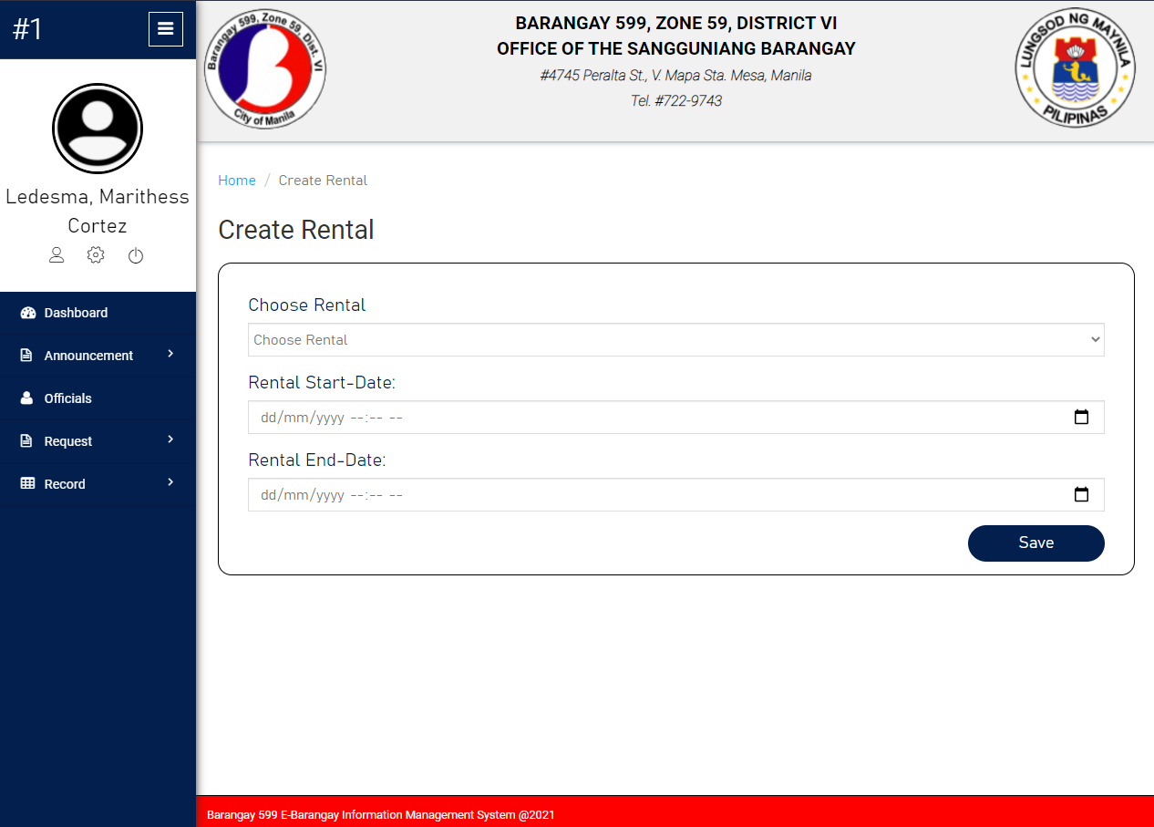

**Create Rental Resident Side of System Prototype**

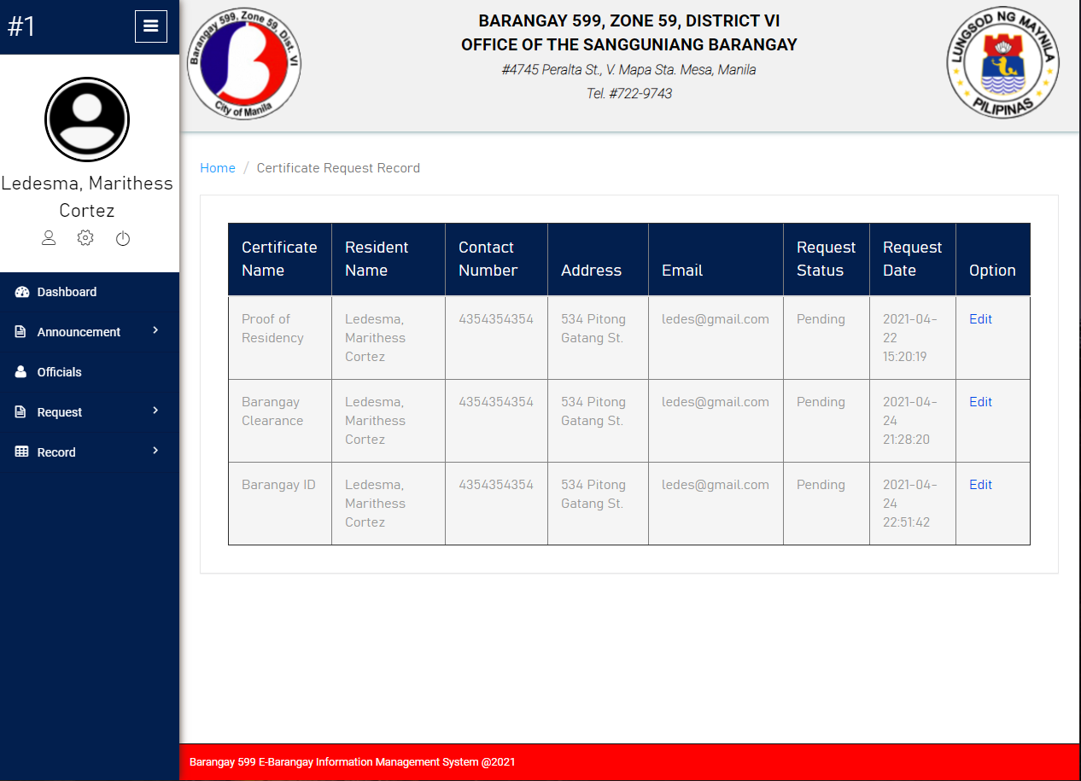

**Certificate Request Record of Residents Module of System Prototype**